Annanhill Primary School
Session 2025/26
Handbook

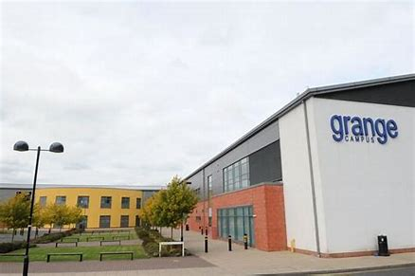

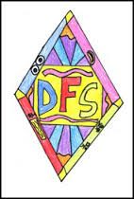“Be the best you can be!” 
Annanhill Primary School
Grange Campus,
Beech Avenue,
Kilmarnock
KA1 2EW
Telephone No: | 01563 549988
Email: | Annanhill.primary@eastayrshire.org.uk
School Blog: | https://blogs.glowscotland.org.uk/ea/annanhillprimaryschool/
Twitter: | @annanhillps
School App: | Available on appropriate mobile devices
Denominational Status (if any): | Non-Denominational
School Roll: | Co-educational school with a roll of 462 pupils.
Further information: | www.east-ayrshire.gov.uk/schoolhandbooks

WELCOME TO ANNANHILL PRIMARY SCHOOL

Dear Parents/Carers,

The school handbook is compiled to give you, as the parent of a new pupil to the school, basic information regarding the school and what we can offer your child. A very warm welcome to you and we hope that the time your child spends in our school will be a happy, productive and enjoyable experience.

Education involves co-operation between home and school and we would hope that you would wish to become involved in educational activities whenever possible.

Our aim is to provide, in partnership with parents, a well-balanced curriculum that will enable each child to reach their full potential, not only in the more formal aspects of education, but also in the many other activities which the school aims to provide. We hope to create in all children a positive attitude to learning, the ability to co-operate with others, to make reasonable moral judgements and to have a caring attitude to the community as well as fostering an appreciation of the world in which a child lives. In addition, children will be equipped with the skills required for a technological age and be prepared to take part in leisure activities. We aim to provide our children with the skills for life, learning and work.

Every child of school age has the right to a school education provided by an education authority. (Standards in Scotland’s Schools etc. Act 2000). Through Rights Respecting Schools, we are committed to Article 28 – ensuring every child in our care has “the right to an education.” We are dedicated to creating a positive learning environment that is based on excellent relationships across the school community. If you have any problem or query regarding your child, please do not hesitate to contact the school as soon as possible. Similarly, the school will contact you, if there is any concern regarding your child’s development, welfare or behaviour in order that minor problems are prevented from developing into major issues.

The following information is intended as a guide to parents of pupils in Session 2025/2026 and will be supplemented by regular newsletters, app messages and blog updates throughout the session. The school handbook can be made available on request, in other formats e.g. Braille, large print, recorded on to tape or translated into another language. It is also available on the school blog https://blogs.glowscotland.org.uk/ea/annanhillprimaryschool/

Yours sincerely,
Emma Johnstone
Head Teacher

SECTION 1

Our School Aims
We aim to give our children skills for learning, life and work. As a school, our values of Achievement, Kindness and Respect are embedded across the school community.

Our Consistent Messages


Benefits of having shared aims and consistent messages within Annanhill are:
- Pupils and adults feel safe and protected
- A positive learning environment is created
- Develops mutual respect
- Everyone’s qualities and attributes are valued
- Our emotions are understood and how we understand how our behaviour affects others
- Being able to disagree without getting into conflict
- Being able to use relational approaches to resolve problems and repair relationships
We all work towards our school vision to “Be the Best You Can Be!”
Our School Culture

Within Annanhill we see the value of relationships across the school community. This is of paramount importance to us as we see the benefit of working together as a team. Everyone’s voice is valued. Our relationship approach creates an ethos that includes all our staff, pupils and parents in the life of the school. We celebrate diversity and aim to get it right for all the children in our care. Our commitment is to achieve our goals by regularly reflecting upon and evaluating our success.
Annanhill Primary is an inclusive school based in Grange Campus. We cater for the needs of all children in our care by providing them with high quality learning and teaching experiences, where we strive to improve attainment and wider achievement for all learners. No barrier should get in the way of children achieving and making progress in their journey through school and we are committed to ensure every child has the support they require to meet their full potential. We aim to “Get it right for every child, “by using a variety of supports and flexible pathways.
Annanhill Primary recognises the importance of the partnership between parents, carers, teachers, pupils and the wider community in achieving its aims. By following a relevant skills-based curriculum we are developing the skills needed for life-long learning. We encourage every child to try new things and become resilient when making a mistake. We want our children to be inquisitive, interested and motivated in the world around them, their history and their local community. Learning is set in real-life contexts, is engaging, motivating and relevant. The campus provides us with valuable opportunities that enhances the learning experiences of the children and adults in our care. Working together we will provide a curriculum and create an ethos of the highest quality that will develop:
- SUCCESSFUL LEARNERS
Enthusiastic with a determination and willingness to fulfil their true potential.

♦ CONFIDENT INDIVIDUALS
Positive young people with the ambition to express their values and beliefs.

♦ RESPONSIBLE CITIZENS
Open minded young people with respect for others in their community.

♦ EFFECTIVE CONTRIBUTORS
Creative young people with the initiative to take on different roles within the wider community.

Communication between home and school
The school strives to keep all parents and carers informed in a variety of ways. We make use of the local authority Safer School’s App for day to day notices. The app also includes information sent directly from East Ayrshire Council and our school blog.
Each class has a blog that gets updated regularly. Primary 3 to 7 make use of Microsoft Teams which is an online way for our children to access learning, work on homework and reinforce class work. As well as this the teacher can regularly engage online with the children and assess progress through setting assignments.
We like to update our parents and carers on our wider school achievements by regularly posting pictures on our school X/Twitter page.
We regularly seek the views of parents on a school subjects and do this through the use of online surveys and questionnaires. We encourage parents to be involved in the school development planning and seek the views of the parent council and wider parent forum on a number of initiatives. Our Parent Council is very active and supportive. Their main aim is to support the children, parents and staff to ensure we are moving the school forward, continually making improvements and raising funds to ensure the children get the very best they deserve.
Although the school app, Twitter and school blog are used regularly to keep you up to date, your child may bring information home in their school bag. Please encourage them to pass these on. REMEMBER TO CHECK BAGS.
Annanhill Primary’s school blog can be found at the address below:
https://blogs.glowscotland.org.uk/ea/annanhillprimaryschool/
Safer School Scotland App can be downloaded on your phone via the app store.

Emergency Information
We make every effort to maintain a full educational service, but on some occasions, circumstances arise which lead to disruption. Schools may be affected by, for example: severe weather; temporary interruption of power and provision of transport or fuel supply. In such cases we shall do all we can to let you know about the details of closure, temporary arrangements or re-opening. We shall keep you in touch by using letters, notices in local shops and community centres, announcements in local churches, the press and on local radio and the East Ayrshire website and Twitter feed.

It is vital that you keep your emergency contact numbers up to date!

SECTION 2
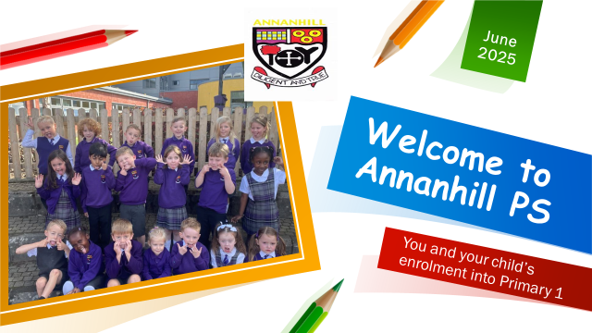

Enrolment
Enrolment takes place annually in January when exact details are given in the local press and posted in pre-5 establishments as well as on our school app. Children who reach the age of 5 years before 1st March of the following year are eligible for enrolment for the primary class beginning in August.

Parents should have access to their child’s birth certificate and proof of address it comes to register their child. All registration processes are now online and can be accessed through the East Ayrshire Council website.

Any parent wishing to come along to view the school and meet us before enrolling their child in January can do so and ask any questions they may have about provision. Appointments can be made by telephone/letter or email.

Children who live in the catchment area of a particular school are required to enrol at that school. They will then be informed of their right to make a placing request to another school of their choice and the conditions pertaining to this.

Information and forms regarding placing requests can be obtained from the school and/or (click here: East Ayrshire Council Placing requests)

Transitions
Transfer from Pre-school to Primary
We are committed to ensuring the transition from Early Childhood Centre to School is as smooth as possible. We start to engage with our new pupils early in the second term with teachers, buddies and SMT visiting various Early Childhood centres to start to build our relationships with our new children. After the January enrolment, we organise various visits by our Primary 1 class teachers to the early education establishments, and welcome our families to the school for a ‘Meet and Greet’, and ‘Stay and Play’ experience.
A calendar of events and visits are introduced in May and we also have “Summer Sizzlers” programmes in August before the young people start primary school.
A special meeting for parents will be arranged around this period to provide detailed information about school procedures and to answer queries. Parents will be invited to further meetings to discuss work programmes being used in the school and to discuss how they can help their children with these at home. We want to ensure we are getting it right for your child right from the start so we engage in meetings for children with any additional support need or medical condition that requires support. We ensure that all information is gathered to support an excellent start to the child’s journey through school.

Transfer from Primary to Secondary School
Pupils are normally transfer to secondary between the ages of 11 and 12, so that they will have the opportunity to complete at least 4 years of secondary education. Parents will be informed of the arrangements no later than December of the year preceding the date of transfer at the start of the new session.

The children of Annanhill Primary School normally transfer to:

Grange Academy
Grange Campus,
Beech Avenue,
Kilmarnock.
KA1 2EW
Tel: 01563 549988

Staff of Annanhill Primary, together with other schools within the Grange Learning Community, meet regularly with Grange Academy to discuss pupil progress and to plan programmes of study across the curriculum.

Children from the primary schools, particularly at primary 7 level are involved with Grange in a variety of curriculum projects, including in primary 7 an extended visit to Grange in June prior to their transfer.

Schools listed below also transfer to Grange Academy:

Shortlees Primary  Blacksyke Avenue  KILMARNOCK, KA1 3SR  Tel 01563 533678 | Crosshouse Primary School  Playingfield Road  CROSSHOUSE , KA2 OJJ  01563 521459
Gargieston Primary School  Dundonald Road  KILMARNOCK  KA1 1UG  Tel 01563 533067 | Hillhead Primary School  2 Kilmaurs Road  Kilmarnock  KA3 1 QJ  Tel 01563 521504

Education Group Establishments

The school is a member of the Grange Education Group which brings together a wide range of services to benefit young people.

The principal purpose of the learning community is to:

- Ensure that services are better co-ordinated in order to meet the needs of young people and raise attainment.

- Learning Communities support the government’s approach to GIRFEC (Getting it Right for Every Child). This means that if a child/young person needs support then, where possible, there will be one co-ordinated assessment and one plan for that child/young person.

School Head Teacher  Mrs Emma Johnstone  Annanhill Primary School  Grange Campus,  Beech Avenue,  KILMARNOCK  KA1 2EW | Parent Council Chairperson  Mrs Natalie Speirs  c/o Annanhill Primary School  Grange Campus  Beech Avenue  Kilmarnock  KA1 2EW |  | Associated Secondary School and Campus Head  Mr Scott Roberston  Grange Academy  Grange Campus,  Beech Avenue,  KILMARNOCK  KA1 2EW
Annanhill Primary School  Beech Avenue,  KILMARNOCK  KA1 2EW  Tel 01563 549988 |  | Hillhead Primary School  2 Kilmaurs Road  Kilmarnock  KA3 1 QJ  Tel 01563 521504
Crosshouse Primary School  Playingfield Road  CROSSHOUSE  KA2 OJJ  01563 521459 |  | Gargieston Primary School  Dundonald Road  KILMARNOCK  KA1 1UG  Tel 01563 533067
Shortlees Primary School, Early Childhood Centre  Blacksyke Avenue  KILMARNOCK  KA1 3SR  Tel 01563 533678 |  | Grange Academy  Grange Campus,  Beech Avenue,  KILMARNOCK  KA1 2EW  Tel 01563 549988
Willowbank School  30 North Hamilton Street  KILMARNOCK  KA1 2QJ  Tel 01563 526115 |  | Crosshouse Nursery  Playingfield Road  CROSSHOUSE  KA2 OJJ  Tel 01563 532300
Flowerbank Nursery  39 Portland Road  KILMARNOCK  KA1 2DJ  Tel 01563 522722 |  | Park School  Grange Campus,  Beech Avenue,  KILMARNOCK  KA1 2EW  Tel 01563 549988

The Community Education Centre offers a variety of facilities. For further information and application for use of any part of the school then contact:

Gateway Community Education Centre
Foregate Square
Kilmarnock
KA1 1LN
Telephone No: 01563 554947

Our Class Structure for 2025/2026
Annanhill is a non-denominational, co-educational school. The present roll of 462 pupils are organised into 18 classes. Teaching Staff is currently 22.6.
Head Teacher: | 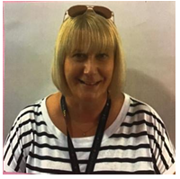  Emma Johnstone
Depute Head Teacher: |   Diane McGougan, Ruth O’Neill
Principal Teacher(s): | 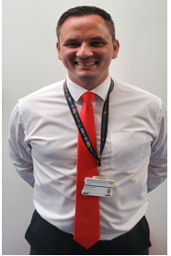  Alan Simpson Claire Haggerty
Classes | Class Teacher
Pr 1J | G. Jarvie
Pr 1M | R. McDade
Pr 1/2SB | A.Stewart/D Bell
Pr 2MH | N. Mason and L.Howie
Pr 2CH | E.Coles and C.Haggerty
Pr 3P | E. Pitt
Pr 3E | C.Ewing
Pr 4M | L.McDowall
Pr 4GM | E.Gemmell/R.McVie
Pr 4TM | L.McCall/G.Todd
Pr 5B | U. Barrie
Pr 5T | J. Telfer
Pr 6B | J. Bracher
Pr 6M | L. McConnochie
Pr 6D | L.Dickson
Pr 7M | C.McAllister
Pr 7W | C.Wallace
Pr 7RD | K.Robertson/M.Donohoe
NCCT/PT | C.Haggerty
NCCT/PT | A.Simpson
Nurture | K.Wallace
East Support Teacher | C.Paton

From time to time the school has the services of various personnel if and when the need arises, for example: Teachers of English as a second language

Support Staff
Senior Clerical Assistant - Una McKenzie
Clerical Assistant - Ann Cuthbert and Ashley Hamilton
Classroom Assistants - Elizabeth McIlwraith, Margaret Boyce,
Karen Duncan, Viv Lambert, Alison McConnell, Kirsty Hart, Jane Clocherty, Elaine McAllister, Tricia Fulton, Amanda McGarvie and Lynne Christie, James Craig and Katherine Duff

Contacting the School

Normally the school is open to parents at any time. During the day, parents will be permitted to attend events and attend meetings by appointment only. Parents should not hesitate to contact the school about any matter concerning their children. Small problems can often be prevented from becoming major ones if prompt action and co-operation is sought by teacher and parent. If wishing to talk to a teacher, parents should first contact the Head Teacher, Depute Head Teacher or Principal Teachers.

Should you wish to contact the school to discuss any issue you should phone 01563 549988 or email the school mailbox eaannanhill.ps@eastayrshire.org.uk. Our clerical staff will then forward your concerns to the relevant member of the management team who will return your call/email as soon as possible.

Formal parents’ evenings are held twice a year. An annual report of children’s learning will be provided in March 2026. Communication about children’s learning will be added to their blog or Teams page termly to give you an overview of what is being explored. Each class have their own format, but will be similar to the one below.
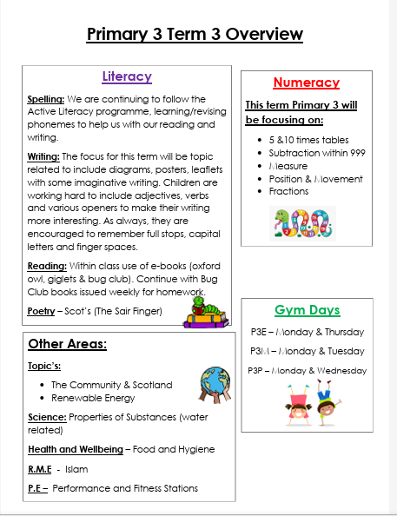
Should you wish to comment on or make a complaint about any aspect of provision made by the establishment, you should contact the establishment in the first instance. Our aim is to resolve as many complaints as possible at the first point of contact. Please see our app for the complaints procedure. The senior management team will do their upmost to ensure your complaint is dealt with in a timely manner.

Additional Support Needs
Within Annanhill additional support is first highlighted by the class teacher to the Senior Management Team.
Interventions are put in place within the classroom through in class supports. Interventions are evaluated on a termly basis and if no significant impact is evident, the child is then highlighted to the additional support needs co-ordinator. A meeting with the teacher and parents is set up to identify whether an action plan or Individual Learning Plan (ILP) is needed to support the young person’s learning. Action plans are reviewed annually and are in addition to parents evening appointments.
ILPs are reviewed as and when required. Please see school Inclusion Policy for more details.
The Parent Council
As a parent of a child in attendance at the school, you are automatically part of the Parent Forum of the school. The membership of the Parent Forum is made up of all parents who have a child at the school. The Parent Forum can decide to form a smaller body called the Parent Council. The Parent Council is a group of parents selected by members of the Parent Forum to represent them. This is a very active group in the school who aim to provide the best support for our pupils, staff and parents.
Parent Council Members

The Parent Council meets regularly in the school and focusses on school planning issues, resources, health and safety, experiences for children and fundraising.
Chairperson - Natalie Speirs
Vice Chairperson - Ruth Cameron
Treasurer - Heather Arkinson/Emma McCandlish
Secretary - Fiona Kealey/Laura Campbell

Meetings are held once a month on different nights of the week to allow people to fit this into their work schedule. We meet in the staffroom and have a coffee and discuss the school’s successes, achievements and any problems that required to be worked on as a group. We have presentations from staff members on key initiatives and children also attend to display some of the good work they have been a part of.

A big part of the Parent Council is the hard work we put into raising funds for the school. The Parent Council have funded trips, Panto, play equipment, outdoor classroom, ICT equipment and art resources. The parent Council are a group of volunteers who aim to get the best experiences for the children of Annanhill. They are extremely supportive of the school and engage fully as members of the whole school team.

Parental Involvement Opportunities
We continually strive to work in partnership with parents and carers. We regularly hold breakfast meetings and parent meetings to seek your views and opinions on how we as a school can improve. Our website and school blog is also updated regularly updated to provide you with information as well as catching glimpses of your child’s learning.
Home School Links
We encourage parents to be part of the life of the school as much as possible, all we ask is that parents make an appointment before entering the school. Parents should not hesitate to contact the school about any matter concerning their child/ren. Small problems can often be prevented from becoming major ones if prompt action and co-operation is sought by teacher and parent. If wishing to talk to a teacher, parents should first contact the school office who will direct your enquiry to the class teacher, principal teacher for the department your child is in, the Depute Head Teacher or the Head Teacher. Parents’ evenings are held twice a year.

Any parent wishing to come along and meet us before enrolling their child in January can do so. Meet and greet sessions will be set up to introduce the school team. The parents of children starting school for the first time meet in June when issues relevant to starting school and schemes of work discussed.
Throughout the year, we like to invite parents into the school to work alongside their child/children. This year stay and play sessions have been very successful and it is lovely for you to be a part of your child’s learning.
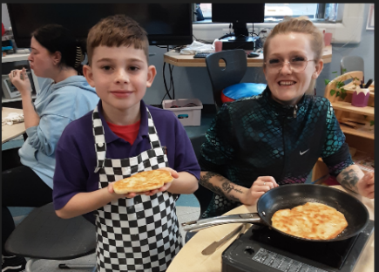
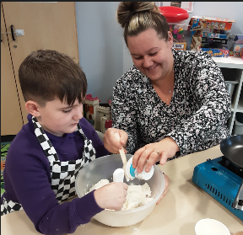
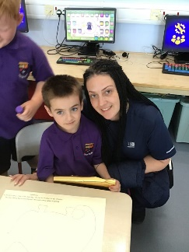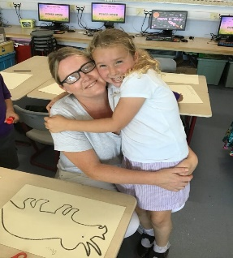
Volunteers are always warmly welcomed to come in and support us within the school. We have been very fortunate to have parents helping us with a range of activities throughout the year. However, new legislation requires that all adults working with children on a regular basis are Disclosure Scotland checked. The school can arrange for a PVG to be completed if this necessary. We can call on adults to help us supervise walks to the church, parks and our Kilmarnock Town trail.
The Grange Learning Community has one Active School’s Co-ordinator who works across the community to provide support to staff and pupils. The children will regularly bring information home in their school bag. We now use the Parent Pay sign up for school clubs and they are on a first come first serve basis so please register your child’s interest in the club quickly or they may miss out on a place.
Information can be viewed on the school blog https://blogs.glowscotland.org.uk/ea/annanhillprimaryschool/ and also on Annanhill Primary School app. (Search for the app in your app store, or visit jsa4.me/Annanhill)

School and Community
As the school is an integral part of the community, children should be aware of the importance of treating the community and those who live in the community with respect and concern.
The school endeavours to share in community projects e.g. local fairs, fund-raising for charity, old folks entertainment etc. and it is hoped that those who live in the community will recognise that the school welcomes participation by parents and friends of the school.
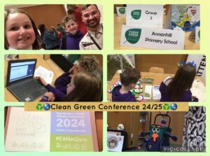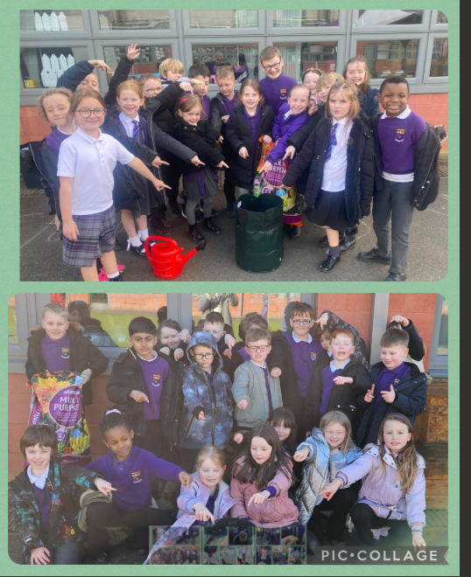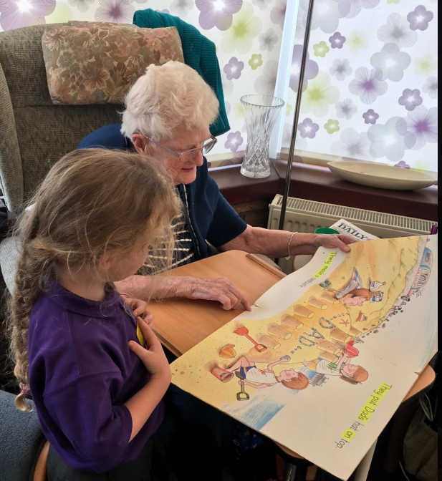

SECTION 3
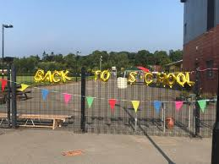
Our School Day
Starts: 9:00 am Ends: 3:00 pm
Interval Starts: 10: 40am Ends: 10:55 am
Lunch Starts: 12:20 noon Ends: 1:05 pm
School finished: 3:00pm

At the beginning of each new session we have alternative arrangements for our new primary 1 pupils. This information will be found on our school app.

Attendance and Time Keeping
Attendance at school is of a paramount importance to ensure opportunities for learning are maximised. If your child is going to be absent from school for any reason you must telephone the school landline on 01563 549988, email the school or log the absence using the safer schools app, giving the reason for absence. Under Child Protection Procedures any absences not reported to the school must be followed up by the school with a text or phone call home.

Attendance and time keeping are monitored currently by our Depute Head Teacher Miss McGougan and will be followed up with parents should any difficulties emerge. Holidays are not authorised absences. We keep a track of your children’s attendance data and if it falls below 90% we will send you a letter to make you aware of this.Following this we will follow our school’s attendance policy which can be found on our Blog.

Dress Code
Within the school we have a uniform which comprises of:
- Grey/black school trousers/skirt or pinafore (our girls also wear tartan skirts/pinafore’s)
- White/Purple polo shirt or shirt/blouse
- School tie
- Purple sweater/cardigan (no hoodies)
- Black school shoes

Security and Visitors
For safety and security reasons it is essential that we know who is in the building at any point of the day. To this end all visitors, including parents, are asked to use only the main entrance to the school to enter the building. We ask parents not to enter with the children through the school playground doors as this makes it difficult to keep track of who is in the building. If parents wish to speak with the teacher please enter through the main entrance and speak to the Senior Clerical Assistant or a member of the Senior Leadership Team who will make an appointment for you to meet with the teacher at a suitable time.

All visitors and trades-people are asked to sign the register at the front of the school and sign out as they leave.

In the interests of your child’s safety, if a different adult is collecting him/her from school that the identity of this person is made known to the school. We will not allow your child to leave the school with an unknown adult, please do not be offended if you are asked to verify who the adult is!

We ask that after the September holidays no parent or carer from our primary 1 classes access the playground. If you need a message passed to your child to come to a different gate, our classroom assistants can assist you with this, through walkie talkie communication. Our gates and playgrounds are manned from 8:50am until 9 am and from 3pm until 3:15pm every day.

School Meals

Meals in P1-7

The Schools (Health Promotion and Nutrition) Act 2007 sets out in detail the National Nutritional Food Standards. School Meals in East Ayrshire offer nutritionally balanced well, presented food in an environment that is sensitive to the needs of pupils. It offers a good lunchtime experience with an important break in the day away from the classroom, while still being in the safety of the school.

All pupils in P1-5 are now entitled to a free school meal. All other pupils can either purchase a school dinner or bring a healthy packed lunch. Children from P4-7 entitled to a school meal can apply for this from the local authority.
Normally the school kitchen also provides a range of snack to purchase at break time. This has been stopped at the moment following COVID guidance.

Cashless Catering - We operate a cashless catering system. Money is paid either online or via point stores.

Complaints Handling

Any complaint should in the first instance be directed to the school and the PT or Depute Head Teacher for the infant or upper department. Should any investigation be required the Head Teacher will be involved in the final decisions and therefore needs to instruct the PT/DHT to carry out an investigation. No matter how big or small your complaint is please allow us the opportunity to fully investigate and get back to you. This may involve a telephone call, email or team meeting as a follow up. Please see the galleries part of the app for our complaints flow chart.
Administration of Medicine 

The administration of prescribed medicines in an educational establishment is a matter for the discretion of the Head Teacher. If the Head Teacher agrees to administer medicine at the establishment, the member of staff administering the medication is legally required to exercise reasonable care to avoid injury. The Head Teacher is entitled to the full co-operation of the parents in helping to observe safe practices.

The only medicines allowed to be prescribed are those issued by a doctor or pharmacist – a prescribing label must be present and full administration details provided. Parents will be required to complete a form before medicines can be administered. You can obtain a copy of this from the school office. In the instance of ongoing medication a Health Care Plan will be formulated by the DHT, school nurse and parent to ensure consistency of administration.

Data Protection

The school will handle all data in relation to children as per Data Protection Act 2018.

The establishment has a range of policies and procedures which are available for parents to read. There are a number of ways we like to communicate with you about your child’s learning and social media has become more popular over the past few years. In the first instance you will be provided with a form that gives us the information about what your child can and can’t access or be photographed for. This form must be completed and returned to school or your child will not have access to the internet for school studies. If at any time you would like to change the access your child can have please update the school teacher/office by letter or email.
Promoting Positive Relationships
At Annanhill we aim to create an atmosphere in which all pupils and staff can work, learn and play safety. A variety of resources and strategies are in place to promote positive behaviour. The school aims to work in partnership with parents and will always consult parents when concerns and difficulties arise.
The school is a community in which children and staff spend considerable time together. If children are to learn and teachers are to teach, there must be agreed rules for everyone’s health and safety.

Anti-Bullying Policy/ Positive Relationships
East Ayrshire Council is committed to creating and sustaining a safe, positive and inclusive environment, where respect is shown to and is given by all of its children, young people, staff and parents/carers. We aim as a school to show kindness, care and connectedness. A number of initiatives and policy documents are in place to support, protect and encourage children and young people to lead happy and successful lives. These policies have a direct influence on the “Respect and Protect” anti-bullying behaviour policy, launched in November 2010, which outlines guidance and procedures for schools.
Information leaflets are available for parents/carers and children and young people giving relevant information outlined in the policy.
It is our commitment at Annanhill to ensure we have positive relationships with staff pupils and parents and through this we have designed a school-based system where positive behavior is rewarded and negative behaviours have natural consequences. We ask parents to support us in this and if there are any concerns we work together as a team to support our children the best way we can.
Homework
Annanhill Primary School encourages children to take responsibility for their own learning. Evidence from recent questionnaires show that parents feel homework has a positive impact on their child’s learning but a lot of parents find the time to complete homework a real struggle. It is our aim to make homework more active, manageable and enjoyable for the children.
Purpose
Homework should enable children to:
- Practice skills and to consolidate learning.
- Take responsibility for their learning and work independently.
- Demonstrate to parents the type of learning they are doing at school.
Types of Homework
The type of tasks undertaken as homework is up to the individual teacher. The main areas of the curriculum in which homework is issued from will be:
- Spelling
- Literacy
- Mathematics
- Social Subjects/Community projects
- Enterprise
- Research/Investigations
Timescale
The average time spent on homework each night should be 20-30 mins.
Physical Education (P.E.)
Young people in Annanhill Primary School have 2 hours of P.E. per week. Children will know their days for P.E. P.E. kits are usually kept in school. We do follow the Council’s Health and Safety play and insist that jewellery including earrings cannot be worn for P.E.

SECTION 4
Curriculum
Curriculum for Excellence is the education system in Scotland. It includes early childhood centre, schools colleges and community learning from 3-18 and beyond.

The table below matches the five curriculum levels to stages of learning generally applicable, with flexibility (for example, for young people who are particularly able and/or have additional support needs).

Level | Stage
Early | The pre-school years and P1, or later for some.
First | To the end of P4, but earlier or later for some.
Second | To the end of P7, but earlier or later for some.
Third and Fourth | S1 to S3, but earlier for some. The fourth level broadly equates to Scottish Credit and Qualifications Framework level 4.  The fourth level experiences and outcomes are intended to provide possibilities for choice and young people’s programmes will not include all the fourth level outcomes.
Senior  phase | S4 to S6 and college or other means of study.

From pre-school to the end of S3 (3-15), young people will experience a broad general education which is designed to enable each child or young person to be a successful learner. A confident individual, a responsible citizen and an effective contributor. The broad general education will include all of the experiences and outcomes across all curriculum areas up to and including the third level.

Throughout all learning, prime importance is given to literacy, numeracy and thinking skills; skills for learning, life and work; an understanding of society, the world and Scotland’s place in it and an active and healthy lifestyle.

A range of teaching methods and contexts for learning is used, including active and enterprising learning, which encourage young people to become enquiring; learning across the curriculum which helps young people make links between subjects and learning outside classrooms in the outdoors and in the community, which gives opportunities for learners to deepen their learning in real-life contexts. Most learners will progress into the fourth level in many aspects of their learning before the end of S3, laying strong foundations for more specialised learning.

Curriculum for Excellence emphasises that assessment is an integral part of the day-to-day teaching and learning. Learners’ progress will be closely monitored by staff, who reflect with them on their strengths, learning needs and next steps and take action based on this. Learners themselves will be increasingly involved in this process, as they develop the skills needed to be able to make effective judgements on their own learning; skills that will be important to them throughout. Assessments tools will be administered providing additional evidence of what learners know, understand and are able to do and helping teachers plan learning experiences which are motivating and challenging.

Information about how the curriculum is structured and curriculum planning
www.educationscotland.gov.uk/the curriculum/
www.youngscot.org (learners)
www.sqa.org.uk (information on qualifications)
www.ltscotland.org.uk (teaching practice and support)
www.engageforeducation.org (share ideas and questions about education)
www.scotland.gov.uk/cfeinaction (real-life examples)
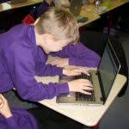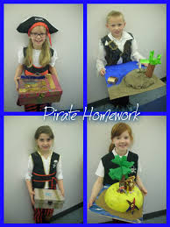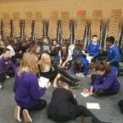
The establishment is implementing CfE through main curricular programmes- Health and Wellbeing, Literacy, Numeracy, French and a range of Interdisciplinary Studies that provide a context for Science, History, ICT and Geography.

Pupils are involved in a wide range of activities:- Pupil Council, Eco Committee, Digital Leaders, Cool Learners, Language Ambassadors, Junior Road Safety Officers, playground and lunchtime monitors, football training, cross country, athletics, choir, cycling, annual musical performances, residential experience, art club, newspaper production, outdoor learning.

Children are consulted at the beginning of investigations and topics about what they would like to learn. Pupil Council are consulted about their learning. Parents are invited into class at the end of projects and are informed by their children about the curriculum covered.

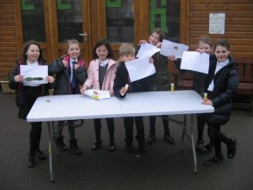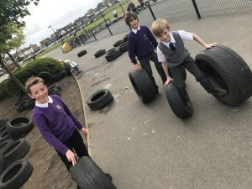

Parents will be informed in writing about sensitive aspects of learning such as sexual health and relationships, parenthood and drugs awareness. They will have the opportunity to discuss any aspect with the establishment or school nurse.

Health & Wellbeing

Health and wellbeing is a crucial part of your child’s education. We teach all health and wellbeing in line with Easy Ayrshire guidance and authority wide planners. We have information sessions where we encourage parents to see the resources and discuss the lessons planned for the more sensitive aspects of health lessons.

Religious & Moral Education

This forms an important part of social education, assisting pupils towards a consistent set of values, attitudes and practices arising out of experience. Religious Education will encourage children to become aware of religious interpretations of personal experience and to appreciate dangers of prejudice. Our arrangements for pupil assemblies afford opportunities for gathering as a community, for communal worship with our chaplain and for sharing expressions of the feelings of the community. Parents from ethnic minority religious communities may request that their children be permitted to be absent from school in order to celebrate recognised religious events. Only written requests detailing the arrangements will be considered. Appropriate requests will be granted not more than three occasions in any one session and the pupil noted as an authorised absentee in the register. If you do not wish your child to take part in religious activities, please notify the Head Teacher who will make any necessary arrangements.

Outdoor Learning

All children and young people will have regular opportunities to learn outdoors both in the establishment grounds and in the local community. Parents will consent to this regular localised outdoor learning once at the beginning of session, with medical and emergency contacts being requested. Thereafter, parents will be notified of the venues and dates of off-site visits, in order that pupils come adequately prepared. However, it is the parents’ responsibility to inform the establishment if emergency contacts or medical conditions change or they don’t wish their child to participate in a visit.

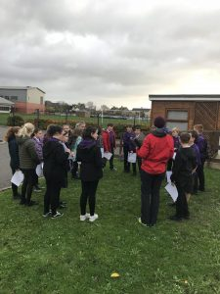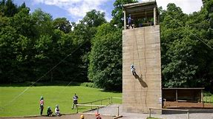

Dyslexia Friendly Schools
Annanhill has achieved the Gold Dyslexia Friendly Schools Award and maintained this award for 3 years. This is a result of developing dyslexia friendly classrooms; having robust processes for assessment of dyslexia and dyscalculia and working with the whole school community to raise awareness of dyslexia and dyscalculia.
Dyslexia and Dyscalculia Assessment
- If there is a concern about a pupil’s progress in literacy and numeracy, teachers or parents can ask for further assessment to be carried out.
- With parental agreement, there will be a referral to the Assessment Group. Teachers will gather evidence of learning, which will be discussed at Assessment Group. Interventions will be suggested and recommendations for further assessment agreed.
- All information is recorded on an Assessment Summary grid and updated throughout the process. Parents are updated throughout the process.
- East Ayrshire’s Staged Intervention process will be used to carry out assessment of dyslexia or dyscalculia.
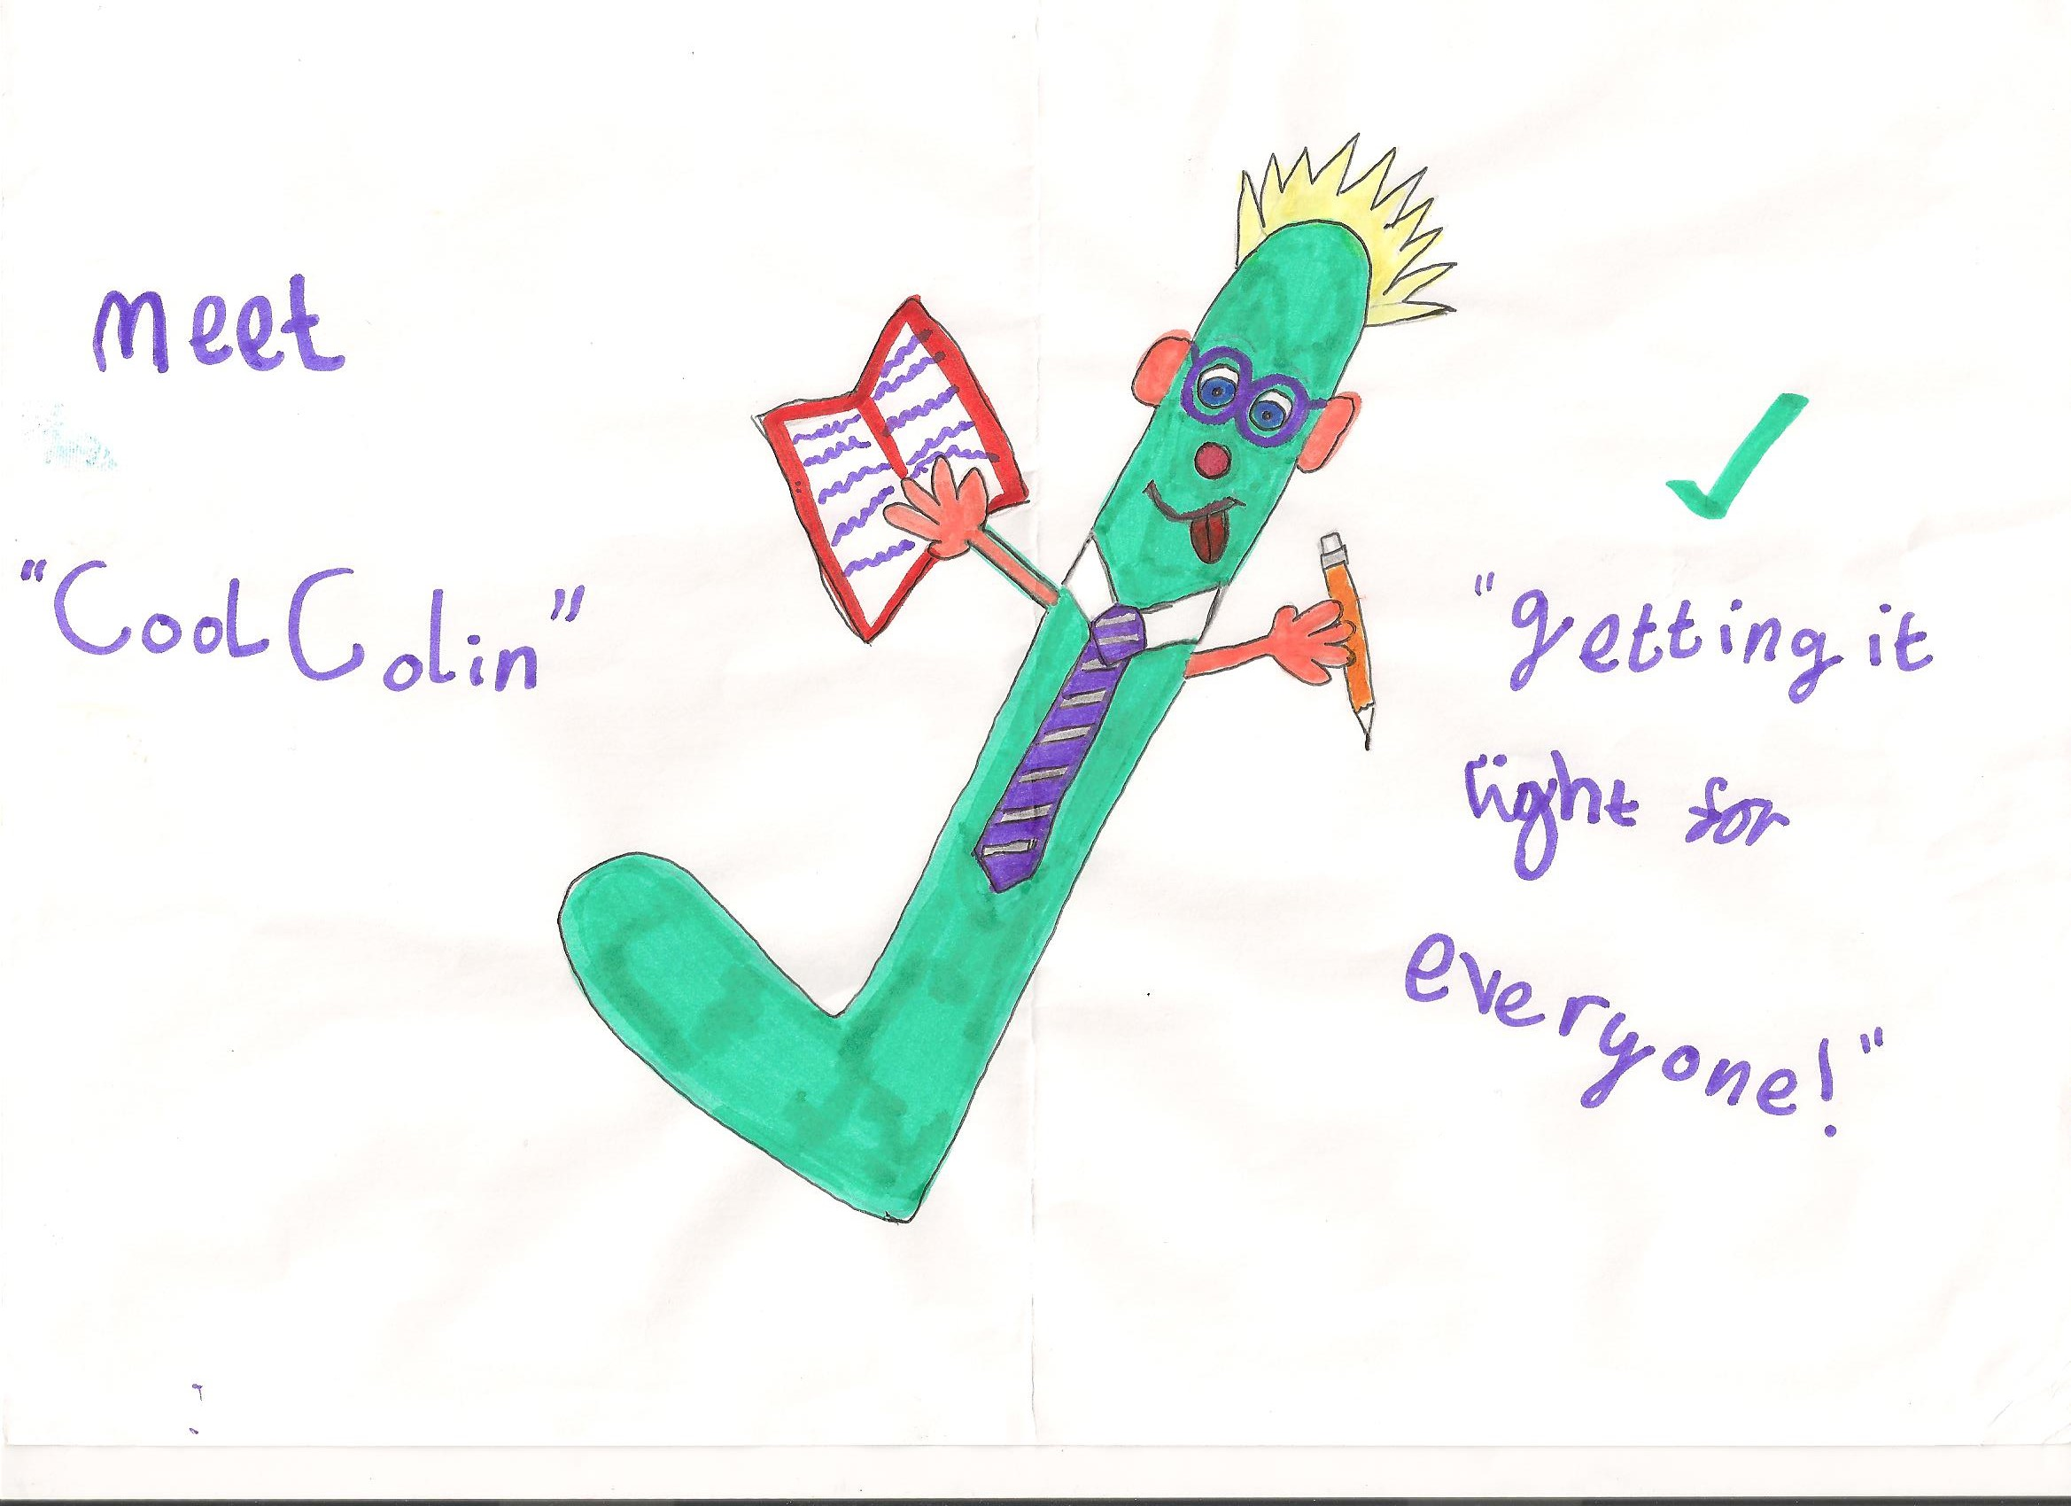
Dyslexia Friendly Classrooms
- There are support resources (FAB boxes) in every classroom for pupils to access
- Pupils are encouraged to use ICT (Word and the immersive reader) for extended writing
- Pupils are encouraged to access audio texts using PDFs and the immersive reader
- Pupils design their own pupil passports to communicate what they need for their own learning
- Pupils are encouraged to demonstrate their learning in a variety of ways.
- There is limited copying from the board and different coloured pens are used.
- Pupils use worksheets which have dyslexia friendly fonts and layouts
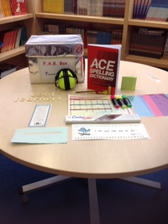

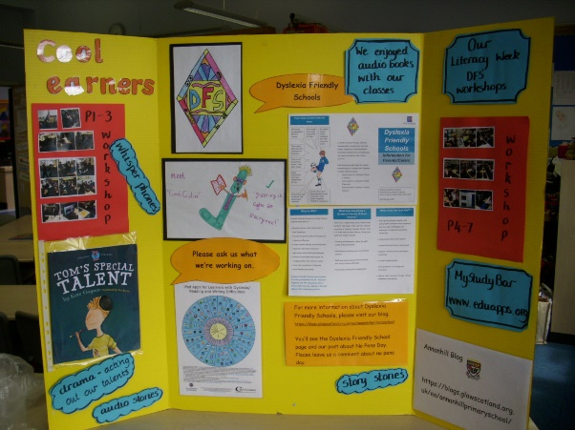
Raising Awareness of Dyslexia and Dyscalculia within the Annanhill School Community
- All staff have regular input about learning and teaching in a dyslexia friendly manner.
- Cool Learners is the Pupil group.
- They support the whole school community by mentoring younger pupils who have barriers in their learning.
- They regularly deliver presentations at assembly.
- They help organise literacy events in the school.
- They deliver workshops at parents’ evenings.
- The Parent Council support the school in ensuring the FAB Box resources are maintained and updated.

SECTION 5
Achievement and Improvement
This sessions we have:
- Improved Health and Wellbeing by introducing the Relationships, Sexual Health, Emotional and Mental well-being and Parenthood programme.
- Raised attainment in Reading, Numeracy and Maths.
- Revised our current curriculum design to promote skills progression for life, learning and work.
- Developed an inclusive approach to all aspects of learning.
- Assessed and moderated information handling in maths and tools for reading and writing in literacy.
- Introduced the children to online work through TEAMS
- Increased the amount of children who participate in school based after school activities and secured a Sports Scotland Silver award
- Created more opportunities for children to be involved in local authority sporting events
- Introduced the active literacy approaches to learning reading, writing and phonics
- Provided children with a flexible curriculum that meets the children’s needs using partners to support key areas.
- Continue to improve learning and teaching in reading using the new Annanhill lesson proforma.
Increase the involvement of the whole school community by promoting the school blog, Twitter, You Tube and the app.

This year we aim to:
Raising Attainment, particularly in Literacy and Numeracy | Increased in sustained positive destinations and employability skills
- Increase attainment in teaching and learning in Numeracy and Maths by using skills progression planners and introducing Heinemann active maths  - Increase attainment in Literacy by introducing phonics, grammar, writing Active Literacy approaches and CYPIC writing approaches  - Revise and update our maths assessments to make sure we are assessing what has been taught  - Provide real life contexts for learning so children can apply the skills that they have been taught  - Focus on interventions that will raise attainment for our children | - All staff and children will use GLOW to access emails, resources and blogs  - Further develop the use of Teams and blended learning approaches to ensure continuation of skills developed  - Develop digital skills across Primary 4-7 and ensure we are aligning the skills taught to the world of work  - Digital leaders will form a committee to further enhance coding and the use of social media and GLOW platforms to communicate with parents  - Continue to make use of platforms to encourage homework through home learning models
Ensuring the health and wellbeing of all young people | Closing the poverty related attainment gap
- Increase the amount of children who participate in school based after school activities  - Create leaders in children who have an interest in coaching in specific sports  - Create leadership opportunities across the school for staff, pupils and parents  - Further develop programmes such as LIAM programme, Seasons for Growth and Circle of Friends to support our vulnerable children.  - Develop the use of the Glasgow Wellbeing tracking tool. | - Look at ways in which spelling and grammar and introduce interventions for children who need support  - Nurture provision extended  - HWB groups create for infant and upper stages to work on resilience, emotional literacy and support peer relationships  - Focus on raising attainment for children in SIMD 1 and 2 using a variety of literacy, numeracy and health and wellbeing interventions  - Providing children with a flexible curriculum that meets the children’s needs using partners to support key areas.

SECTION 6
Assessment
Curriculum for Excellence emphasises that assessment is an integral part of day to day teaching and learning. Learners’ progress will be closely monitored by staff, who reflect with them on their strengths, learning needs and next steps and will take action based on this. Learners themselves will be increasingly involved in this process, as they develop the skills needed to be able to make effective judgements on their own learning; skills that will be important to them throughout life. Testing will continue to be part of the framework of assessment, providing additional evidence of what learners know, understand and are able to do and helping teachers plan learning experiences which are motivating and challenging.
Assessment is the means of obtaining information which allows teachers, pupils and parents to make judgements about pupil’s progress and identify where we go next.

We do this in a variety of ways:
- day to day observations
- ongoing assessments such as end of topic activities
- teacher devised tests
- set tasks
- self-assessment
- homework opportunities.
- standardised and diagnostic testing, for example:P1 ELLAT, P3 Quest and SNSA testing for P1,4 and 7

All assessments will generally be carried out by the class teacher. Information gathered from all assessments will be used to assist the school in reporting to pupils, parents, colleagues and other agencies. Feedback from class-based assessment is given to the children to assist with their targets and next steps in learning. The percentage given in a test is not reflective of a child’s ability it is dependent on what is being assessed at the time and their journey across the CfE levels. We triangulate our assessment data with teacher’s professional judgements and a child’s class work or observations. All of this information formulates the children’s levels of attainment and what their next steps and learning are.

Reporting To Parents
- Parents will have the opportunity to meet with teachers twice a year. A pupil computerised report has been introduced and is issued to parents in March.
- Children who may have additional support needs, or who require a Co-ordinated Support Plan will be assessed in a way suited to their individual requirements. Further information is available from the Head Teacher.

Attainment and Achievement

We celebrate attainment and achievement within the school through individual certificates, class successes and whole school achievement. This can be in class, playground, at assemblies, through newsletters, our blog and in local newspapers and social media. Our annual prize giving ceremony recognises attainment, achievement, citizenship, sportsmanship and resilience. We aim to recognise the wider achievements of our pupils at assemblies and welcome information from home about involvement in other activities out with the school.

We work in partnership with others to promote and enhance learning enabling all pupils to achieve success. We have strong partnerships with many external agencies within the community including Active Schools, Dean Park Rangers, Tesco, the SSPCA, Kilmarnock Football Club, Annanhill Golf Club, Kilmarnock Harriers, Centre Stage and Ayrshire College. We regularly have special events planned during the school day and out with school hours to ensure all our pupils have access to a wide range of learning and social and cultural experiences.

We seek to provide opportunities for our pupils to learn in real life contexts and we promote positive relationships with families to build strong learning teams to meet outcomes and build on positive outcomes for all.



