***Every school day matters***

|  |  |  |  |  |  |
| --- | --- | --- | --- | --- | --- |
|  |  |  |  |  |  |
| **100 %** Excellent Attendance | **98%** Impressive  4 days off | **96%**  Good  8 days off | **94%**  Needs to Improve  12 days off | **90%**  Danger Zone  19 days off | **80%** Extreme Impact  38 days off |

***BUT every minute counts***

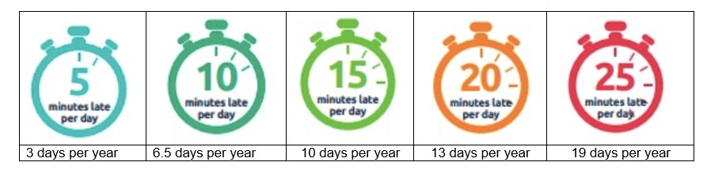

**When you're in school you...**

   

**Attendance at school allows all our pupils to…**

