**Annanhill Primary School**

**Inclusion and Positive Relationship Policy**

***October 2024***

**Rationale**

Inclusion and building positive relationships are crucial to developing pupils who are:

CONFIDENT, RESPONSIBLE, EFFECTIVE and SUCCESSFUL.

At Annanhill Primary School, we aim to ensure that every child reaches their potential and their individual needs are met no matter what their barrier to learning. In accordance with a range of polices globally, nationally and locally, we hope to achieve this aim through the development of this policy.

*The Salamanca Statement and Framework for Action on Special Needs Education* (UNESCO 1994) discusses the educational difficulties of inclusion and getting it right for all children. Emphasis is not only put on education but on the impact on the whole school community if wellbeing is not supported, *‘*A Child-centered pedagogy can help avoid the waste of resources and the shattering of hopes…moreover, the training ground for a people-oriented society that respects both the differences and the dignity of all human beings' (UNESCO, 1994, p. 7). Therefore, highlighting that attainment alone is not the answer to education and we need to consider the whole child to support individual needs,

*Getting it Right for Every Child (GIRFEC) Policy Statement*, (Scottish Government, 2022), emphases the importance of pupil wellbeing and how this is critical to children flourishing in their learning, ensuring we provide support at the right time to allow children to meet their full potential. The Scottish Government (2020) document, *Support for Learning: All our children and All their Potential* makes reference to ‘Relationships and Behaviour’ through one of their identified themes, stating, 'Unmet needs and inability to express intense, difficult feelings can result in a child or young person expressing these through verbal and physical abuse' (Scottish Government 2020, p. 51). Assumptions created suggest that the underlying problems linked to mental, emotional, and social wellbeing could be linked to relationships between staff and pupils. Therefore, exploring positive relationships is crucial to getting it right for all our pupils through the development of an ethos which is built on trust and mutual respect where all children feel included and valued. As discussed by the Scottish Government (2021a), leaders need to support and guide staff to create this environment.

The General Teaching Council Standards (GTCS) (2021) advocate that Wellbeing is the responsibility of all, and that everyone in the school community has a key part to play in building positive relationships. Within local policy, it has been highlighted that we must ensure staff feel supported, and equipped with the skills and qualities required to support pupils’ wellbeing. (East Ayrshire Psychological Services 2016).

**Contents**

Our Vision

Annanhill Values

Roles and Responsibilities

Meeting Pupil Needs

Whole School Approaches

Group Approaches

Individualised Supports

Cost of the School Day

Attendance

Child Protection

Positive Relationships and Behaviours

Supporting Behaviours

Consequences

Positive Reinforcement and Celebrating Success

Appendices

**Our Vision at Annanhill**

Annanhill Primary School is committed to meeting the needs of all our learners, ensuring that their understanding, skills, capabilities and attributes are developed from early level and are revisited and refreshed throughout their time at Annanhill and into lifelong learning.​

​

As a school we create a safe and nurturing environment through a consistent whole school approach to wellbeing which is supported through high quality learning experiences and ongoing assessment of needs.  ​

​

Every pupil feels they are valued and included allowing them to reach their full potential. We remove barriers to learning through an inclusive approach underpinned by positive relationships and a relentless drive to get it right for every child in our care.​

***At Annanhill Primary School we encourage every pupil to:***



**Annanhill Values**

**Our Values**

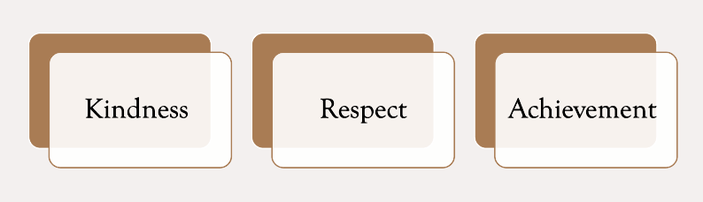

**Our Consistent Messages**

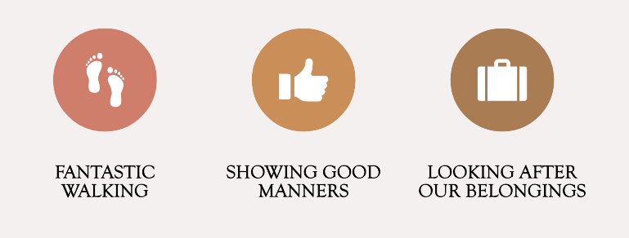

**Benefits of having shared values and consistent messages within Annanhill are:**

• Pupils and adults feel safe and protected

• A positive learning environment is created

• Develops mutual respect

• Everyone’s qualities and attributes are valued

• Our emotions are understood and how we understand how our behaviour affects others

• Being able to disagree without getting into conflict

• Being able to use relational approaches to resolve problems and repair relationships

**Roles and Responsibilties**

**Senior Management Team**

The SMT are responsible for:

* Leading by example by establishing a positive, caring ethos which is underpinned by supportive and open relationships across the school community.
* Modelling behaviour which highlights the school aims and values.
* Supporting a whole school approach to inclusion and positive relationships by involving class teachers, classroom assistants, clerical staff, pupils, parents/carers and the wider school community.
* Providing resources necessary to deliver and support the development of inclusion.
* Providing staff with regular CLPL opportunities to improve their professional skills and competencies.
* Supporting the assessment processes to meet the needs of all our pupils.
* Monitoring and tracking progress of our pupils who are accessing interventions.
* Reviewing policy regularly to ensure continued improvement.

**Class Teachers**

Class teachers are responsible for:

* Being proactive in ensuring they meet the needs of all learners within their classroom by building a positive learning environment built on open and honest relationships.
* Planning and delivering learning and teaching which incorporates wellbeing and meeting the needs of learners.
* Providing rich experiences in day-to-day learning and teaching programmes and engaging in cross curricular links and real-life situations.
* Using a wide range of innovative strategies and resources to inspire and motivate learners and ensure that lessons are active.
* Utilising assessment strategies to support individual needs.
* Taking part in regular CLPL opportunities to improve their professional skills and competencies within inclusion.
* Being aware of policies linked to wellbeing, inclusion, child protection and behaviour locally, nationally and globally.
* Adhering to their responsibilities with the GTCS standards.
* Ensuring that a consistent approach to inclusion is achieved in line with this policy to support our whole school approach.

**Pupil Support**

Pupil support staff are responsible for:

* Establishing positive relationships with pupils which make them feel safe, happy and supported.
* Being aware of the wellbeing needs of the pupils they are working with by liaising with teaching staff and SMT.
* Guiding and supporting pupils through group and individual activities to support their learning or wellbeing.
* Ensuring that a consistent approach to inclusion is achieved in line with this policy to support our whole school approach.
* Being aware of policies linked to wellbeing, inclusion, child protection and behaviour locally, nationally and globally.

## **Pupils**

Pupils are responsible for:

* Building positive relationships with peers and staff (supported if required)
* Supporting the aims and values of the school and using these expectations to inform their actions.
* Taking responsibility for their own actions and consequences
* Respecting the individual needs of others around them
* Identifying strategies which support their wellbeing (Supported if required)

**Parents and Carers**

Parents/carers are responsible for:

* Taking time to talk and listen to their child/children every day
* Praise and encourage effort and successes to help build resilience
* Encourage independence and responsibility at home
* Exploring techniques which may support their child/children when they are distressed
* Developing positive and open relationships across the school community.
* Modelling behaviour which highlights the importance of accepting our mistakes and learning from these.
* Are proactive in in establishing open, positive, supportive relationships across the school community and in modelling behaviour to their child which promotes health and wellbeing
* Keep the school informed of any changes or losses that may impact on their child/children’s learning.

**Meeting Pupil Needs**

At Annanhill we have a range of ways to support the needs and wellbeing of all our pupils and staff, which is underpinned by our inclusive approach and positive relationships.

Below is an overview of the supports we put in place across the school.

**Further Learning**

Wellbeing Champions

Dyadic Developmental Practice, Psychotherapy & Parenting

Nurture

Educational Psychologist Input

Novel Study across the Campus

**Whole School/Class**

Circle Framework

Communication Friendly

RRS – Class Charters

SHANARRI

GMWP

***Inclusion Support in Annanhill***

**Specialist Supports**

Sunflower Room

Nurture

Dysregulation Trackers

Bespoke Timetable

LIAM

Outside Agency Support

**Group/Targeted intervention**

Teacher Assessment

Classroom Assistant Support

EAST

SALT

Educational Psychologist

Junior Duke

Adventure Programme P7

Seasons for Growth

**Whole School/Classroom Approaches**

All teaching staff have the responsibility to ensure the following areas are part of their classroom daily practice and these will also be reinforced within whole school assemblies.​

* **Circle Framework** – The Circle Framework has been developed to support the expertise of our teachers in creating an inclusive environment for all learners. The framework provides comprehensive checklists which explore the Physical and Social Environment, Rules and Routines, Motivation and Skills in connection with inclusion. All teachers will complete checklists throughout the year linked to our ASN calendar.
* **Communication Friendly Strategies** – Each class teacher should ensure their learning environment is accessible to all. All areas of the classroom should be labelled appropriately and resources available to support the learning of pupils in their class. This area is closely linked with the Circle Framework Checklists.
* **RRS – Class Charters** – As part of being a Rights Respecting School, and in line with UNCRC Article 12, pupils should be full partners in agreeing what the shared expectations and boundaries are within their class through the creation of a Class Charter. This aims to create a positive learning environment for pupils, as well as, building shared values and trusting relationships. Charters should be seen as a framework for both adults and children on how to respect each other’s rights.
* **SHANARRI** – Supporting pupil’s wellbeing is a key concept of the ‘Getting it Right for Every Child’ policies and as a school we ensure we are following Standard Circular 76. With this is mind all pupils will explore the wellbeing indicators and what this means to them through whole class activities.  Pupils should be familiar with the Wellbeing Web.  This can be used to support pupils who may be displaying difficulties with their social, emotional, and physical wellbeing. ​
* **Glasgow Motivational and Wellbeing Profile** (GMWP) – This is a 20 question survey which is completed by pupils in primary 3 to 7. Analysis of results of the questionnaire will allow for individual targets to be created.  This will be completed twice throughout the year in September and May.

**Group Support/Targeted Intervention**

If areas explored within whole school approaches have not successfully reduced barriers to learning for pupils, as a school, Annanhill will explore further interventions and supports.​

* **Teacher Assessment** – Following the flow chart below staff will ensure that they gather a robust amount of evidence to support the learning needs of the pupils. This process will be supported by SMT, parents, pupils and outside agencies if required.

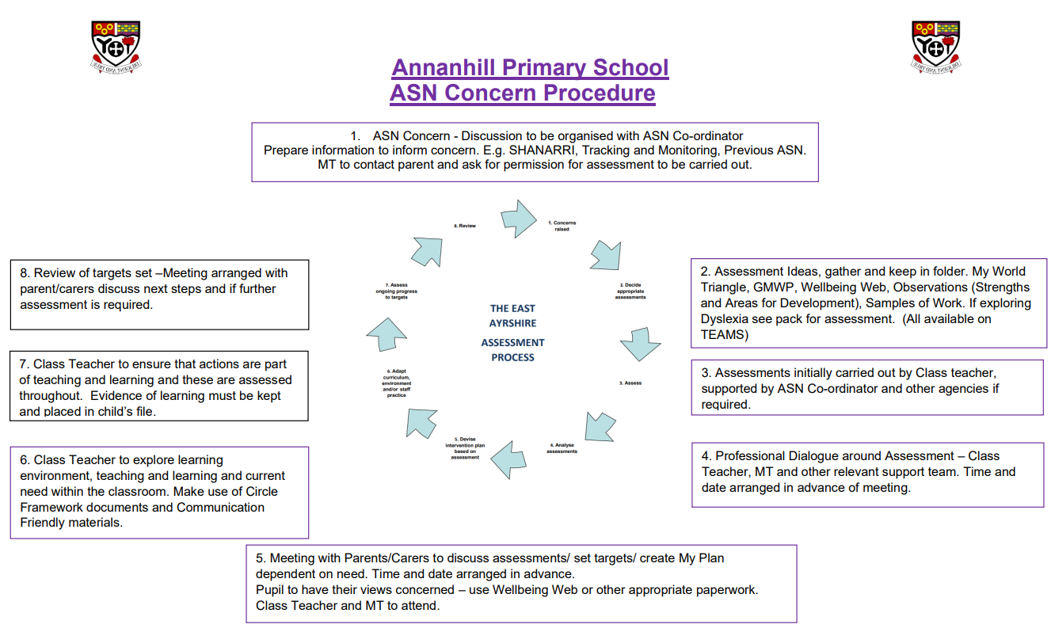

Following the assessment process, we may explore some of the following next steps of support:

* **Classroom Assistant Support** – Our classroom assistants support pupils as part of their class, within small groups or on a one to one basis if required. Our classroom assistants can deliver a range of interventions such as Active Literacy and Numeracy, Talk Boost Groups, 5minute box intervention as well as other individualised wellbeing supports for pupils.
* **EAST –** Each term our SMT meet with our EAST member of staff to discuss pupils who may already have an identified need. Pupils receiving this support may have a child plan or ILP in place and require specific learning strategies and approaches tailored to their needs. The EAST team also provide short term interventions to support pupils who may have small gaps in their learning.
* **SALT** – Speech and Language Therapy – As a school we can explore a Request for Assistance for this service to support language and communication needs. Staff from this service come into the school to work with pupils and their teachers.
* **Educational Psychologist** – Each term our SMT meet with our educational psychologist to discuss key worries and concerns linked to pupils. Our educational psychologist can support us through observations, assessments and further interventions and strategies for pupils who may require more specialist supports.
* **Junior Duke Award** – This award is provided by our classroom assistant team. Class teachers can identify pupils who may require support with life skills and would benefit from small group intervention. This award has also been successful in enhancing pupil wellbeing through increased motivation and enthusiasm for learning.
* **Adventure Programme** – This programme is specifically designed to support our primary 7 pupils who may need enhanced preparation for their next big step to secondary. This explores aspects of anxiety, confidence and having a positive mindset. Primary 7 staff will be asked to identify pupils who may require this support during term 2 of the year.
* **Seasons For Growth –** This programme helps pupils to build knowledge and skills to strengthen their emotional wellbeing and resilience following a significant change or loss. Information sessions are given to both pupils and parents before pupils accessing this programme to ensure it is suitable for individuals.

**Specialist Supports**

If pupils continue to find accessing the curriculum difficult and assessments carried out show a need for more specialists supports, we have a range of individualised learning opportunities that pupils can access.

**Our Sunflower Room**

* **Soft Start** - We offer pupils the opportunity to have a soft start to their day if required. Pupils can come into school from 8.45am to 9am and can access a safe space with a range of self-regulation activities.
* **Breakfast Club** – We provide breakfast for some of our pupils from 9am to 9.30am this also provides an opportunity for anyone who may require some wellbeing support before the start of their day.
* **Lunch Club** – Our dinner hall can be very overwhelming for some pupils therefore our Sunflower Room offers a calm, quiet space for the children to have their lunch if required. This is very flexible to individual needs and can change fluidly throughout the year.

**Dysregulation Analysis Tool –** This will be used to monitor and track the behaviours of a child who may be showing dysregulated behaviours. From the evidence gathered, we will be able to analyse and explore possible triggers to behavior supporting with relevant strategies and interventions. This is a new strategy which we will pilot within the school and will be supported by East Ayrshire Inclusion Team.

**Nurture Provision** – As a school we provide a nurture environment for pupils who require a more bespoke package of learning. Our nurture group runs every morning for designated groups. This provision is underpinned by robust assessment and evaluation of need, and is supported through the 6 principles of nurture:

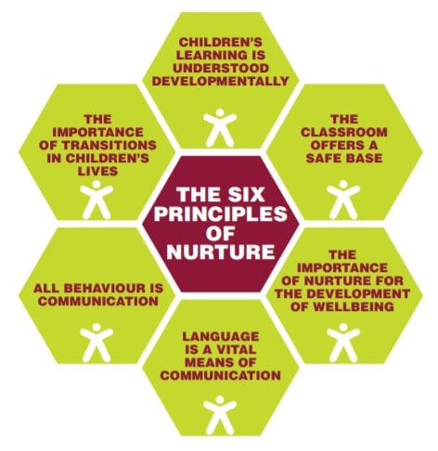

Within our nurture class we set each pupil individual targets linked to the Boxall Assessment as well as ensuring the children have the opportunity to develop their literacy and numeracy skills across the curriculum. Targets are reviewed regularly within ILPs and Child Plans through a TEAM approach involving staff, parents and pupils. We have found that nurture improves attendance, behaviour and attainment, and ensures every child is able to learn.

**Bespoke Timetables** - This timetable may be a combination of activities such as whole class learning, small group activities and 1:1 intervention. The bespoke timetable provides opportunities that are different from or in addition to what is ordinarily available for a pupil within the class. Class teachers work very closely with the nurture team and SMT to ensure pupils still have a sense of belonging to their class.

**LIAM** – **Lets Introduce Anxiety Management –** This programme is an individualised programme for pupils who may be struggling with anxiety symptoms. The pupils are supported by a trained member of staff to explore how to manage their worries and anxiety. Within Annanhill this programme is currently supported by our School Nurse Service and when possible our school team are able to support the development of the programme.

**Outside Agency Support**

Annanhill have links with a number of outside agencies and supports, below is a list of some of the key supports we liaise with regularly.

**School Counselling Service –** This service is dedicated to the psychological wellbeing of our pupils. They work with children and families who may be experiencing difficult circumstances leading to prolonged periods of sadness, anxiety, anger and other difficult emotions. Children can be referred to the service by their teacher or key adult working within the school. However, parents will always be informed before a referral takes place.

**School Nurse Service** – This service work closely with the school to develop the health and wellbeing of our pupils. Nurses help identify health needs early, determining risk and protective factors, supporting with early interventions to stop issues escalating. They also offer valued support for parents/carers.

**Children’s First​–** This serviceprovide short term support to explore challenges and strengths and their impact on emotional wellbeing. Family support with dysregulated behaviours. Request would be explored with the support of the school nurse and parents before sending to Children’s First.

**Social Work​–** This service supports the school when they have any worries or concerns around child protection. Social workers can support children both in school and in the home. Please see Child Protection information on the following page.

**Cost of the School Day**

The concept of equity is taught to the children in the school ensuring that everyone understands that different people need different supports and levels of support within school and that’s ok.​

​

It is our aim within Annanhill Primary to remove as many barriers to learning as we possibly can. We are mindful of the ‘cost of the school day’ and will, as far as possible, minimise or subsidise costs e.g. events, trips, uniform, and fund-raising**. (Appendix 1)**

**Attendance**

At Annanhill we ensure that attendance of pupils is monitored closely. We have developed clear protocols for managing attendance and supporting pupils to attend school in line with Standard Circular 5.

All staff have the responsibility to ensure that attendance is monitored and discussed with our Senior Management Team.

We aim to engage with parents/carers as early as possible to support any worries and concerns around attendance.

If a child’s attendance drops below 90%, our Senior Management Team and class teachers will begin to monitor by doing the following:

* Look at the background of the pupil through exploring pastoral notes, discussion with teachers, discussion with pupil if appropriate, and any additional support need information.
* Where there is an area for concern, initial conversation with parent will take place over the phone and discussion of supports to eliminate any barriers to attendance. This will be monitored over 2-3 weeks.
* If attendance continues to fall, parents will be invited into the school to have an informal meeting to discuss next steps. If support from outside agencies is required for example: Financial Inclusion Officer, Homelink, or social work a more formal TWTF will be arranged.
* Time will be given for actions to be followed from the TWTF this will be dependent on each individual situation.
* If no improvement and attendance continues to fall without due cause, there may be a need for a report to be sent to the Children’s Reporter through SCRA to support the pupils attendance as it will now be having an impact on wellbeing and learning.

The importance of attendance leaflet for parents **(Appendix 2)**

**Child Protection**

“Child Protection” means protecting a child/young person from child abuse or neglect. Abuse or neglect need not have taken place; it is sufficient for a risk assessment to have identified a likelihood or risk of significant harm from abuse or neglect. All staff in Annanhill have responsibility for the wellbeing of children/young people no matter what their role.At Annanhill, all our staff act in the best interests of the pupils at all times. Where there are grounds for concern all staff immediately follow Standard Circular 57 and Annanhill’s Child Protection Protocol shown below.

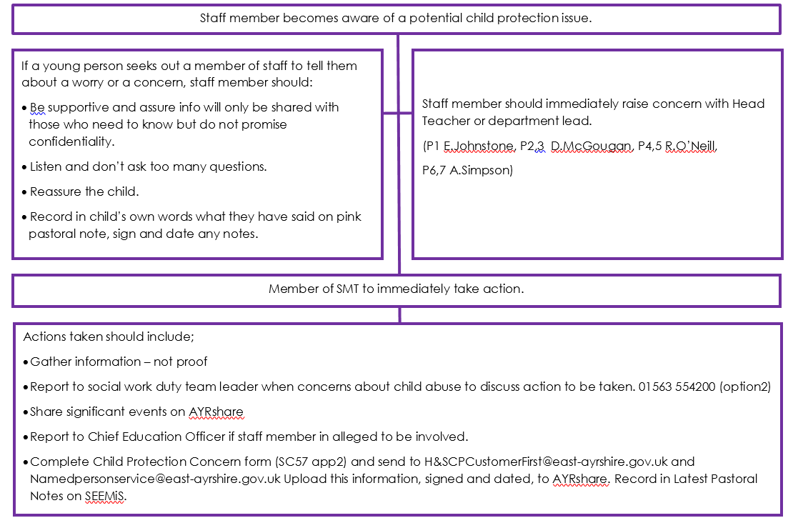

**Positive Relationships and Behaviour**

Annanhill Primary School’s main means of managing behaviour is through a positive relationships approach in line with East Ayrshire’s Relationship Policy and Annanhill’s Respect Me Policy. This is achieved by recognising that children and young people are still developing and displays of “inappropriate” behaviour are a sign of an unmet need, difficulty coping or lack of knowledge. As a staff we take time to deal with behaviours ensuring we consider what the behaviour is telling us so that we can respond accordingly.

As discussed in the Relationships Policy all children grow and develop best in the context of safe and secure relationships. Our inclusive approach to supporting pupils provides a solid foundation to building positive relationships and managing positive behaviours across the school.

The approaches in the diagram below further extend a safe environment for the pupils through relationally enriched experiences.

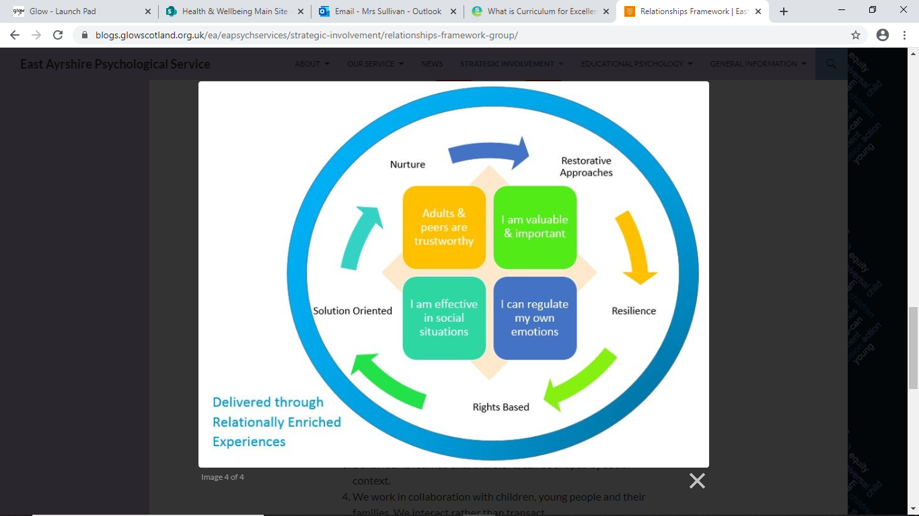

**Restorative Approaches** – Within Annanhill we adopt a restorative approach to managing conflict. The approach is based on the theory that those best placed to deal with resolving conflicts are those who are directly involved (Solutions that are imposed are less effective and less likely to be carried through). Within Annanhill all pupils have the opportunity to engage in a restorative conversation after an incident has occurred, this may be straight after an incident or at a more appropriate time.

The restorative approach to conflict and wrongdoing is composed of the following four key questions:

* + What has happened?
  + Who has been affected?
  + How can we involve everyone who has been affected in finding a way forward?
  + How can everyone do things differently in the future?

The starting point for all restorative processes involves active non-judgemental listening. The process can be used with one person or with more to help them reflect on a situation and find ways to reach an amicable solution. Our management team support staff with restoratives if and when required.

**Nurture** – As a school we have developed a whole school nurturing environment which is underpinned by the 6 nurturing principles:



Nurture in Annanhill means supporting pupils to form positive relationship, build resilience and improve their social, emotional and mental health and wellbeing.

**Rights Based** *- The United Nations Conventions on the Rights of the Child* (UNCRC) (1989).  ‘Children’s rights and wellbeing are intrinsically linked and are mutually reinforcing.  When a child’s rights are respected, protected and fulfilled, their wellbeing improves; equally restricting access to their rights may have a negative effect on their wellbeing.’ (Scottish Government. 2022, p. 7). ​ At Annanhill we have achieved our Rights Respecting Schools Silver Award and we ensure that pupils rights are embedded through whole school approaches and classroom practice. Each class has their own class charter which the pupils have been involved in creating.

**Supporting Behaviours**

At Annanhill, we ensure we take a relational approach to support individual needs when responding to poor, dysregulated or harmful behaviour instead of more traditional ‘one size fits all’ fixed punitive responses. In dealing with these behaviours staff should consider what the behaviour is telling us about the child and their needs and respond accordingly.

**Our Interpretation of Dysregulation**

**Emotional Regulation** -The ability to maintain a state of calmness, focus and alertness. Being regulated supports the ability to process, think, interact and learn.

**Emotional Dysregulation -** Inability to maintain a state of inner calmness attention, focus or be alert. Results from experiencing stress beyond one's range of tolerance or ability to cope.

**Self-regulation -** is the ability to monitor and control our own behaviour, emotions, or thoughts, altering them in accordance with the demands of the situation.

**Supporting behaviours**

At Annanhill, we have ensured our classroom environments support all individual needs as much as possible. Our staff do their best to support pupils who are showing distressed behaviours by exploring some of the following strategies:

* Connect before you correct - quietly asking the pupil if everything is ok (*being aware of the audience and the impact it could have on the pupil*)
* Communicate in a calm, non-judgemental and non-threatening manner (*being mindful that less is more)*
* Use non-verbal communication effectively (*a smile, eye contact, visual prompts towards the clock or towards their work/the board etc.*)
* Giving the pupil time to de-stress, respecting personal space and giving space. When possible provide a quiet environment with reduction in noise and lighting *(Spaces may include: a different seat in the class, accessing a different space; Sunflower room, Rainbow room or The Hive)*
* *D*istraction in the moment where this is helpful to the child or young person (*This will be dependent on the individual*)
* Appropriate use of humour – when used well it can disarm and de-escalate
* Create an opportunity to speak to the learner, listen to them, and potentially remind them of class expectations (if possible, give them time to respond/change their behaviour)
* Remind the learner of the positive consequences of maintaining class/school expectations
* Remind the learner of times/activities that they’ve done well
* Calmly remind learners that harmful behaviour will not be ignored as this is not kind or respectful to the learner or to others
* An activity or movement break that supports self-regulation (*Use calm box or calm corner within the class, agree on a walking path around the school if required*).
* Time with a trusted adult or time alone, with an adult in close proximity (*Senior management to support if required).*

***We are mindful that every scenario and individual is unique and what works for one individual may not work with another.***

**Consequences**

At Annanhill we recognise that at times our pupils may fall below the expectations we have of each other. However, this should not be ignored. Consistency is key to ensuring we get it right for our pupils however we lead by the assumption that one size does not fit all, thus sanctions cannot be made explicit. Individual needs and circumstances always need to be taken into consideration.

At Annanhill we recognise that we all need to experience consequences if we are to properly understand ‘cause and effect’. They can be positive or negative, natural or imposed *(usually by an adult).* Children and young people need to understand consequences if they are to become both **successful** learners and **responsible** citizens. For example, if I work hard I my attainment improves, **OR** if I damage something I’ll have to try to fix it. They are about learning and are not about punishment

When consequences need to be applied they should be:

* Logical – the consequence should relate to what’s happened, and should be reasonable in connection with the action.
* Related to the situation - if a consequence isn’t related to the behaviour then it’s likely to cause resentment rather than be an opportunity for learning.
* Have a focus on learning – explore opportunities for natural consequences.
* Take account of the needs and capacity of those involved.

Our approach should be consistent focussing on repairing the harm caused, preventing it happening again and returning and focusing on learning as quickly as possible.

**Natural Consequences**

When possible we impose natural consequences for actions, again a one size does not fit all in this situation.

Examples:

* A natural consequence of forgetting a coat could mean we get wet when it rains
* A natural consequence of ripping our jotter could mean writing on paper for the rest of the year
* A natural consequence of not completing work may mean completing at a social time
* A natural consequence of breaking something may mean trying to fix it
* A natural consequence of making a mess of a room is you need to tidy it up
* A natural consequence of fighting may mean you have to help others in a different area of the school

When carried out consistently and discussed with the pupil, it helps with the exploration of cause and effect and often provide pupils opportunities to learn how to make better choices in the future. Some pupils may need help to find a better way of doing things to support future independence and responsible choices. As part of a team approach if a pupil refuses to explore a natural consequence, the school will contact a parent/carer to support their child/children to understand the reason behind the consequence and the importance of meeting the school expectations agreed by everyone.

**Emergency situations**

**When behaviours show risky behaviour which may impact on the safety of the pupil and others we:**

* Assess Risk
* Consider the best interests of everyone involved. The age of the pupil/pupils, physical health, additional support needs, disability and any known experience of trauma
* Notify Senior Management
* Explore regulation strategies and previously used techniques, avoid physical contact when possible, encourage pupil led withdrawal
* Evacuate area if required
* Ensure everyone is safe and calm
* Physical intervention would only be deemed acceptable when a pupil/pupils or staff member is at significant risk of harm
* Contact parents/carers to discuss the incident and to help support the child/children in distress.
* This would be followed by a discussion around safety and next steps and actions to support everyone involved. **(Appendix 3)**

**Positive Reinforcement and Celebrating Success**

At Annanhill we ensure that we celebrate and recognise the attainment and achievement of all our pupils. Pupils recognise when they are doing well and have the opportunity to celebrate within their classes and across the wider school. Class teachers have the autonomy to create their own ways of celebrating success however these are still underpinned by the school’s main vision.

Whole school celebrations of success include:

* House Points – Each child has a house colour and the house work together to gain points each term. At the end of each term the house with the most points receives a treat. House points can be given to children from all staff within the school.
* Class of the Week – During assemblies a class is chosen each week for their contributions and showing the school values.
* Line of the week – Each week a class is chosen within each department for showing the school values in the playground.
* Celebrating achievements – We like to celebrate all pupils who have had achievements in and out of school.

Every pupil feels they are valued and included allowing them to reach their full potential. We remove barriers to learning through an inclusive approach underpinned by positive relationships and a relentless drive to get it right for every child in our care.​

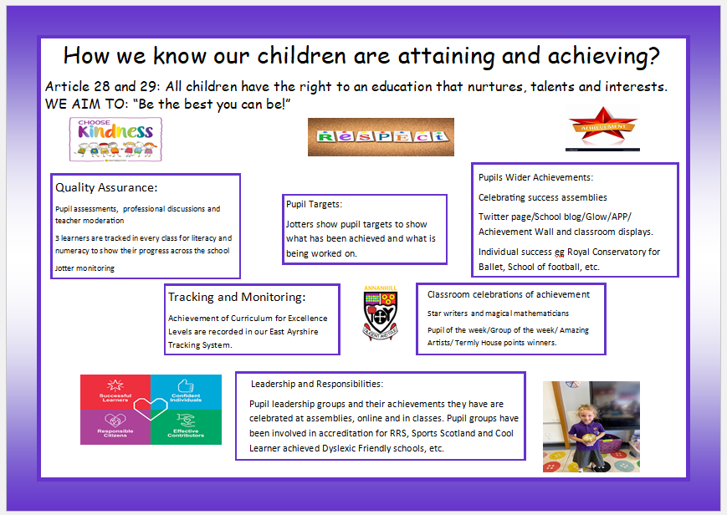

**Appendix 1**

**Annanhill Primary School **

**Cost of the school day – Supports**

A range of supports are in place to tackle poverty and the cost of the school day. We ensure that supports are regularly highlighted on our school app or BLOG.

**Breakfast Club** – offered from 9am to 9.30am – supports a range of children from not only SIMD 1 & 2 but pupils who are identified as requiring a breakfast through speaking to staff and parents. Register of pupils accessing this available, however this is very fluid and can change day to day. We also provide toast each morning for pupils coming into school, this allows for all children to have access to breakfast in the morning if required.

**Snacks** – Fruit is available in all classes and we also have extra within our Sunflower Room which pupils can access throughout the school day and at break/lunchtimes. Children know where to come to if they require this.

**Period Poverty** – Pupils from Annanhill, Park School and Grange are working together to ensure everyone has access to resources. We also have a range of clothing to support pupils who may need it. The pupils in the group went shopping to ensure all pupils had what they needed. Awareness raising has taken place in p6-7 classes so far. Posters around the school so that the children know where to go.

**Learning Barriers** – We ensure that all our pupils have what they need to learn. We have set up homework clubs, provided resources for pupils who require them, access to IT if required both in and out of school. Each class ensures that they have enough resources to support learning in the class.

**Travel** – Support for transport costs – signposting parents to access financial supports if required, support for parents who may need to access school through a range of different transport needs.

**Uniform** – Within our Sunflower room we have extra uniforms available in all sizes. We ensure that if any child requires extra pieces of uniform they are provided with what they need. At parent’s evenings, community events and at the beginning of each session we set up areas where parents can come and collect uniforms if required.

**Appendix 1**

** Annanhill Primary School **

**Cost of the school day – Supports**

A range of supports are in place to tackle poverty and the cost of the school day. We ensure that supports are regularly highlighted on our school app or BLOG.

**School Trips and outings** – As a school we are aware of our pupils who live within SIMD 1&2 in each class and also access free school meals. This allows us to track pupils and families who are most vulnerable. Office staff ensure that no child misses out and we ensure that we make use of PEF or money raised through cash for kids for children to access these activities. Staff in each class also aware of this. Children all have the opportunity to go on Residential Trips in primary 6 & 7, and we make it clear to parents if support is required we will do our best to support with costs.

**Extra-Curricular Clubs** – Our staff team ensure that a range of activities are available for children to access during the school day or after school at no extra cost. These include arts and crafts, chess, badminton, gymnastics, football, athletics, and dance. Registers taken to ensure we are encouraging all children to give this a go, so no one misses out.

**Community Event** – This session our aim was to create more community events. So far we invited over 700 family and friends into the school free of charge. Our catering staff offered hot meals, teas, coffee, juice and biscuits were also available. A range of fun and enjoyable family activities were available for parents/carers and children to enjoy.

**Christmas Jumpers/Halloween Costumes** – Our parent council have supported the school throughout the years with a range of extra Halloween Costumes and Christmas Jumpers so that no child feels that they are not included. We also have this for events such as dress down day or World Book Day.

**Food Boxes** – If we have families in immediate need of support, we can access food boxes and we work hard with our catering staff to ensure that extra food parcels go home with our families.

**Christmas** – Working with Cash for Kids, HillHouse, Our Parent Council, The Local Church and Businesses we ensure that all families have what they need to create a Christmas experience for their children. This involves vouchers for food, Christmas Dinners, Presents. We ensure that this is done in a supportive and discrete way to support our most vulnerable families.

**Appendix 2**

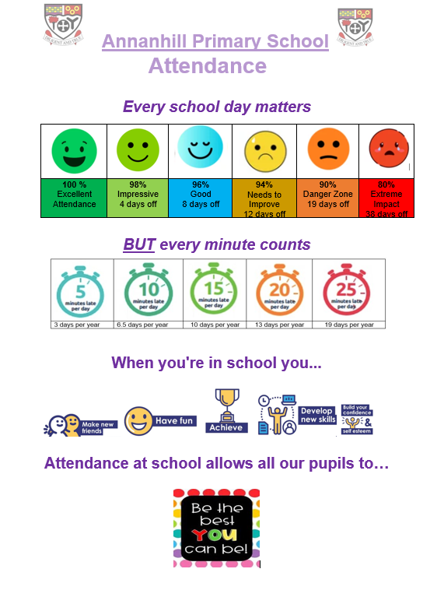

**Appendix 3**

