Annanhill Primary Parent Council Meeting

Invitees | Attending | Apologies
Scott Robertson (Head of Campus) |  | Scott Robertson (HoC)
Emma Johnstone (HT) | Emma Johnstone (HT)
Diane McGougan (DHT) | Diane McGougan (DHT)
Alan Simpson (DHT) |  | Alan Simpson (DHT)
Ruth O’Neil (DHT) | Ruth O’Neil (DHT)
Julie Bracher | Julie Bracher
Natalie Speirs (PC Chair) | Natalie Speirs (PC Chair)
Ruth Cameron (PC) |  | Ruth Cameron (PC)
Hollie Marshall (PC) |  | Hollie Marshall (PC)
Charlie Adams (PC) |  | Charlie Adams (PC)
Karen Rae (PC Vice Chair) | Karen Rae (PC Vice Chair)
Fiona Kealey (Secretary) | Fiona Kealey (Secretary)
Laura Campbell (Secretary) | Laura Campbell (Secretary)
Megan McMurray (PC) |  | Megan McMurray (PC)
Karen Tocher (PC) |  | Karen Tocher (PC)
Lisa McLean (PC) |  | Lisa McLean (PC)
James Adams | James Adams
Heather Nicolson (PC) | Heather Nicolson (PC)
Heather Arkison (Treasurer) | Heather Arkison (PC)
Russell Smith (PC) | Russell Smith (PC)
Emma McAndlish (Treasurer) | Emma McAndlish

Item # | Content | Led by
1 | Apologies and approval of previous minutes | NS
2 | Head Teacher Report | EJ
3 | Councilor Report | JA
4 | Treasurer Report | HM
5 | Christmas Fayre | NS
6 | AOCB | NS

Minutes of Meeting – 16/11/23 @ 15.15hrs
Agenda Item | Action

1. Apologies and approval of previous minutes (NS)

Attendees and apologies: See table above

Minutes: were approved

2. Head Teacher Report- (EJ)

Anti-bullying – Listen up campaign

The school is making progress towards Gold award

House teams are keen to take this forward

Pupils will undertake self-evaluation toolkit

There will be support for parent workshops in the future, allowing parents to input on how to move this forward.

Conversations will also take place during assembly to ensure that kids understand and get it

Literacy update

Focus is on writing, reading and health & wellbeing

School is looking for parental involvement with the homework experience, including the impact of teacher praise & feedback has on those children who hand in homework

Homework isn’t compulsory, however across the school there is currently a 68% non-engagement with homework tasks.

Health & Wellbeing update

Key areas being explored/used just now are

Motivational tools

Children asked 20 Q’s

The results of these will be used to inform next steps moving forward.

Pupil voice

Playground Needs Analysis is being carried out (Mrs Bracher) a theme from the feedback is around RESPECT the pupils feel that they are not being listened to

Educational Psychologist (Lynsey Thomson) will provide support around the relationships policy/framework.

Key development area will be looking at the consistency of the words/language used by staff in this setting.

Mrs Stewart has put a lot of work into the organization of the playground resources and checking that these are fit for purpose for use by the pupils

January 2024 – introduction of parent workshops for neuro-divergent pupils which will focus on sports

Health & Wellbeing updates are now available on the school blog.

Rags2Riches campaign: collection bins available within the school, pupils/parents will continue to be encouraged to donate where possible

Other areas of discussion included the focus on manners and acts of kindness by pupils and Assembly is a big success with House points working well

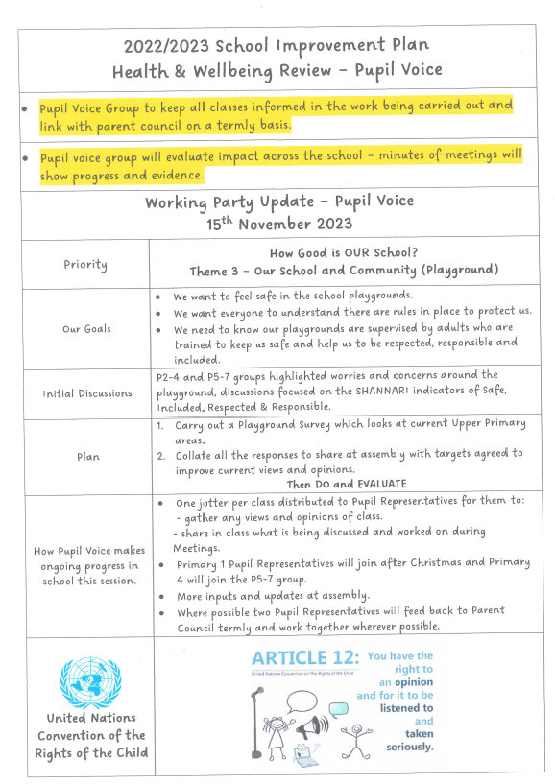

3. Councillor Report (JA)

Budget Consultation 24/25 is live

Members of the Parent Council are encouraged to have your say to help shape our future as a council

Councillor James Adams provided the following update:

No rise in Council Tax this year has meant less money available to spend

£8 million extra is required to fund additional support needs within East Ayrshire

Scottish Government will provide a £2 million subsidy

Council has received £6 million back via LGPS (pension)

PEEF money – hard to manage/stretch as needed

Cleaner Greener communities – a litter pick is planned f0r Sunday 19th November, around the Annanhill Gardens and local area; promotion via social media to encourage pupils/parents to participate. Another activity will be planned for 2024.

4. Treasurer Report (HM)

Balance is £

This was not discussed

5. Christmas Fayre (NS)

Group discussion around various items in connection with the Christmas fayre including:

Logistics of folding tables from Howard Centre

The Street area - access/egress for set up

Update on progress of sweetie cones etc

Stall layout – change from last year, so vendors are near the back area

Use of school catering area for tea/coffee’s

Implications of after school classes taking place 5-6pm

Accessibility and use of school tables

Welcome/arrival process – tickets can be purchased at door

Vendors access – via main door

Overview of vendors attending

Overview of stalls organized via PC

Confirmation of year groups singing in assembly hall

It was acknowledged that a lot of hard work and co-ordination has been required for the preparation of the fayre and everyone is confident it will be another great success for the local community and raise much needed funds for the school.

6. AOCB

Confirmation of roles within Parent Council (NS)

Existing: Natalie Speirs (PC Chair)

New: Karen Rae (PC Vice Chair); Heather Arkison/Emma McAndlish (Joint Treasurer); Fiona Kealey/Laura Campbell (Joint secretary)

Advised Kirsty McGuffie and Hollie Marshall have stepped down from their positions and I thank them for all their help last year. Hollie will- remain on Parent Council, Kirsty has left the school in June.

Date of next meeting: Not confirmed

