**Primary 3 Term 3 Overview**

**Numeracy**

**This term Primary 3 will be focusing on:**

* 2, 4, 8 times tables
* Introduce Division
* Fractions
* Money – change from £1.00

**Literacy**

**Spelling:** We are continuing to follow the Active Literacy programme, learning Stage 3 phonemes to help us with our reading and writing.

**Writing:** The focus for this term will be topic related to include diagrams, posters, leaflets with some imaginative writing. Children are working hard to include adjectives, verbs and various openers to make their writing more interesting. As always, they are encouraged to remember full stops, capital letters and finger spaces.

**Reading:** The Owl Who Was Afraid Of The Dark – Unit Study. Continue with Bug Club books issued weekly.

**Poetry** – Scot’s (The Sair Finger)

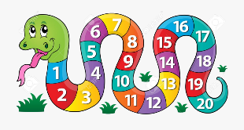



**Gym Days**

Thursday and Friday

(Grange gym on Thursday’s)

**Other Areas:**

**Topic’s:**

* Whole school 50th birthday celebration topic (focus on 2010’s)
* Nocturnal Animals

**Science:** Life Cycles and Food Chains

**Health and Wellbeing** – Food and Hygiene

**R.M.E –** Islam and Easter

**P.E –** Performance and Fitness Stations

