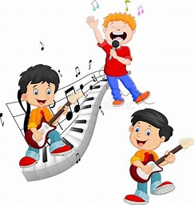

**Health and Wellbeing**

This term we are learning about substance misuse with a focus on alcohol and smoking. Through this we will learn about different types of alcohol and their percentages, the different ingredients in a cigarette, and the long term and short-term effects of alcohol and smoking. The children will also focus on gymnastics, target games and social dancing during PE.

**Primary 5 PE days are Tuesdays and Fridays. Please remember to bring your PE kit with you on these days. You can also keep them in the classroom to save you forgetting.**

**Science**

To finish off our Antarctica topic, this term we will focus on climate change, lifecycles, food chains and Reduce, Reuse and Recycle.

**Literacy**

This term we will access Bug Club in class, allowing more opportunity for independent, paired and group reading. Through this we are developing our knowledge of reading strategies including prediction, main ideas and summarising. In Spelling we are using the East Ayrshire Active Literacy programme to explore a range of phonemes including ‘j’ and ‘sh’. We will also look at a range of spelling rules. We will also create a range of writing pieces based on different genres.

**Please remember to bring water bottles with a sports cap to keep hydrated. Fizzy or sports drinks are not permitted.**

**Topic**

Solids, liquids and gases is our topic this term. We will be finding out about states of matter, the melting process, the water cycle and will also carry out a range of experiments.

We will also celebrate Halloween and Christmas.

**Music**

This term we are continuing to use the scheme ‘Charanga’. This will enable us to explore singing, keeping the beat and use of percussion. We’re currently learning ‘STOP’ the anti-bullying rap and ‘Lean on Me’ by Bill Withers……it’s great fun!

**Mandarin**

Nǐ hǎo! This term we are lucky enough to be visited by our lovely Mandarin Teacher. The children will be concentrating on greetings, numbers, colours, how to write in Mandarin and will explore Chinese celebrations and culture. Feel free to practise these at home!

**Maths and Numeracy**

This term we are concentrating on Addition, Subtraction, Rounding and Estimation. In Practical Maths we are learning all about Time.

This term the children will also be given the opportunity to develop skills through curricular activities: coding, sewing, STEM and many more! ☺

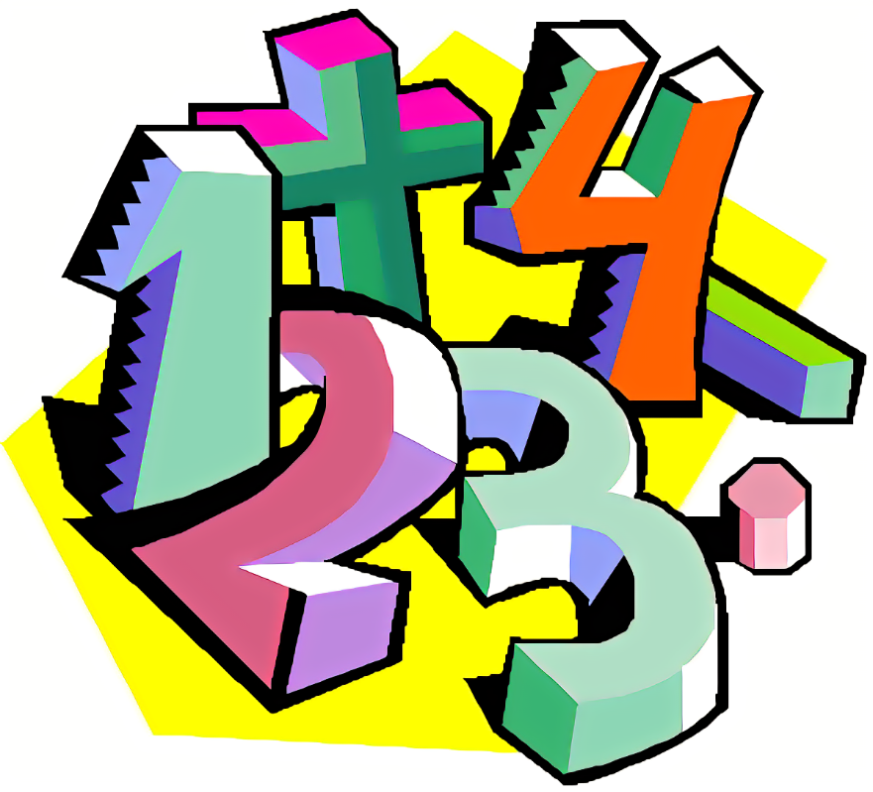

PRIMARY 5 2023/24