****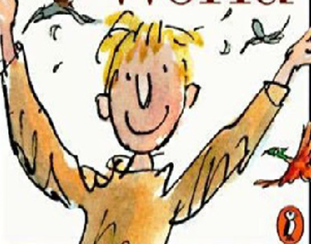

PRIMARY 5 2023/24

**French**

Bonjour! This term we will be concentrating on greetings, numbers to 10 and days of the week. Feel free to practise these at home!

**Maths and Numeracy**

This session we are concentrating on Number Place Value and Negative numbers in real contexts. We are also revising times tables and would appreciate these being practised at home. In Practical Maths we are learning all about Angles, Position and Direction.

**Primary 5 PE days are Tuesdays and Fridays. Please remember to bring your PE kit with you on these days. You can also keep them in the classroom to save you forgetting ☺**

**Please remember to bring water bottles with a sports cap to keep hydrated. Fizzy or sports drinks are not permitted.**

**Music**

We are lucky enough this term to be using the music scheme ‘Charanga’. This will enable us to explore singing, keeping the beat and use of percussion. We’re currently learning ‘Mamma Mia’ by Abba……it’s great fun! ☺



**Science**

This term we are looking at Biodiversity and how living things have adapted in Antarctica to ensure their survival. We will also be investigating how ecosystems and food chains are essential for survival and how climate change is affecting this.

**Social Subjects**

‘Antarctica’ is our topic this term. We will be finding out about the similarities and differences between Scotland and Antarctica, including lifestyles, animals and climate and how these are being affected by climate change.

**Literacy**

Our novel this term is ‘Danny Champion of the World’ by Roald Dahl. Through this we are developing our knowledge of reading strategies including prediction, main ideas and summarising. In Spelling we are using the East Ayrshire Active Literacy programme to explore a range of phonemes including ‘oi’ and ‘ck’. We will also look at a range of spelling rules.