**Primary 1 Term 3 Overview**

**Literacy**

**Spelling:** We are continuing to learn our sounds to help us with our reading and writing. We have learned all of our single sounds and have now moved onto learning our double sounds (e.g. sh, th, oo, ee). *Children have a homework flyer explaining this and activities related.*

**Writing:** Children are working very hard to write basic sentences, remembering full stops, capital letters and finger spaces.

**Reading:** Children have started using the Rocket Phonics reading scheme and are completing activities in class and are provided with a new book to take home each week.

**Poetry** – Scot’s (The Snawman)

**Numeracy**

**This term Primary 1 will be focusing on:**

* Number words
* Numbers to 20
* Data handling
* Shape

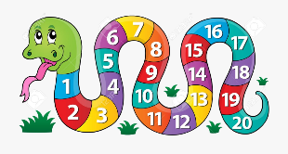

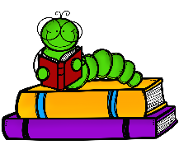

**Other Areas:**

**Topic (IDL) -** *(RME, expressive arts)* **:**

* Whole school 50th birthday celebration topic (focus on 2020’s)
* Our Community

**Science:** Senses and Weather

**Health and Wellbeing** – Food and Health

**P.E –** Scottish Dance, Fitness and Badminton/ Gym with the Grange leaders

