**Numeracy**

**Numbers to 10/20/100**

* Recognition and formation
* Counting forwards and backwards
* 1 to 1 correspondence
* Position (before/after/in between
* Pattern

**Literacy**

**EA LITERACY –** We are learning initial sounds following EA Literacy.

P2 revision of sounds and CVC words

READING STRATEGIES –blending sounds to make 2,3 and 4 letter words

**READING** – Listening, enjoying and talking about stories.

**WRITING** – Foundations of Writing (drawing books)

**HANDWRITING -** Letter formation

**TALKING AND LISTENING** – Oral news. Audience awareness, being a quality audience

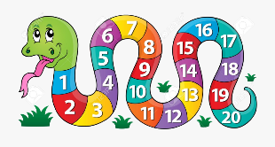

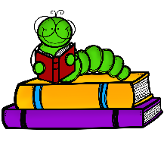

**Other Areas:**

**IDL:** Colour Monster (emotions)/ Marvellous Me

**Health and Wellbeing**: SHANARRI/RRS, Colour Monster, Families

**P.E:** Team games, rules and following instructions, co-ordination

**Expressive arts**: Role play activities, colour, line, shape colour monster, line drawing (portraits)

**Technology (Mrs Haggerty)**

TCH 0-01a/ TCH 0-14a/TCH 0-14b/TCH 0-15a

**French/RME/Science (Mrs Bell)**

French focus this term

