 Kirkstyle’s Newsletter - Extra
March 2013

Can we say a huge thank you for your donations of Easter Eggs to The Cash for Kids appeal the trolley at the front door is brimming with chocolate delights! These will be delivered to our local ASDA to be distributed by the charity to children across Ayrshire. Once again thank you for your kindness and generosity.


Games Legacy for the Future
Monday 11th March 2013 kick starts the Commonwealth Games Legacy with Sport your Trainers event – everyone can come to school in their trainers!
This will also start the school thinking about House Teams, elections for Captains and Vice Captains and events for our sporting term coming up.
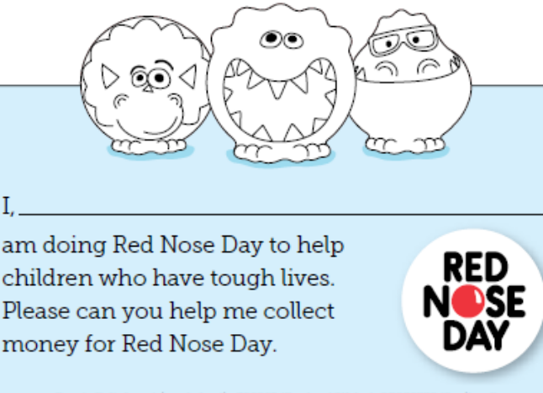

RED NOSE DAY – Friday 14th March
The pupils have been busy setting themselves some charity
challenges for Red Nose Day on Friday 14th March; as a
whole school and in class.
The pupils voted at Assembly and picked the top three:
- To wear pyjamas and onesies to school.
- To wear red noses.
- To hold a talent show for Assembly.

Each class has also set themselves a challenge from; Pr.4
& 4/5 cake decorating (cakes on sale on Red Nose day
for 30p) to Pr.3 dancing gangnam style in their pjs!
To take part we ask that the pupils bring a donation of £1.00 to school on Friday 14th March 2013.
However if the pupils would like to purchase a red nose, the new dinoseaurs are on sale from Monday 11th March
priced £1.00. And if they are interested in entering the talent show then we ask that you give your permission on the returns slip overleaf.

Assemblies

Two weeks ago our Assembly focused on Red Nose Day and the main reasons for the charity; looking at My World DVD a story about Robert who lives in the slums of Kenya.
The pupils were encouraged to compare their lives with Robert and see the impact that charitable donations to Comic Relief could have on families like Robert’s.
Some classes will take a closer look at Robert’s story as their challenge.
At the Assembly the pupils all learned the new Red Nose Day song and we will sing this at the talent show event.

Last week we focused our learning on Hand Hygiene with the pupils learning the rules of hand washing to stop the spread of germs and the tummy bugs. The classes are all going to get a shot at using the light box and our glitter bug gel to practice their hand washing skills and each class will receive a refillable hand gel to keep the germs at bay.
This week’s Assembly sees a visitor joining us from Guide Dogs for the Blind to share some of the work and history behind the charity. We hope that next session we will raise funds for the charity as one of our chosen fund raisers and we hope to work towards adopting a puppy for training.



ART EXHIBITION
The acclaimed artists within Kirkstyle Primary
School, invite you to attend a formal opening of
their exhibition and gallery.
Tuesday 26th March 2013
For one night only the pictures from the students
of the Art Academy of Kirkstyle will be on sale!
£7.00 per mounted and framed picture.

Book Fair
As always the Scholastic book fair will be on display in school during parents afternoon and evening. Parents and carers will have an opportunity to browse the fair and make any book purchases they wish to. The pupils will hopefully have given you some ideas of their interests following on from their viewing sessions. Due to the timing of the fair this year the pupils will be able to take advantage of their World Book Day vouchers and use them to receive £1.00 off any purchase they make.

Reports
We will continue with the new format of reports issued last year with Curriculum for Excellence levels indicated, detailed comments on progress and next steps identified. The report does contain an overview of the levels across the school stages but feel free to ask the staff about these at Parents Evening.

Scots Poetry Recital competition finals
One of our recent Assemblies saw the finalists of the Scots Poetry competition receive their certificates. The pupils received merit, first, second and third place certificates from the Burns Federation. We were entertained by two pupils in Pr.5 who scored a near perfect score, Emma Kavanagh & Andrew Maxwell, and the whole class were given a special certificate for the outstanding performances from all pupils.

FIRST SECOND THIRD
Primary 1 Room 1
Callum Nunn Kirsty Warnock Caitlin Shaw

Primary 1 Room3 Ally Bally
Samuel McEwan Eve Nailen Iona Bolland

Primary 2 Room 4 Robin Robin Redbreist Wee Willie Winkie
Ami Love Carmen Lewis Haili Martin Holmes
Maya Orr Aiden Mullen Nicole Kavanagh

Primary 3 Room 12 The Sair Finnger
Cameron Maxwell Blair Graham Emma Lindsay

Primary 3 Room 13 The Sair Finnger
Cameron Sloan Gracie Murphy James McCamon
Primary 4 Room 16 Street Talk
Ellie Morrison Jody McGill Aimee Philipson

Primary 4/5 Room 15 The Ballad of Janitor MacKay
Alix McAteer Madeline Campagna Cody Hill

Primary 5 Room 14 The Ballad of Janitor Mackay
Andrew Maxwell Rhys Lusk Lewis Corson
Emma Kavanagh

Primary 6 Room 8 Tam O’Shanter
Nicole Cameron Erin Arthur Cameron Maxwell

Primary 6/7 Room 9 Willie Wastle
McKenzie Alston Rachel Britten Ross Graham
Morgan McCreadie

Primary 7 Room 10 My Love is Like a Red, Red Rose.
Greg Hillan Megan Donnelly
Shannon Chrisite

Primary 4/5 to the Science Centre
In Term 2 the pupils in Pr.4/5 started working on an interdisciplinary topic called ‘Flashes of Genius’ ; looking at Scottish inventions of everyday items. The pupils carried this exploration work through into their electricity circuits work and to round of their learning they headed to Glasgow Science Centre for the Car crazy workshop. Designing, inventing and making model cars. Primary 7 will also be making model cars as part of a transition project to race against Loanhead and Hillhead in a Formula 1 challenge.

R.N.L.I.
As part of their continuing ‘Unsinkable Ship’ theme the pupils in Pr.4 & 4/5 welcomed a guest speaker from the R.N.L.I. to talk to them about how disasters at sea are handled by the organization. The pupils learned a little about the history of the R.N.L.I, volunteers training, equipment and what to do in an emergency at sea or how to get emergency assistance.

Diary Dates

07.03.13 Primary 1 to Timorous Beasties at Burns Centre in Alloway
08.03.13 Rugby after school class week 6
11.03.13 Sport Your Trainers for the Commonwealth Games
11.03.13 Talk from East Ayrshire’s Young Carers Team to Pr.6, 6/7 & 7 pupils
12.03.13 Primary 6, 6/7 & 7 visit to Amazonia
12.03.13 Football after school class week 6
12.03.13 Taekwondo after school class week 5
14.03.13 Guitar After school class week 1
15.03.13 Red Nose Day
15.03.13 Pr.1, 2, 4, 4/5, 5, 6, 6/7 & 7 pupil report cards due out
18.03.13 Primary 6. 6/7 & 7 receiving Spanish input from K.A. S5 & S6 pupils
18.03.13 Taekwondo after school class week 6
21.03.13 Guitar after school class week 2
22.03.13 Book fair viewing for pupils
25.03.13 Primary 6. 6/7 & 7 receiving Spanish input from K.A. S5 & S6 pupils
26.03.13 Parents afternoon & evening & Kirkstyle’s Art exhibition
28.03.13 School closes for Easter holidays -2.30pm
15.04.13 In service training day for teachers
16.04.13 Pupils return

