

 Kirkstyle’s Newsletter

October - November 2012

Massage in Schools

Parents were invited to join their children for the final Primary 3 session of massage prior to the holiday. The pupils and teachers have completed evaluations to describe their views on the activity. We hope to start soon with a new group of pupils in Primary 4 and Primary 4/5 the week beginning 5th November 2012.

Primary 4 and 4/5 – Magic Castle Open Afternoon

Parents and Carers gave full marks to the Open Afternoon presentation on the Magic Castle an evaluation form from parents, gave the parents an opportunity to comment on strengths and areas for improvement (using the 2 stars and a wish technique the same as the pupils do in class work) Some of the comments were:

“***obviously they’ve worked very hard on this”***

***“nice to see the children’s classrooms and them show us all their work”***

***“kids performance was brill”***

***“great seeing work kids had achieved during class time”***

***“It was excellent for the kids confidence”***

***“the songs were very catchy”***

***“ my son’s classroom looked super and he loved telling me all about his experiences”***

***“great insight into what the kids get up to in school”***

Kilmarnock Harriers

Forty pupils from Primaries 6 and 7 entered into the Harriers fun run; which was held this year in the new Ayrshire Athletics Arena. The pupils got a taster of cross country running and entering a long distance race, as well as a chance to see the new centre on their doorstep. We hope to be able to use the facility more in the coming years and we have already approached the Harriers to look into the possibility of an after school class for all those pupils bitten by the running bug!

History Alive for WWII

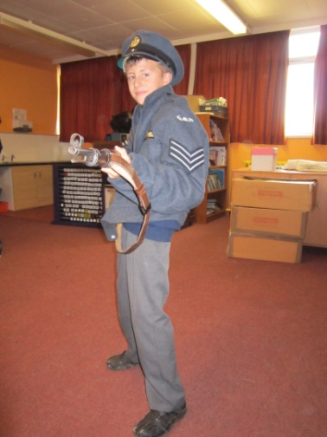 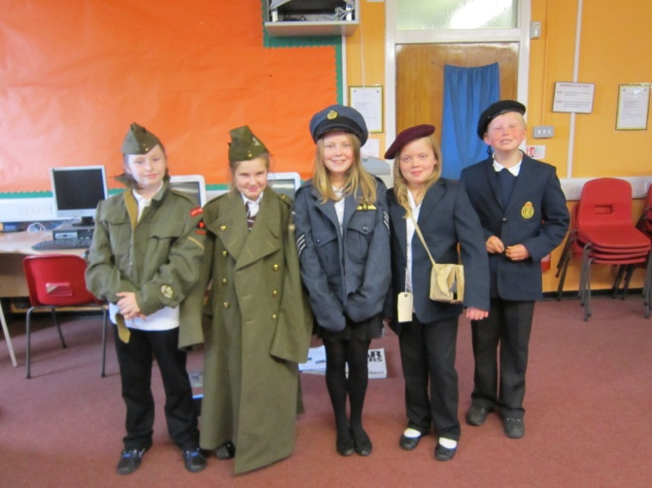 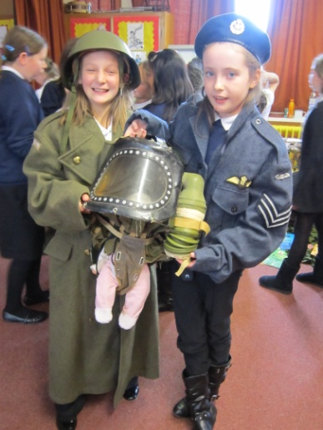

The pupils in Primary 7 and 6/7 welcomed our speaker from History Alive back to kick start their learning on World War II. The corridor has already been transformed into an air raid zone with an Anderson Shelter and taped windows – the topic is coming to life.

Halloween

The school asks pupils, staff and the school community to nominate charities each year that we could help in their efforts to raise funds and awareness of their cause. Every year some of our parents are fortunate enough to receive funds from Cash for Kids charity and the staff identified that we should give something back. Therefore this Halloween it was ‘Dress for Halloween’ – donations for Cash for Kids charity we raised over £60.00.

Primary 1 to 3 pupils also participated in their Halloween activities with the support of some of our willing parent helpers, to whom a big thank you must go out to. The pupils douked for apples, made witches brew, dressed up and many more activities meeting new teachers and friends along the way.

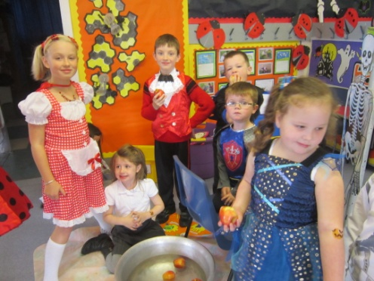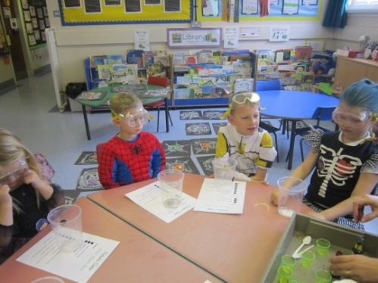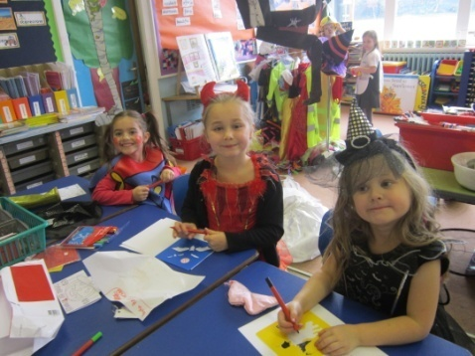

ASDA colouring competition

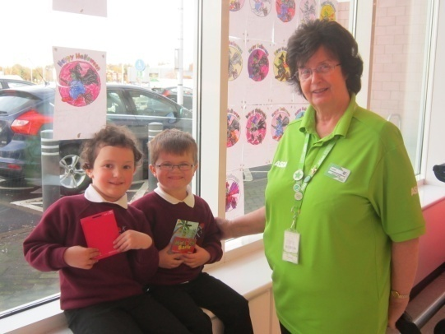Late on Friday just before the ghosts and ghouls started to roam around Kilmarnock we received some great news from ASDA – Latoya Widger and Scott Henderson both of Primary 1 had won a £5.00 voucher from ASDA for their colouring competition entries. Therefore we took them to ASDA to receive their prizes. A real surprise and a treat!

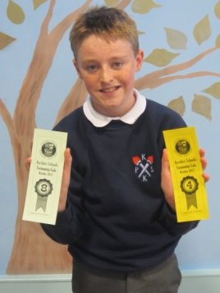

Swimming

The dates scheduled still to come are; 02.11.12, 09.11.12, 16.11.12 and 23.11.12.

In addition to this one of our school swimmers in Pr.7 achieved success at

the Ayrshire Schools’ Swimming Gala with Jamie MacKinnon getting a 4th

and an 8th place award.

Parent Council Bingo

The Parent Council would also like to remind all parents, carers, family and friends of Kirkstyle about their up and coming BINGO night. This evening has been planned to help raise funds to benefit all of our pupils and your children.

The Parent Council raised some money towards reducing the cost of the panto during their recent bag packing at Morrisons. However with the cost of buses being approx. £600.00 before panto tickets you can see the have a mammoth target to try to reduce costs for everyone. The school has also requested that any funds raised this year go to purchase new audio visual equipment i.e. televisions and DVD players.

Please come along and support the school on:

Venue:Kirkstyle Main Hall

Time: Thursday 15th November at 6.30pm for 7.00pm start.

Cost: only £6.00 for 6 games of Bingo and entry (which includes tea and coffee and shortbread)

Remember you have to be in it to win it – prizes include:

***MGM Garden Centre 28cm Santa Dome Effect worth £30, Flowers by Karen £10 ,Gift Voucher Kandi Car wash Mini Valet and Polish Voucher, William Luke & Son butcher Bellfield Meat Voucher sealed envelope, Campbell's Fuels donated a French Press Coffee Maker, Office Shoe company donated Gents, Ladies and Kids Shoes, a bottle of Whisky, a bottle of Vodka and a Party Palz Voucher for a free kids party.***

Diary Dates

***29.10.12 – Two pupils to ASDA to receive competition prizes***

30.10.12 – Food Standards Agency/Football for Primary 5

30.10.12 – Parent Council Meeting 6.30pm

30.10.12 – Block 2 After school gymnastics

***30.10.12 – Block 1 of Pr.6 and Pr.7 after school football***

31.10.12 – Firework talk for Pr.6, Pr.6/7 & Pr.7

31.10.12 – Sportshall Athletics heat for selected primary 7 pupils

***31.10.12 – Rugby P.E. session for Primary 4/5 and 5***

****************01.11.12 – Shiny Golden Time-Primaries 1-4 attending Brave showing at Odeon****************

01.11.12 – Taekwondo taster session from Phoenix – Pr.3- Pr.7

02.11.12 – Primary 5 swimming

****************06.11.12 – Shiny Golden Time- Primaries 5- 7 attending Diary of a Wimpy Kid showing at Odeon********

06.11.12 - Food Standards Agency/Football for Primary 5

06.11.12 - Week 2 After school gymnastics

***06.11.12 – Week 2 After school football***

08.11.12 – Primary 7 and 6/7 to Dumfries House and Estate

08.11.12 – Owl Magic visiting Primary 3

09.11.12 – Primary 5 swimming

13.11.12 - Food Standards Agency/Football for Primary 5

13.11.12 – Week 3 After school gymnastics

***13.11.12 – Week 3 After school football***

13.11.12 – Kilmarnock Academy parents meeting for Pr.7 pupils

15.11.12 – Kilmarnock Academy Quiz

15.11.12 – Parent Council Bingo night

16.11.12 – Primary 6 and 6/7 attending Hopscotch Theatre group ‘Burns an a That’ production

**16.11.12 – Children in Need – Show your Spots!**

20.11.12 - Food Standards Agency/Football for Primary 5

20.11.12 – Week 4 After school gymnastics

***20.11.12 – Week 4 After school football***

23.11.12 – Primary 5 swimming

27.11.12 - Food Standards Agency/Football for Primary 5

27.11.12 – Week 5 After school gymnastics

***27.11.12 – Week 5 After school football***

29.11.12 – Primary 3 visiting Kelvingrove and Riverside Museum

03.12.12 – Whole school visiting Panto.

***04.12.12- Shiny Golden Time reward for first block of winners – Panto workshops.***

***04.12.12 – Early Lunch – 12.15 – 1.00pm***

***05.12.12 – Primary 3 pupils singing at ASDA***

***11.12.12 – Pr. 4- 7 Pantomime performance – am***

***11.12.12 - Food Standards Agency/Football for Primary 5***

***12.12.12 – Pr.1- 3 Nativity performance – am***

***13.12.12 – Pr.1-3 Nativity performance – pm***

***13.12.12 – Primary 4 pupils (including Pr.4 from composite Pr.4/5)singing at Morrisons***

***13.12.12 – East Ayrshire Schools Orchestra Christmas Concert – 4.00pm***

***14.12.12 – Pr.4-7 Pantomime performance – pm***

***18.12.12 – Primary 1 and 2 Christmas Party – pm***

***19.12.12 – Primary 5 and 6 Christmas Party – pm***

***20.12 .12 – Primary 3 and 4 Christmas Party – pm***

***20.12.12 – Primary 7 – Fish & Chip tea and Party – evening***

***21.12.12 – School closes for Christmas at 2.30pm/***

***All new dates added since last Newsletter are in italics and bold.***

Reminder:

As part of the improvements to our promoting positive behavior; Shiny Golden Time – all pupils will attend the two showings at the Odeon as a reward for their behaviour, efforts and attitude in school. (If you do not wish your child to attend please contact the school)

01.11.12 – Shiny Golden Time-Primaries 1-4 attending Brave showing at Odeon

06.11.12 – Shiny Golden Time- Primaries 5- 7 attending Diary of a Wimpy Kid showing at Odeon