 Kirkstyle’s Newsletter

September - October 2012

October Holiday

Please remember the school will close on Friday 12th October at 3.00pm and will re-open for pupils on Tuesday 25th October for Term 2.

Houses & Homes

Primary 2 have recently completed their first Pr.2 theme on Houses & Homes as part of this topic the pupils have observed their local environment and looked at types of houses including their own. Parents and family members have been helping the pupils with their enterprising homework a new development of houses was on display – not for sale! during Parents Evening.

Author Visit

The pupils always welcome the opportunity to learn from an expert and our latest school visitor was no exception. Rose MacGregor, a grandparent of one of our pupils, came to school to raise awareness of a condition called hyper mobility. She did this by sharing her grand-daughter’s story of life with the condition using her own published story book, the pupils listened and asked questions about Rose’s story writing skills but also about the condition.

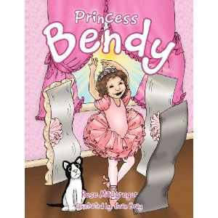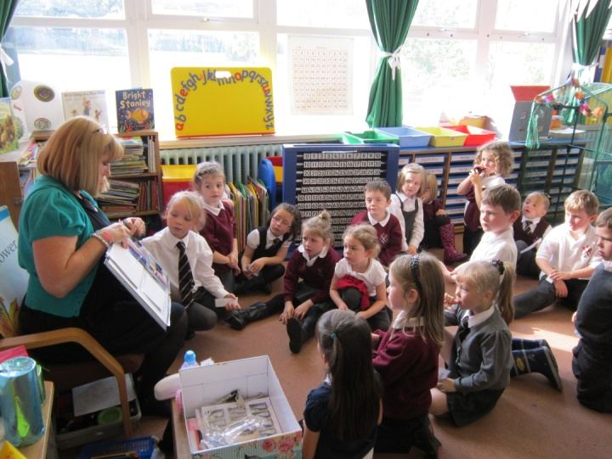

Global Footprint

Before the holidays Pr.5, Pr.5/6 and Pr.6 shared their Interdisciplinary Learning through a topic on our Global footprint looking at reducing waste and recycling, energy consumption, water consumption and food. As part of the waste part of the theme the pupils in Mr. S. Nutt’s class designed litter bin to share the message of recycle, reduce and reuse. Due to the effort and high standard of entries from the pupils it was agreed that the last collection of the school year from the Rag Bag recycling would be used to produce the winning design into an actual litter bin for our school playground. The lucky designer was Daniel Wood whose winning design can be viewed at the front entrance to the school.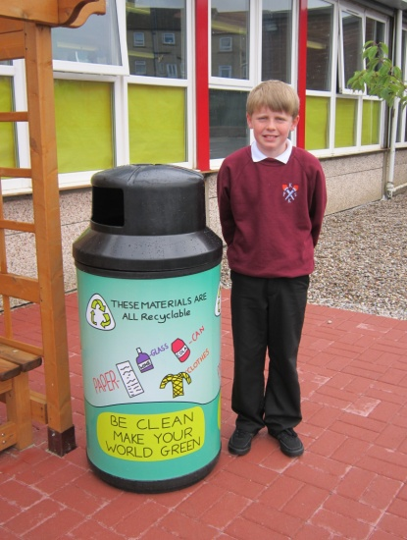

Green Fingers

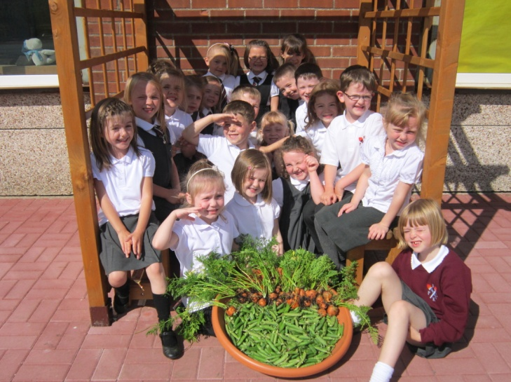

Green Fingers

This year Harvest Festival came early for our green

fingered gardeners. The photo opposite shows the successful

crop of peas and carrots picked by this year’s Pr.2 after

their hard work growing plants in Pr.1. The pupils will get

the chance to taste their home grown Winter warmer

vegetable soup this Autumn. The staff and pupils had

already enjoyed a crop of strawberries, lettuce and salad

nasturtiums prior to the holidays.

The Pr.4’s have already cleared the area ready for the

next lot of planting.

Pr. 3 Science visit to Culzean

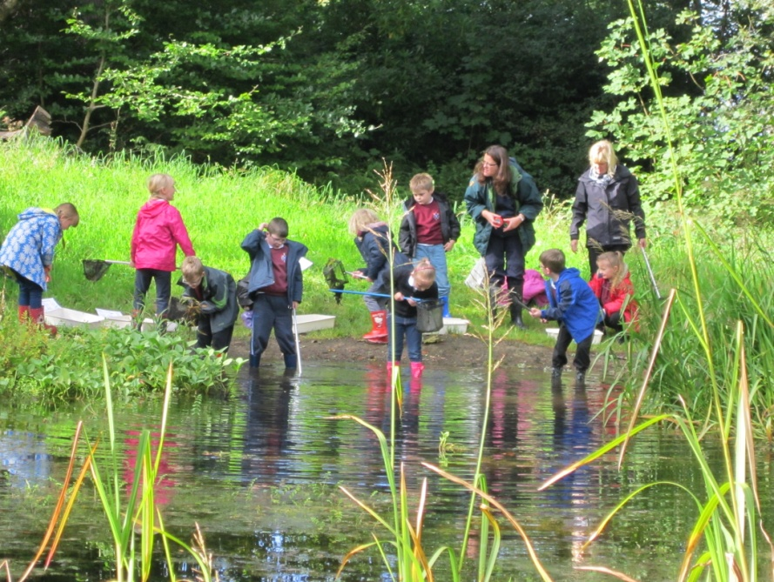

Primary 3 pupils tried to stay dry

during their recent visit to Culzean –

pond dipping for creepy crawlies and

beasties! We hope to develop a section

of the school garden to encourage our

own minibeast habitat and our

budding entomologists will be keen to

help! Thanks to our TESCO vouchers

we already have ladybird boxes and a

hedgehog home ready to go out in a

suitable location.

ASDA Community Grant

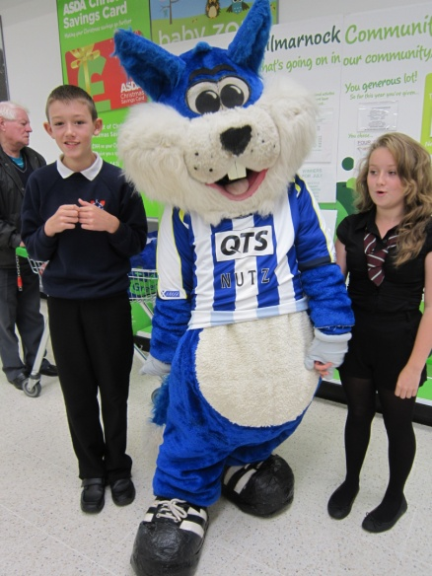

All of the ASDA shoppers got a big surprise when Nutz the squirrel popped

into the local store to help present the Pr.7 representatives; Dylan Dickson

and Jade Cunningham with our Community cheque for £200.00. The cheque was all thanks to kind shoppers who posted their tokens to make Kirkstyle the winner. The grant is going to be used to help purchase bird feeders and food for the winter visitors to the school. We will be encouraging classes to try out the Big Little Birdwatch with the R.S.P.B. again

Book Fair

Parents Afternoon and evening

We would like to thank you on behalf of all of the pupils and staff for your attendance yesterday; we had a 93% turn out from parents and carers. Your visit was made even more special with your kind words of encouragement and praise for your children; they loved reading them and sharing them today.

I would also like to thank our Primary 7 volunteers who were on hand for the I.C.T. demo and helped our teachers keep to time.

Book Fair

The pupils were invited to view the Book Fair on Tuesday within school time and have hopefully returned home with a slip; listing their preferred choices and also a leaflet with a selection of what’s on offer. These books and many others went on sale during parents’ evening. All proceeds from the Fair go towards purchasing reading materials for use in classes and due to the support of parent we achieved a total of £334.00 of books for the school.

Swimming

The dates scheduled still to come are, 26.10.12, 02.11.12, 09.11.12, 16.11.12 and 23.11.12.

Ayrshire Schools’ Swimming Gala is also scheduled to be held in October and some of Kilmarnock Swimming Club have asked to represent Kirkstyle at this event. We wish Kerry Gibson Pr.5, Ross Graham Pr.6/7 Megan Donnelly Pr.7 and Jamie McKinnon Pr.7 every success in their individual races.

School Pupil Council

The Pupil Council have lost some key players this session with the move of Primary 7 onto the Secondary and elections have been held to invite some new and budding politicians to join the existing group. Newly elected members this school session include:, Katie Dilloway and Bradyn McColm from Primary 3 and a first for this Pupil Council is to include a Primary 2 member who was chosen from Mrs. F. Drennan’s class; Bailey Conner. Existing members are secretaries Mia Hay Pr.5, Louise Cameron Pr.4/5 and McKenzie Wright Pr.4 and Vice Chairperson; Ling Liao Pr.7 and the Chairperson being Louise Hilton Pr.6/7.

The first role for the Council was to renegotiate and discuss the school values basing their ideas on; 2011-2012 final school term’s work on the Olympic and Paralympic values. The ideas of how these could reflect school life were presented to the Parent Council for any additional ideas.

At Kirkstyle we value:

**RESPECT** for all pupils and staff, in a school who protect each other’s feelings and safety.

**FRIENDSHIP** among pupils, getting along together sharing our work, rest and play times.

**COURAGE** demonstrated through an ‘I can attitude’ and having the courage to stand up for what’s right.

**DETERMINATION** in all that we do, being the best we can be.

**EXCELLENCE** in education with pupils and staff going for gold.

**EQUALITY** within our school community, treating people equally and being respectful of others.

**INSPIRATION** when we work together to try something new to motivate others.

Breakfast Club

Letters inviting parents/carers to take up the option of their pupils attending Breakfast Club have now gone out. Please return slips asap. to allow us to arrange sufficient staffing for this. The cost is 90p for first child and 70p for further siblings but if your child is in receipt of free school meals this incur no cost.

School Clothing

Can I please remind you to clearly label all clothing including; jackets and sweatshirts as we often find it difficult to return lost items to their rightful owners, if there are no names on the clothing. However we are still on the hunt for a jacket; Lochlan Tyrie Room 16 is still missing a school reversible fleece age 5- 6 which does have his name tucked under the hood – please can you check at home and return this to the school if you find it amongst your own child’s school wear.

Any old school clothing is greatly received in school for spares in emergencies and also don’t forget our Ragbag recycling project with bins inside and outside the school.

Once a week – take a peek!

Unfortunately the minute we return to school we also seem to have unwelcomed visitors in school – head lice! Approximately one in 10 UK school children have head lice at any one time and contrary to popular belief, they are easier to treat nowadays. The best advice we can offer parents to help us all tackle the problem is in line with one of the campaigns and website appropriately named - Once a week take a peek! Checking your child’s hair regularly should be part of your family’s personal hygiene routine and could stop a small problem becoming a persistent issue. There are many ways to go about treating head lice should you discover the problem but we need to act fast and check frequently first. The website [www.onceaweektakeapeek.co.uk](http://www.onceaweektakeapeek.co.uk) offers free advice to parents, we annually discuss the health and hygiene issue with the pupils in school and we hope to send out advice leaflets to help educate the whole family in the near future as well.

Diary Dates

12.10.12 – Massage in schools – Parents session

12.10.12 – Primary 5 swimming

15.10.12 – 21.10.12 HOLIDAY

22.10.12 – Teachers return to school

23.10.12 – Pupils return to school

23.10.12 – Sportshall Atheltics practice for Pr.7 selected pupils

24.10.12 – Primary 7 visit from History Alive for WWII

24.10.12 – Primary 4/5 & 5 Rugby input

24.10.12 – Dental health checks for Pr.1 & Pr.7

25.10.12 – Parent Council Halloween Disco

25.10.12 – Primary 1 -3 Halloween Activities

26.10.12 – Primary 1-3 Halloween Activities

26.10.12 – Dress for Halloween – donations for Cash for Kids charity

30.10.12 – Food Standards Agency/Football for Primary 5

30.10.12 – Parent Council Meeting 6.30pm

30.10.12 – Block 2 After school gymnastics

31.10.12 – Firework talk for Pr.6, Pr.6/7 & Pr.7

31.10.12 – Sportshall Athletics heat for selected primary 7 pupils

01.11.12 – Shiny Golden Time-Primaries 1-4 attending Brave showing at Odeon

01.11.12 – Taekwondo taster session from Phoenix – Pr.3- Pr.7

02.11.12 – Primary 5 swimming

06.11.12 – Shiny Golden Time- Primaries 5- 7 attedning Dairy of a Wimpy Kid showing at Odeon

06.11.12 - Food Standards Agency/Football for Primary 5

06.11.12 - Block 2 After school gymnastics

08.11.12 – Primary 7 and 6/7 to Dumfries House and Estate

08.11.12 – Owl Magic visiting Primary 3

09.11.12 – Primary 5 swimming

13.11.12 - Food Standards Agency/Football for Primary 5

13.11.12 - Block 2 After school gymnastics

13.11.12 – Kilmarnock Academy parents meeting for Pr.7 pupils

15.11.12 – Kilmarnock Academy Quiz

15.11.12 – Parent Council Bingo night

16.11.12 – Primary 6 and 6/7 attending Hopscotch Theatre group ‘Burns an a That’ production

20.11.12 - Food Standards Agency/Football for Primary 5

20.11.12 - Block 2 After school gymnastics

23.11.12 – Primary 5 swimming

27.11.12 - Food Standards Agency/Football for Primary 5

27.11.12 - Block 2 After school gymnastics

29.11.12 – Primary 3 visiting Kelvingrove and Riverside Museum

03.12.12 – Whole school visiting Panto.

We will add additional dates in the coming Newsletters, please keep a look out for them.