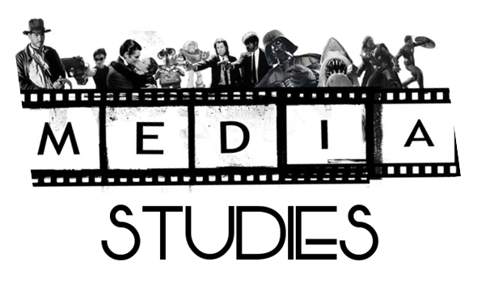
Carry out detailed and complex analysis of media content by:
1.1 Identifying and explaining media content in detail
1.2 Identifying and explaining media contexts in detail
1.3 Explaining the relationship between media content and context
1.4 Identifying and explaining the role of media
1.5 Applying knowledge and understanding of the relevant key aspects of media literacy
Create media content by:
1.1 Planning and developing ideas in response to a negotiated brief
1.2 Applying production skills appropriate to the media content and context
1.3 Evaluating the production process
1.4 Applying detailed knowledge and understanding of relevant key aspects of media literacy

You will become familiar with the following terms: (those in bold are the key concepts along with technology)

Media content
Content-based key aspects of media literacy:
# categories — genre, purpose, tone
# language — medium/form-specific technical codes, cultural codes, anchorage
# narrative — medium/form-specific structures, codes, conventions
# representation — selection and portrayal, stereotypes, non-stereotypes, cultural assumptions
# technology – special effects or the medium used to show a film

Media contexts
Context-based key aspects of media literacy:
# audience — target audience, preferred reading, different audience reactions
# institution — internal factors, external factors
# society — time and the place which may influence how something was presented

Role of media in society
The ways in which media functions within society:
# meeting needs — entertainment, education, information
# achieving particular purposes — profit, promotion, public service
# influencing attitudes and behaviour — intentionally, unintentionally

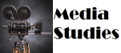 : ANALYSING MEDIA CONTENT
Okay, let’s attempt to break this down without making our heads hurt – God knows mine does after looking at the documents again.
We’re going to keep this simple, real simple, which will give us room to expand out and start to apply the key concepts to some of the media texts we will study during this course.
On the main page the two Media Outcomes are outlined along with a breakdown of what they each mean. Over the next academic year you will work on Analysing Texts and then Create Texts. This will feed into your exam. The whole course has now been split into these two components: analysis and creation. You will create a folio worth 60 marks which will be sent to the SQA and is worth 50% of your end grade. You will also sit an exam which is also worth 60 marks and will make up the other 50% of your grade. Got that?
Component | Mark | Percentage
Folio | 60 | 50
Exam | 60 | 50

So what is Media Studies? ‘Media Studies’ is the study of the theory and practice of producing media texts. One of the aims of media studies is to enable you to look at and listen to media products, not simply as a consumer of these products, but as a critic, able to question the content and purpose of the messages rather than take them for face value.
The media’ refers to the different channels we use to communicate information in the everyday world. The main forms of media are:
- Television  - Press- magazines and newspapers  - Film  - Radio | - Advertising  - Music Videos  - The Internet  - Social Media

In Media Studies there are 7 key concepts that you need to understand and be able to write about before you can tackle a media text. It is these 7 areas of a media text that you will write about when you analyse it. Once you understand these concepts and the language that goes with them then you will be ready to start writing about fiction and non-fiction media texts.
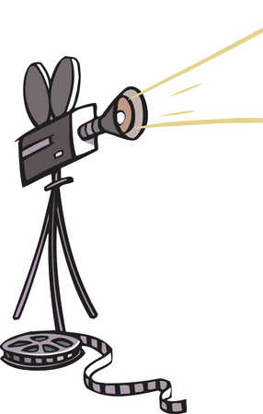
These concepts are:
  - Categories
  - Language
  - Narrative
  - Representation
  - Audience
  - Institution
  - Technology

Right, you ready? Let’s start working our way through what these actually mean!

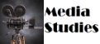 : ANALYSING MEDIA CONTENT: Categories
Media texts may be categorised in terms of:
  - Medium (e.g. press, television, film, radio)
  - Purpose (e.g. to inform, to entertain, to persuade, to educate, to profit)
  - Form (e.g. serial. Light entertainment)
  - Genre (e.g. soap opera, action movie)
  - Tone (e.g. comic, serious)
  - Style (e.g. surrealistic, conventional)

MEDIUM

Press
The Press has its origins in the 15th century when the first printing press was invented by Johannes Gutenberg in 1440. Up until that point books were copied or printed by hand – originally by monks. The printing press meant a huge number of books (and eventually newspapers and magazines) could be printed. The medium of ‘Press’ covers: Books, Magazines and Newspapers.

Television
Television is a ‘broadcast’ medium – meaning its distributed over significant distances via aerials etc. UK television began on 2nd November 1936 with what is now BBC1. ITV began in 1955. BBC2 began in 1964. The next major launch was Channel 4 in 1982, with Channel 5 following in 1997. We are now in an age of multichannel television thanks to Sky (satellite) and Virgin (cable) broadcasting. The idea of ‘television’ as a broadcast medium is now challenged by the increasing popularity of ‘On-Demand’ services like BBC iPlayer.

Radio
Radio is also a ‘broadcast’ medium. In 1922 the first BBC radio station launched. The unpopularity of the types of things being played on BBC led to lots of pirate radio stations being set up in 1950s and 1960s. The government banned pirate radio on the 14th August 1967. BBC Radio 1 launched in 1967 and the other familiar BBC stations followed short after. DAB and digital radio now ensure better quality and variety for listeners.

Film
There are a number of famous film pioneers but the most notable are Thomas Edison and the Lumiere Brothers who truly pioneered the technology. Films were silent and black and white until the late 1920s. Cinemas were particularly popular before the advent of affordable television sets. Many developments have continued in cinema, such as 3D, digital surround sound and HD images.

PURPOSE
Once we have decided on the medium of a text we need to decide on its purpose – why has it been made? Purposes include:
  - To inform – to provide information to the audience
  - To entertain – to provide enjoyment to the audience
  - To persuade – to convince the audience of the validity of some idea
  - To educate – to provide knowledge and understanding
  - For profit – such as advertising a product
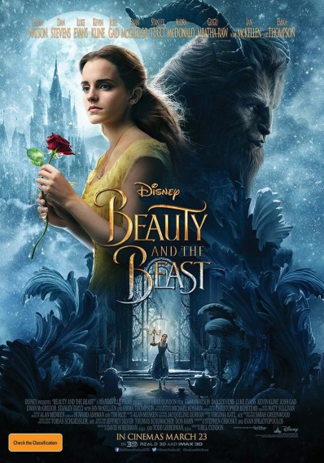
FORM

The form is the broad type of film, TV programme, radio broadcast, magazine you are looking at. It is less specific than genre. For example:
  - TV: serial, light entertainment, quiz show, comedy
  - Film: short film, documentary film, mockumentary film, feature film
  - Radio: discussion, music show, outside broadcast

GENRE

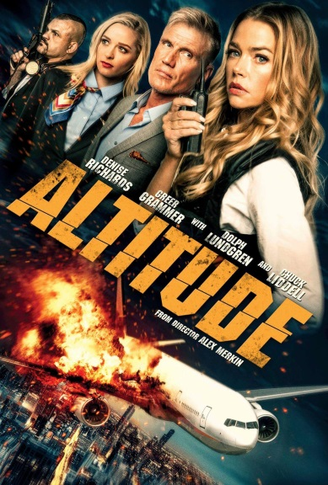
Genre refers to the specific type of text. While the ‘form’ is the overall type of text, the genre is more specific. For example:- A programme that has the form of ‘light entertainment’ could also be classified into the genre of ‘sitcom’. A film that has the form of ‘short film’ may also be classified into the genre of ‘science fiction’. Many texts are ‘multi-genre’ – why do you think this might be?

TONE

The tone of a text, as in English, is the way it treats the subject matter. It can also give a clue about the creator’s view about the subject. Elements in the text that generate tone (imagery, editing, camera shot/angle, dialogue, scenery, colour palette… the list is endless). Some possible tones are:
  - Serious
  - Comical
  - Formal
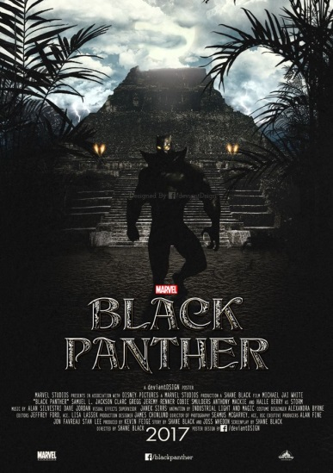
  - Informal
  - Flippant
  - Mocking
  - Scornful

STYLE

The style of a media text refers to the way it looks, sounds and generally appears. Texts with the same style share common characteristics. Some possible styles are:
  - Realist (uses techniques which makes the text seem real and not fictional)
  - Expressionist (uses unconventional and new ways of portraying things)
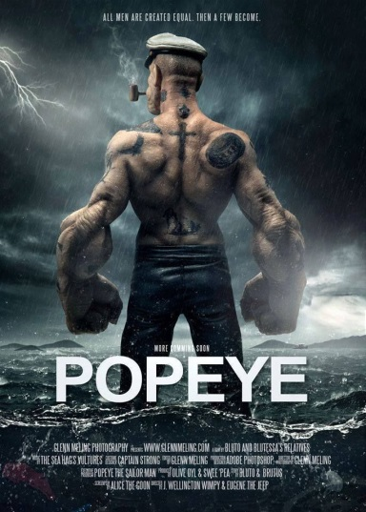
  - Traditional (old, tried and tested methods of portraying events – the news programmes, the layout of papers)
  - Modern (new, unique and different)
  - Elements in the text that establish style: quick/slow pace, use of music, light, colour, editing, dialogue, costume, scenery, imagery, all aspects of mise-en-scene…again, endless.

TASK 1: Pick ten different media texts. Make a note of their medium, purpose, form, genre, tone and style.

: ANALYSING MEDIA CONTENT: Language (Cultural Codes)
Media Language: A glossary of terms…
- Sign: the smallest unit of communication which conveys meanings – eg. word, image, sound.
- Denotation: the description of a sign – its dictionary definition
- Connotation: the associated meanings of a sign. The ideas that are attached to it – e.g. The word ‘palm’ has connotations of things such as sunshine, beaches, blue seas, heat etc.
- Codes: a group of signs that can be analysed technically and/or culturally – for example a high angle shot of a human figure curled up in a ball suggests vulnerability, weakness, a picture of a red rose in some societies would suggest love.
- Motivation: the reason for the use of a specific code (for example ‘how does it help the filmmaker tell his story?’)
- Polysemy: when a sign or code has several meanings at a time (for example a picture that could have more than one meaning because what is happening in the picture is unclear or hazy).
- Anchorage: when something is used to narrow down the polysemy of a sign or code to create a preferred reading (for example a caption underneath an unclear picture to help narrow down what the picture is showing and to make it less ambiguous).

TASK 2: copy the above glossary into your notes.
A sign a sign is something that can stand for something else. In Media Studies, a sign can be an image, a piece of text or a sound. A sign is made up of two parts: its denotation – the literal thing we see, hear, the actual image or sound and its connotation – the ideas to which the sign refers.
The image of a red traffic light is a ‘sign’. It is made up of a ‘denotation’ – the red light. And a ‘connotation’ – the things the light represents (stop, wait)

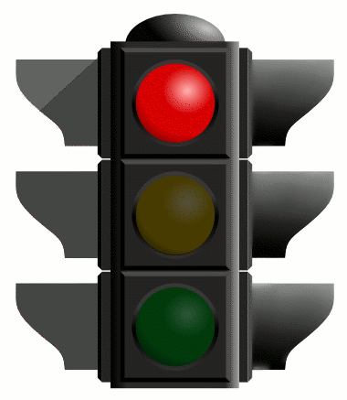
The image of a red rose is a ‘sign’. It is made up of the ‘denotation’ – the red rose. And the ‘connotation’ – the things a red rose represents (love, romance)

TASK: Think of another three signs we use every day. List their ‘denotation’ and their ‘connotations’.
TASK: Find three adverts. Look at them and talk through any signs that are used in them.
In Media Studies, signs are grouped together into groupings called codes:
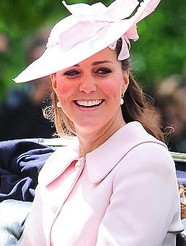
  - Cultural codes – systems of signs whose meaning is shared by members of a culture (e.g. dress/costume, gesture, mise-en-scene, intertextual reference). Often this is associated with cultural ideology.
  - Technical codes specific to media (sound, lighting, camera techniques etc)

TASK 3: Look at the images of Kylie Jenner and the Duchess of Cambridge. What different Cultural Codes do they evoke? Explain in detail how they do this.
BONUS POINTS: If you type in St Andrews University Kate Middleton, you will see images of her in a red suit. What cultural code particular to the St Andrews University was she referencing?
: ANALYSING MEDIA CONTENT: Language (Technical Codes)
Camera techniques
Seriously guys if you don’t know what these are by now, then you might as well drop the course. This is the one area of media you’ve had drilled into you from S1. We break the camera shots up into FRAMING, ANGLE and MOVEMENT.
FRAMING
1. EXTREME LONG SHOT: taken from far away, usually for external shots that set the scene.
2. LONG SHOT: generally shows a full body.
3. MEDIUM SHOT: shows a figure from the waist up.
OVER-THE-SHOULDER-SHOT: showing the back of one speaker and the front of another.
4. CLOSE-UP: concentrates on either a face or a detail of mise en scene used to reveal important details.
5. EXTREME CLOSE-UP: An extreme version of the close-up, magnifying what we would experience in reality

ANGLE
1. BIRDS-EYE VIEW: A scene shown from directly overhead.
2. HIGH –ANGLE: The camera is elevated above the action. This can make the objects photographed seem smaller or insignificant.
3. EYE LEVEL: A fairly neutral shot, taken from natural human level of about five to six feet from the ground.
4. LOW ANGLE: These increase height and give a sense of speeded motion. They can also give a sense of powerlessness to the viewer.
5. OBLIQUE/ CANTED ANGLE: Sometimes the camera is tilted to suggest imbalance, transition and instability.

CAMERA MOVEMENT
1. PANS & TILTS: A movement which scans a scene horizontally or vertically
2. DOLLY SHOTS: Also called TRUCKING or TRACKING shots, the camera is placed on a vehicle and moves alongside the action.
3. HAND-HELD SHOTS: creates a jerky effect as the camera is strapped to a person to follow the action.
4. CRANE SHOTS: A DOLLY shot taken from the air using a crane.
5. ZOOM LENSES: Used to zoom in or out of a shot.
6. THE AERIAL SHOT: Usually taken from a helicopter.

Soundtrack
Music in film is known as the soundtrack. Music can be divided into two categories –
a. Diegetic music (in the film – characters can hear)
b. Non-diegetic music (music that characters cannot hear – not part of the film’s ‘reality’)
c. Parallel sound (when the soundtrack matches the action on screen. i.e. tense music to a horror scene)
d. Contrapuntal sound (when the soundtrack doesn’t match the action. i.e. fast music to playing children).

Lighting
Low-key, high-key, natural - this can be used to affect the mood or atmosphere in a shot. For example, horrors are often low-key to create a spooky mood.
Mise-en-scene
Mise-en-scene is anything that can be seen on the screen. This includes: Props, Costumes, Body Language and Set

Editing
- cut
A visual transition created in editing in which one shot is instantaneously replaced on screen by another.
- continuity editing
Editing that creates action that flows smoothly across shots and scenes without jarring visual inconsistencies. Establishes a sense of story for the viewer.
- cross cutting
Cutting back and forth quickly between two or more lines of action, indicating they are happening simultaneously.
- dissolve
A gradual scene transition. The editor overlaps the end of one shot with the beginning of the next one.
- errors of continuity
Disruptions in the flow of a scene, such as a failure to match action or the placement of props across shots.
- establishing shot
A shot, normally taken from a great distance or from a "bird's eye view," that establishes where the action is about to occur.
- eyeline match
The matching of eyelines between two or more characters. For example, if Sam looks to the right in shot A, Jean will look to the left in shot B. This establishes a relationship of proximity and continuity.
- fade
A visual transition between shots or scenes that appears on screen as a brief interval with no picture. The editor fades one shot to black and then fades in the next. Often used to indicate a change in time and place.
- final cut
The finished edit of a film, approved by the director and the producer. This is what the audience sees.
- iris
Visible on screen as a circle closing down over or opening up on a shot. Seldom used in contemporary film, but common during the silent era of Hollywood films.
- jump cut
A cut that creates a lack of continuity by leaving out parts of the action.
- matched cut
A cut joining two shots whose compositional elements match, helping to establish strong continuity of action.
- montage
Scenes whose emotional impact and visual design are achieved through the editing together of many brief shots. The shower scene from Psycho is an example of montage editing.
- rough cut
The editor's first pass at assembling the shots into a film, before tightening and polishing occurs.
- sequence shot
A long take that extends for an entire scene or sequence. It is composed of only one shot with no editing.
- shot reverse shot cutting
Usually used for conversation scenes, this technique alternates between over-the-shoulder shots showing each character speaking.
TASK 4: look at a number of music videos and vloggers on YouTube and see what cultural codes were used and how they were shown through the camera techniques, soundtrack, lighting, mise-en-scene and editing.
: ANALYSING MEDIA CONTENT: Narrative
Ah, yes, good old story-telling. But did you know that even though hundreds upon hundreds of stories have been told over the centuries of man only a few ‘stories’ actually exist… what? Well, what we actually mean is that stories have a tendency to follow a certain formula and over the years, some people came up with their theories on how these formulas worked. We’re going to take a look at some of them and familiarise ourselves with their points.
Propps Theory
Vladimir Propp noticed that all fairytales follow a similar pattern. He decided that there are 31 functions that occur. Go check them out on Wikipedia. He also concluded that all the characters could be resolved into 7 broad character functions in the 100 tales he analyzed:
- The villain — an evil character that creates struggles for the hero.
- The dispatcher — the person who sends the hero on his quest.
- The helper — a typically magical entity that comes to help the hero in their quest.
- The princess or prize — the hero deserves her but is unable to marry her
- The donor — a character that prepares the hero or gives the hero some magical object, often after a test.
- The hero — he (or she) thwarts the villain, resolves any lacking or wronghoods and weds the princess.
- The false hero — takes credit for the hero's actions or tries to marry the princess
Todorov’s Theory
Tzvetan Todorov's narrative theory suggests that all narratives follow a three part structure where they begin with equilibrium, where everything is balanced, progress as something comes along to disrupt that equilibrium, and finally reach a resolution, when equilibrium is restored.
Levi-Strauss Theory
Everything is in binary opposition. Therefore you cannot have good without bad. Hence Harry Potter has Lord Voldemort, Star Wars has both Jedi and Sith, Lord of the Rings has Gandalf and Nasgul.
Barthes Codes
Barthes came up with a number of codes to help us understand texts.
The Hermeneutic Code – refers to any element of the story that isn’t explained and becomes a mystery. It is done on purpose to keep the audience guessing, until the final scenes where all is revealed and closure is finally reached.
The Proairetic Code – builds tension by referring to other action that is happening and indicating that something is about to happen. It works with the Hermeneutic Code.
The Semantic Code – is about the connotations in a story that give additional meaning.
The Symbolic Code – does the same job as the Semantic but applies it more broadly.
The Cultural Code – a shared idea across a text.

TASK 5: make notes on these narrative theories and then promptly forget Barthes. We probably won’t use his but the other three are really good ones to apply to texts we will look at.
TASK 6: Take three films you have seen recently. Think about how they are structured. Apply each of these codes to them in turn and think about how the theories can apply. Make notes of your findings.
What else do we need to know? Well a story is the order in which the events actually happen, the plot is the way in which this story occurs. Take a look at the list below to see what types of plots we could have in a text:
The Classic Hollywood | - Events occur in the order they happen (chronological)  - Plot begins with normality being shown. Normality is then disrupted and the characters need to overcome this disruption.  - A happy ending where all problems are resolved.
Flashback/Flashforward | - Events are not shown chronologically, but the text jumps back and/or forward in time to show events from the past and/or future.
Investigative Narrative | - Contains interviews and observations, with a summary of findings/opinions
Multiple plotlines | - Various different plots are happening at the same time, with the text jumping between these plots.  - Often, these plots are interwoven – they relate to each other.
Fragmentation | - A narrative that is mixed up and not in any sensible order. It requires the reader to construct order/meaning.
Episodic Narrative | - Short, self-contained plots within something larger. Situation comedies and soaps have episodic narratives.

TASK 7: Try to name at least two films for each different plot type.
TASK 8: take a simple fairy tale like Goldilocks and plan out the plot using each of the above narrative styles.
Resolutions and Morals
Resolution:
- The outcome of the narrative.
- What happens at the end? How does the text finish?
- How does the resolution relate to the text’s representations, ideologies and myths?

Moral of the story:
- What was the point of the narrative?
- What is the text saying about people, society and the world?

TASK 9: look up the top 10 grossing films in 2015 and 2016. Do you notice anything about them?
Hooking the Audience
Examples of techniques to hook the audience:
- Teasers: Used to show something coming up.
- Cliffhangers: Events are left on edge to make the audience come back for more.
- Enigmas: Unanswered questions. The audience are encouraged to watch to find out the answers.

TASK 10: choose four films. Watch their opening scenes and decide how they hook their audience.
TASK 11: Watch the following short film and as a group create a poster analysing the narrative of the film. Remember, you must focus on a) Story vs. Plot, b) Narrative Structure, c) Resolution and moral of story, d) Conventions/Codes used, e) Audience engagement/hooks and f) Narrative theories.
: ANALYSING MEDIA CONTENT: Representation
When you represent something you are not representing or showing the whole thing. Media makers must choose what elements of a ‘thing’ to keep and what to lose. When representing a person, media texts often focus on their:
- Age  - Gender  - Race/Ethnicity | - Financial Status  - Job  - Culture/nationality
Signs and symbols can be used to make this easier – it’s like a visual shorthand. For example, if we want to depict an old man we might chose to show him with a walking stick and white hair to suggest his age or give a lawyer a briefcase and a snappy suit. Not all old men or lawyers have these attributes, but it speeds up the reading of their character.
When you're analysing representation, think about the following questions:
- Who or what is being represented? Who is the preferred audience for this representation?
- What are they doing? Is their activity presented as typical, or atypical? Are they conforming to genre expectations or other conventions?
- Why are they present? What purpose do they serve? What are they communicating by their presence? What's the preferred reading?
- Where are they? How are they framed? Are they represented as natural or artificial? What surrounds them? What is in the foreground and what is in the background?
Representation does not represent reality, just an interpretation of it. And everyone will interpret the representation in different ways. Media-makers must choose what is important to keep and what they can lose when creating a representation. Visual representation in particular is a strong tool as people can ‘read’ images faster than words.
TASK 12: Look at the two newspaper photos below of Lindsay Lohan. Talk me through the representation in each using the above questions to shape your answer.
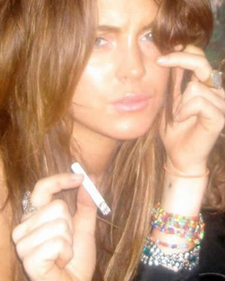
TASK13: You are presenting an article Lily Allen helping the Government to set up businesses. Your are to present this as a good idea and to emphasise how professional Lily Allen is. Which image do you use? Why?
MEDIATION
Mediation refers to the way the media selects and interprets political, economic and cultural events. Consider the way the media shows something (the mediation of it) and ask:
  - What effect does this have on the target audience?
  - What affect does the control on the medium have on the way it represents things?
  - How powerful is the media in shaping people’s perceptions of something?
  - What motivates the media to represent things in certain ways?

TASK 14: Pick three newspaper front pages and answer the above questions for each.

: ANALYSING MEDIA CONTENT: Audience
We’ve done a bit of work on audience in English. Audience considers the people for whom the text was made, the effect it has on them and how they deal with it. Commenting on Audience involves the following areas:
- Target Audience.  - Mode of Address. | - Preferred Reading.  - Differential Decoding.

Target Audience: The group of people that the text is made for. To identify ‘target audience’ we might consider…
- Categories – the type of text and the features of it
- Access – the type of people who have access to the text (eg. What channel is it on? What rating certification age is it suited to?)
- Inter-textual references – similar media texts that the film is linked or related to
- Narrative codes – whether the narrative structure is known to appeal to a certain audience
- Discourses – comments made by the text that might appeal to a certain group.
- Commercialisation of the product – who is it marketed at commercially?

You can break target audiences down a bit further into the following categories.
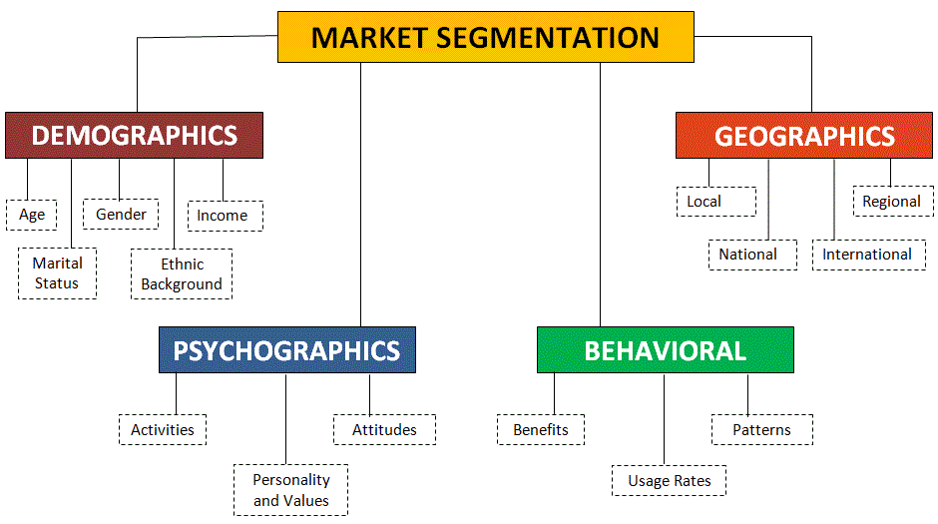
Demographics can also deal with a class of people:
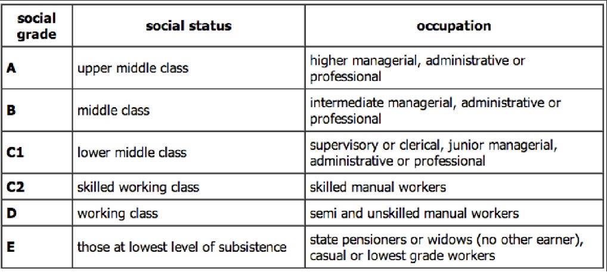
Then there is psychographics:
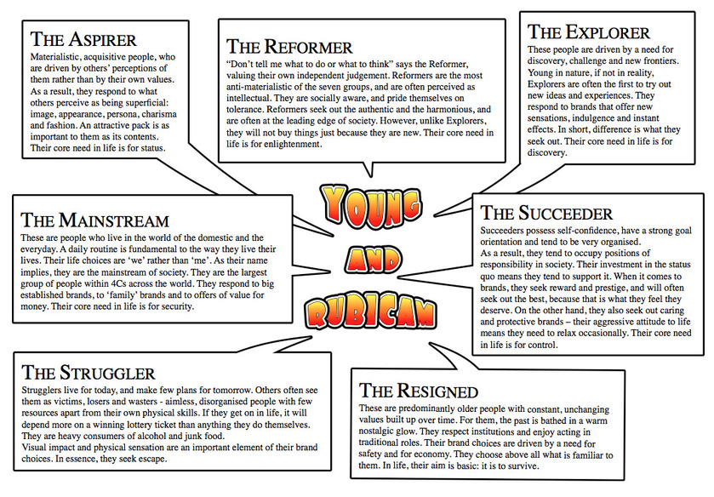

Mode of address: The way that the text speaks to the audience.
- Direct/indirect – does it speak directly to us or not?
- Individual or collective – does it speak to us as if we are the only person watching or as part of a group?
- Omniscient or restricted – Do we get to know and see everything or is our knowledge and sight restricted?
- Subjective or objective – is there an opinion/bias attached to the text or is it a balanced portrayal of events?
- Register – are the words used formal or informal? Serious or light-hearted? Etc.

Preferred reading: The meaning that the maker of the text wants the audience to accept.
Differential decoding: Although texts have preferred readings, we all interpret them differently and this is called differential decoding. Factors that cause ‘differential decoding’ are things like:
- Age
- Gender
- Ethnic background
- Education/knowledge
- Experience
- Affiliation/identification with different groups.

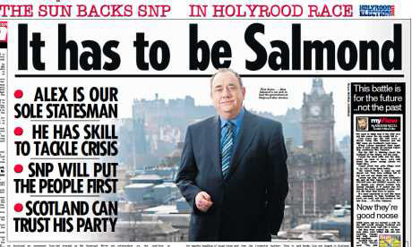
TASK 15: On the following slide are two very different headlines from ‘The Sun’ Newspaper on the same subject – the SNP. As a class we will analyse the first headline in terms of ‘audience’ and then you will do so individually for the second headline.

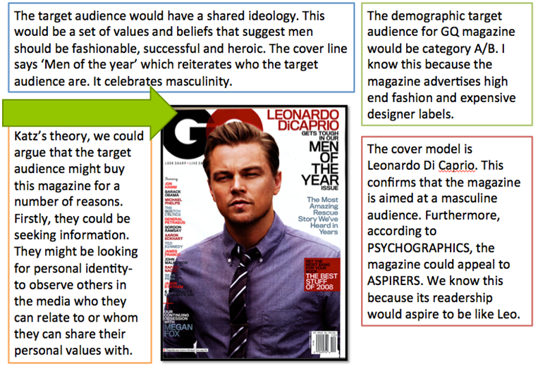

TASK 16: Choose a Young + Rubicam psychographic and a social status demographic. Create the front page of a magazine that would appeal to this audience. Consider:
- Magazine Title
- Front page images
- Headlines
- Information about content
- Price
- Celebrity endorsement

: ANALYSING MEDIA CONTENT: Institutions

Institutions looks at how the media industry, controls, laws and ownership can affect media texts.

Legal Constraints Legislation and laws affect media products. They demand that certain things are done or not done. Some of the laws that impact on media texts are:
Sex Discrimination Act (1975)  Race Relations Act (1976, 2003)  Disability Discrimination Act (1995) | Equality Act (2010)  Copyright, Designs and Patents Act (1988)  Libel/Slander/defamation of character laws

Self-Regulatory Codes of Practice include those established by the Press Complaints Commission,OFCOM (Offices for Communication, ASA and the BBFC (British Board of Film Classification)
Press Complaints Commission:  - Accuracy and anti-discrimination.  - Giving people an opportunity to reply.  - Avoiding harassment and ensuring privacy.  - Advice for reporting on children.  - Advice for reporting on criminal matters. | OFCOM:  - Protecting children  - Harm and offence  - Crime  - Religion  - Ensuring impartiality and fairness  - Privacy
ASA:  - Agreed code for advertising  - Has a code of broadcast and non-broadcast advertising  - Advertising should not mislead, harm or offend  - Special rules for products like alcohol, gambling and financial products | BBFC:  - Decides the age ratings for films in UK  - U, PG, 12, 12A, 15, 18, R18

TASK 17: Find four different types of media text. Think about what Codes above might have affected their production.

: ANALYSING MEDIA CONTENT: The Role of Media

Media does three things…
- Meeting needs: entertain, educate, inform
- Influencing attitudes and behaviours: intentional, unintentional
- Meeting particular purposes: profit, promotion, public service

TASK 18: Search online and find an example of an advert that fits each description below.
ROLE OF MEDIA | EXAMPLE

To entertain

To educate

To inform

To influence

To create profit

To promote

To perform a public service

: ANALYSING MEDIA CONTENT: Media Production
The production of media texts is a complex and expensive process, involving the creative input of many specially skilled people.
Anyone can produce a media text, if they have a bit of time, an idea, and access to a computer.
We live in a world where both the above statements are true. There are many different forms of the media, and the means of production, which one used to be exclusively held by big companies, like movie studios or tv stations, are now within the reach of many. However, this does not mean that the basic media production process has changed. Media texts, whether they are being produced by Time-Warner or a teenager, go through the same stages before they reach an audience. This is what we call the production process.

IDEA
Every media text begins with someone having an idea. They may be a professional song or scriptwriter who is able to package their ideas into a readily saleable form. Or they may be someone who dreams of producing their own movie. Or they may be a publishing executive who wants to launch a new magazine. Whatever. Someone, somewhere has to start with an idea. Once you have an idea, in order to make it into reality, you need $$$.

FUNDING
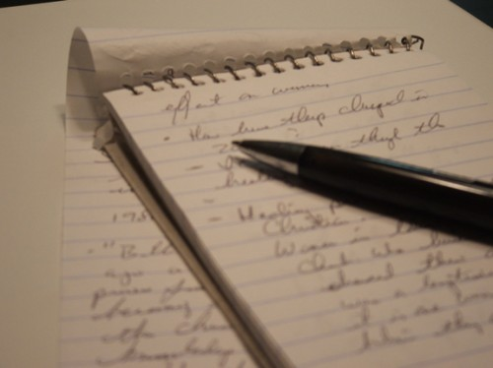
Some media texts are very cheap to produce. Others take millions upon millions of dollars. However, it doesn't matter how much money you need for your media text, it has to come from somewhere. Ideas will be submitted to potential financiers in the form of a proposal. This means that they have a clear idea of what the media text will consist of (a synopsis of the story, a demo tape of songs, character drawings for a comic) and that they also have a clear idea of who the target audience are. Those wishing to retain control of all subsequent parts of the process themselves will take their proposal to independent investors. Investors may want little or no say in what happens during production - they just want a return on their money at the end of the day. Those who don't just want money for their idea, but additional expertise, experience and equipment, will take their proposal to a media production company. The production company will take on the idea, and provide the means for its realisation, whether it is a pop CD or a computer game. often money will come from several different sources.

PRE-PRODUCTION
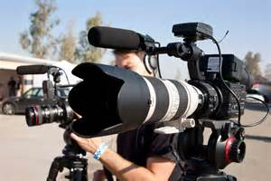
This is a vital part of the process, and often the lengthiest. Research needs to be done into audience, and the idea fine-tuned to meet demand. Existing media texts that are similar in form or content are carefully examined. Each stage of production must be planned, with equipment, locations and personnel booked in advance. Organisation is vital.

PRODUCTION
This is often the most straightforward part of production, and involves creating the raw data (text, images, sound) that will constitute the final product.

POST-PRODUCTION
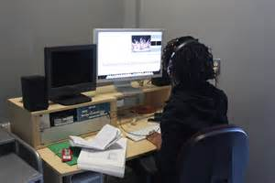
This mainly consists of editing, constructing the raw data into the form that the audience will receive. It is during this part of the process that special effects and soundtracks are added to films, where pop records are mixed, and where magazine pages are laid out and proof read. This often used to be the most expensive part of the process, with heavily specialised equipment and personnel being required. However, the digital revolution means that much of this can now be done on a PC. Skilled operators and specialist software are still required, and there are huge post-production companies dedicated to providing these services.

MARKETING & PROMOTION
Once the text has been created (although these days, particularly in the film industry, marketing and promotion can begin as soon as the main personnel have agreed to do the project) audiences need to be informed about it. This can also be an expensive part of the process (marketing budgets for movies can equal 100% of the production costs. This is therefore around $50M USD for an average Hollywood picture).

DISTRIBUTION
Once an audience know about a media text, they need to get hold of it. Distribution is big business, and is about shipping products rather than creating them. Therefore, media production companies often sell the rights to their text to specialist distributors at this stage, eg HMV will take on all record companies' CDs, rather than them trying to open up record stores themselves. However, the distributor and the production company may be part of the same media conglomerate, so all the profit eventually ends up in the same place. There are many different channels of distribution - CDs can be sold via shops, the internet or telesales, movies can be watched at the cinema, bought on DVD or video, viewed on tv and both CDs and TVs can be downloaded onto your phone or computer.

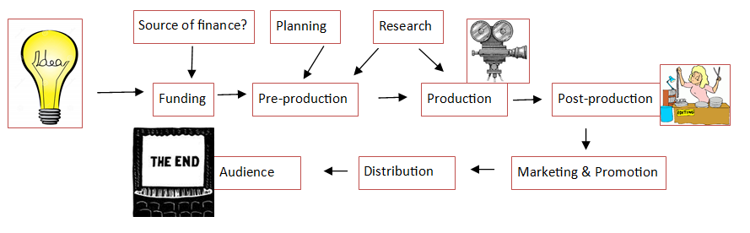

: ANALYSING MEDIA CONTENT: A Closer Look
We are going to select a few media texts to take a more in-depth look at over the rest of this course. To allow for personalisation and choice we’re going to open this up to you guys (within reason). We can look at film, TV shows, documentaries, radio shows, newspapers, magazines or social media. It’s entirely up to you.

