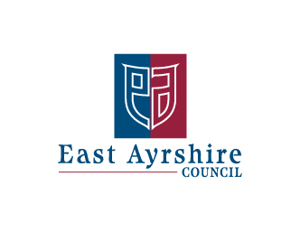
Economy and Skills
Depute Chief Executive and Chief Financial Officer
Alexander McPhee ACMA

Galston Primary School
Head Teacher: Mrs Shona Murphy
Phone: 01563 820221
Fax: 01563 821548

Tuesday 11th September 2018

Dear Parent/Carer

PANTOMIME – Monday 26th September 2018

I am pleased to inform you that Galston Primary School will be going to the Pantomime this year again. If you would like your child to take part in this opportunity, please complete the attached permission slip and return it no later than Thursday 20th September 2018.

Date of excursion: | Monday 26th November 2018 9.15am – 1.00pm
Destination: | Palace Theatre, Kilmarnock
Mode of Travel: | Bus
Cost: Please Pay Via Parent Pay | £14.00
Dress: | School sweatshirt/jumper
Items to bring: | Snack
Money: | None
Parent helpers:  * Please complete the section below. | Yes please – we need 2 parents to accompany us
Activity Information | Sleeping Beauty Pantomime
Accompanying Staff
*Please note that this may change due to unforeseen circumstances.
Person in Charge:
Liaison Officer:

-------------------------------------------------------------------------------------------------------------

The EV5 consent form is used as permission and consent for your child to take part. If you do not wish him/her to participate, please contact the school.

This outing can only take place with parent helpers so please let us know if you can help.

I am able to help on the above outing. If you are required we will send confirmation home with your child.

SIGNED _________________________________ (Parent/ Guardian)

PUPIL ______________________ Reg Class _______________

