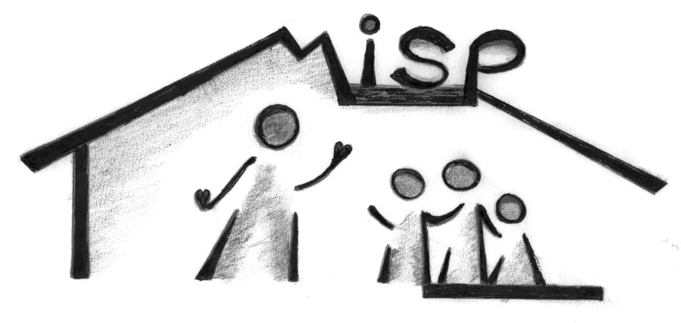

# Massage in Schools Programme

Dear Parent /Guardian,

You are invited to attend and join your child to experience the **Massage in Schools Programme** that has been introduced into your child’s class. This fantastic event is taking place on Thursday 11th October 2018 at 9.10am for Primary 6, 6/7 & 7 and 9.55 for Primary 4a & 4b.

The Massage in Schools Programme involves teaching the children a series of simple massage strokes, which they practise on each other, working in pairs. The massage programme is carried out fully clothed on chairs in the classroom and is built into the daily routine. The children learn to always ask permission from each other before they are allowed to work with their partners and learn about the importance of safe touch and being gentle. Children who do not wish a massage can sit out and watch. The children are only allowed to work with their peers.

The children have enjoyed learning about the benefits of Massage and have shown confidence when asking for permission and carrying out the routine safely in class. We hope that someone from the family can come and share this positive experience with the children.

Yours sincerely

C:\Users\robsonl\Desktop\Lorraine\shona sig.png

Shona Murphy

Head Teacher

-----------------------------------------------------------------------------------

## Massage in Schools

I will/will not be able to attend the Massage in Schools programme event.

Name of child……………………………………………………………………………………

Parent/Guardian’s signature………………………………………………………….