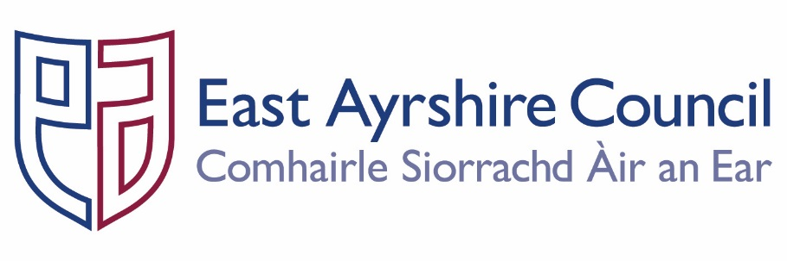
Economy and Skills
Depute Chief Executive and Chief Financial Officer
Alexander McPhee ACMA

Galston Primary School
Head Teacher: Mrs Shona Murphy
Phone: 01563 820221
Fax: 01563 821548

SM/LR

Dear Parent/Carer

In line with East Ayrshire Council guidance, we are contacting you to inform you that this year as part of the Early Level Health and Wellbeing curriculum our children will be learning about Relationships, Sexual Health and Parenthood (RSHP). The topic is fully in line with Curriculum for Excellence which is set down by the Scottish Education Department and includes the study of the following experiences and outcomes:

I am aware of how friendships are formed and that likes, dislikes, special qualities and needs can influence relationships. HWB 0-44a
I understand positive things about friendships and relationships but when something worries or upsets me I know who I should talk to. HWB 0-44b
know that there are people in our lives who care for and look after us and I am aware that people may be cared for by parents, carers or other adults. HWB 0-45a
am aware of the need to respect personal space and boundaries and can recognise and respond appropriately to verbal and non-verbal communication. HWB 0-45b
differences but are all unique. HWB 0-47a I am aware of my growing body and I am learning the correct names for its different parts and how they work. HWB 0-47b
I am learning what I can do to look after my body and who can help me. HWB 0-48a
am learning about respect for my body and what behaviour is right and wrong. I know who I should talk to if I am worried about this. HWB 0-49a
I am learning about where living things come from and about how they grow, develop and are nurtured. HWB 0-50a I am able to show an awareness of the tasks required to look after a baby. HWB 0-51a

Our local authority is committed to the provision of quality teaching in Relationships, Sexual Health and Parenthood education in accordance with National Guidelines. It forms a key element of personal, social and health education in schools and is an important part of children’s preparations for adult life. The purpose of RSHP is to provide the learners with an understanding of how to maintain positive relationships. In addition pupils are encouraged to consider how thoughts, feelings, attitudes, values and beliefs can influence decisions about relationships.
It is very important that taking into account the age and stage of the child that we take steps to use a common vocabulary to descried our emotions, feelings and body parts. The suggested vocabulary which the staff will encourage the early level children to use is shown overleaf:-

We will also be looking at Early Level Substance Misuse. This topic is fully in line with Curriculum for Excellence which is set down by the Scottish Government and includes the study of the following experiencing and outcomes:

I understand there are things I should not touch or eat and how to keep myself safe, and I am learning what is meant by medicines and harmful substances. HWB 0-38a

I can show ways of getting help in unsafe situations and emergencies. HWB 0-42a

The programme is based on a story book called “Jenny and the Bear”.

Relationships

Suggested | Vocabulary
feelings | emotions
happy | worried
concerned | similarities
scared | kind
talent | strength
likes | dislikes
family | differences
weakness | special qualities
thoughtful | friends
angry | unique
Suggested | Vocabulary
difference | male
boy | female
girl | birth
child | grow
body part | same
child | life cycle
parent | family
adult  pants | private  vest

Parenthood

Suggested | Vocabulary
caring | emotional wellbeing
family | change
hygiene | responsible
cared for | safety networks
thoughts

Yours sincerely

Shona Murphy
Head Teacher

