Online Learning
Using GLOW
Sign in to GLOW with Username and Password you have been provided:
https://sts.platform.rmunify.com/Account/SignIn/glow
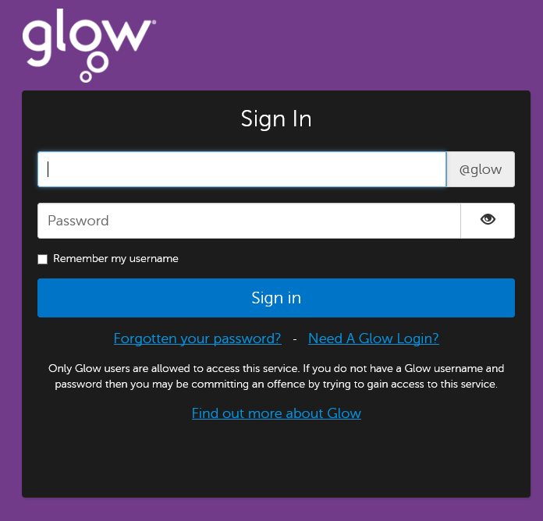

Select the Auchinleck Academy Launchpad

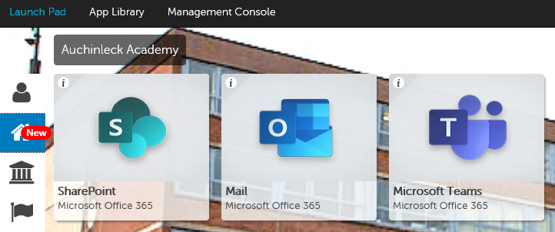

Click on Sharepoint or Click on Mail or Click on Teams

In Sharepoint open the folder to access work in each department
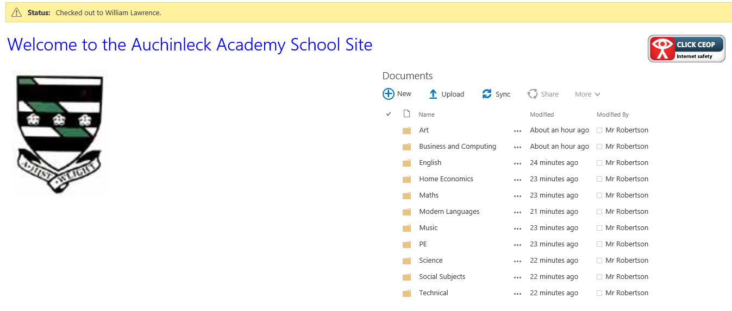

In Mail you may receive work to be completed from teachers or invitations to join Teams, please accept these.
Ensure that you check you mail regularly and keep your Inbox tidy by deleting old mail
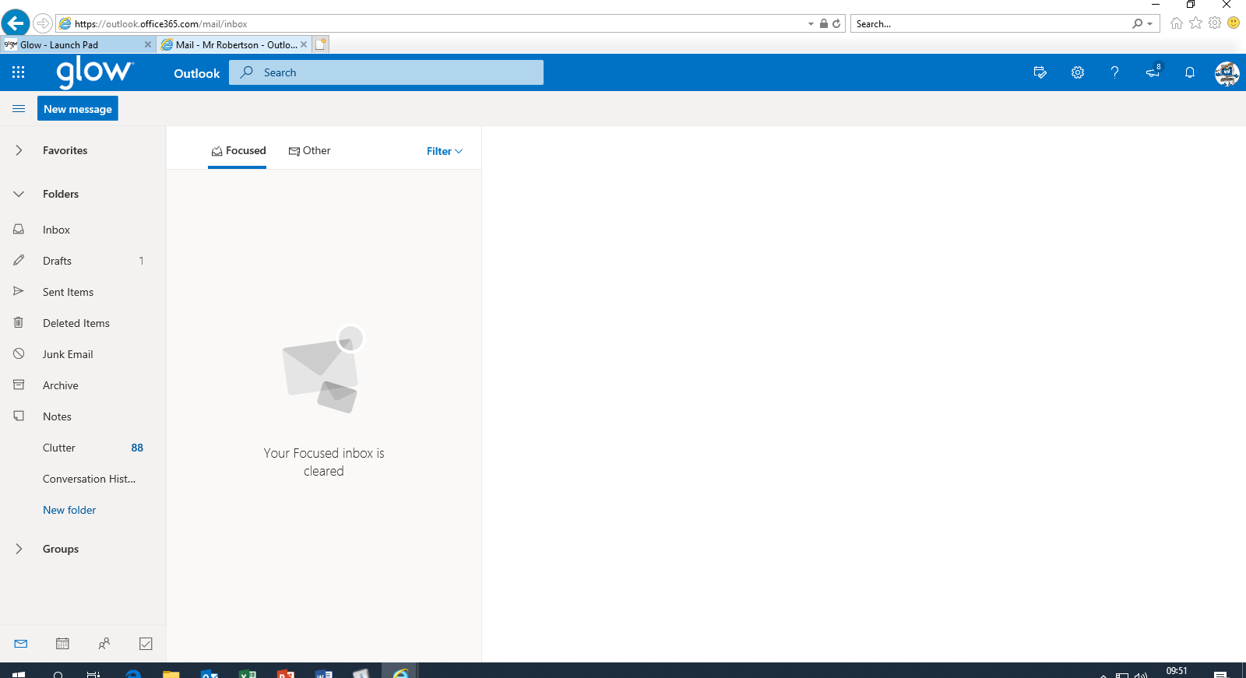

In Teams you will see the Teams that you are a member of or can ask to join if you have not already.
If you have been sent a code to join a Team click on Join Team where you will be asked for the code.
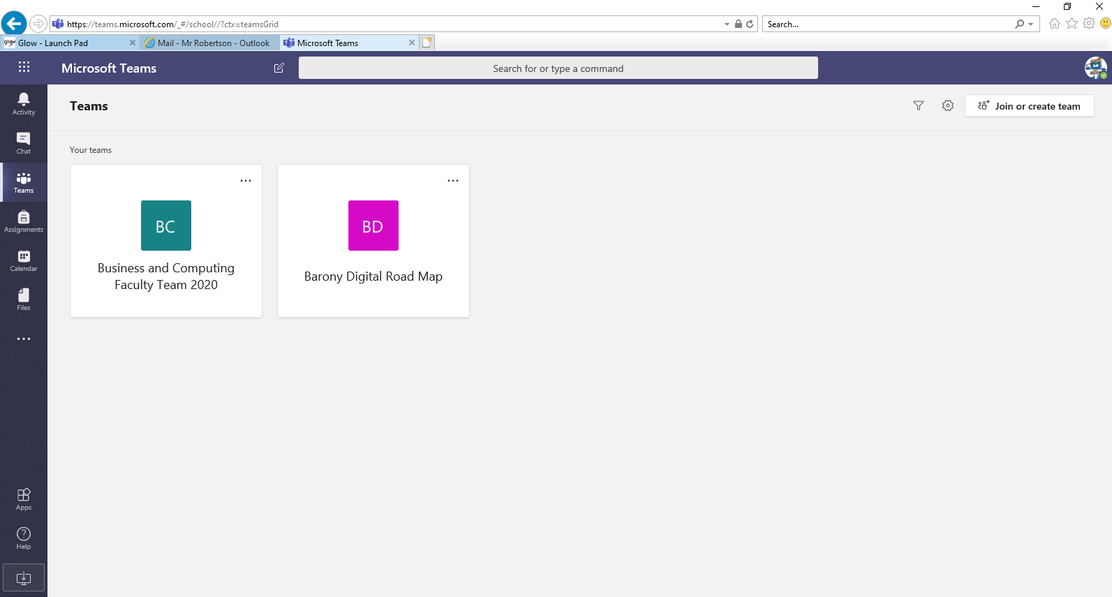

Using the APPS
It is also possible to access Sharepoint, Mail and Teams using an APP which can be downloaded to your device:
Microsoft Outlook Mail Microsoft Sharepoint Microsoft Teams

Instructions
- Download the APPS
- Log in to each app using your glow email address which is: username@glow.sch.uk
- Select that you are using Office 365
- Log in to GLOW when prompted
- The app will now remember your password and keep you logged in.

