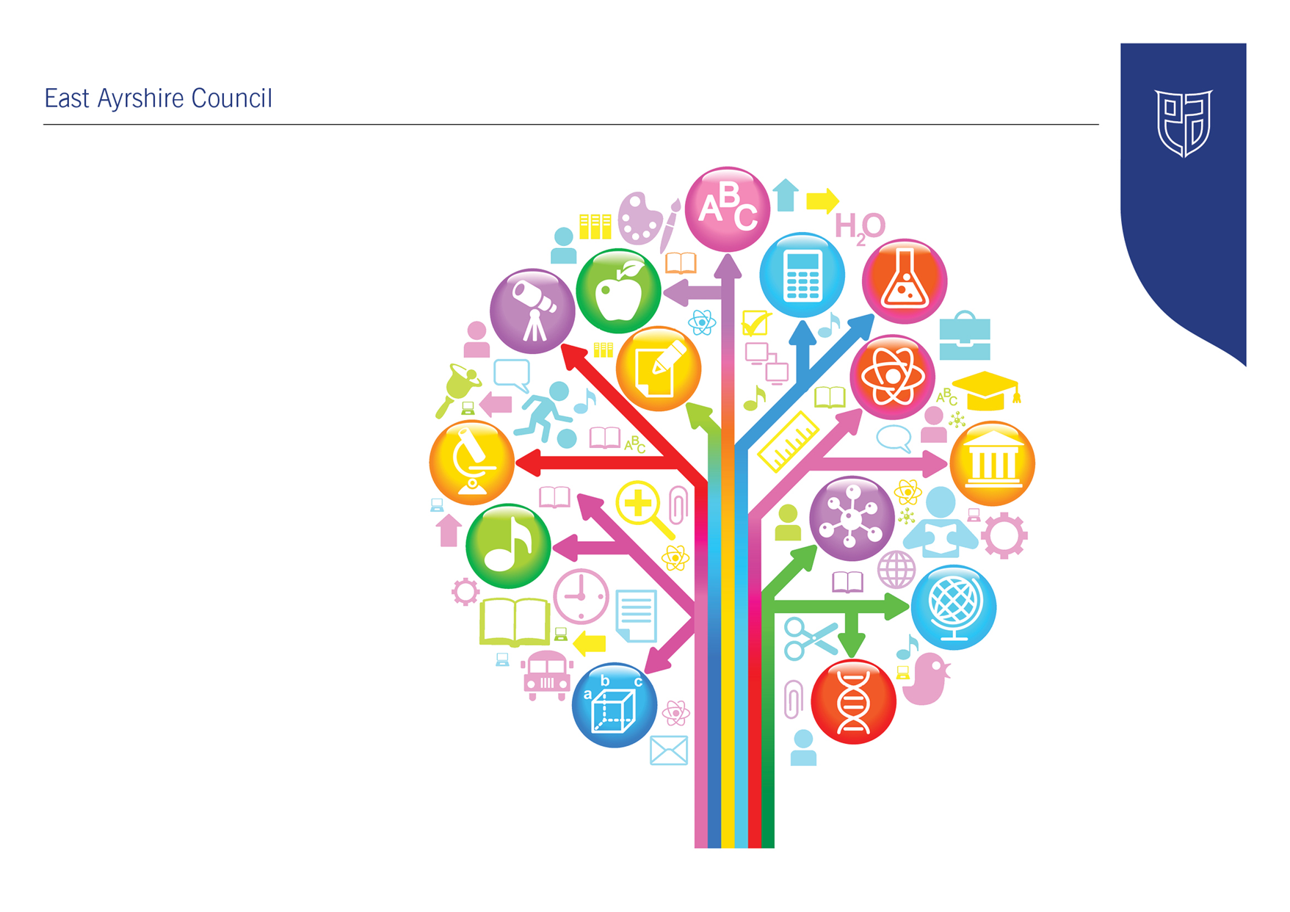
Standards and Quality Report
2017-18

Auchinleck Academy

Standards and Quality Report 2017-18
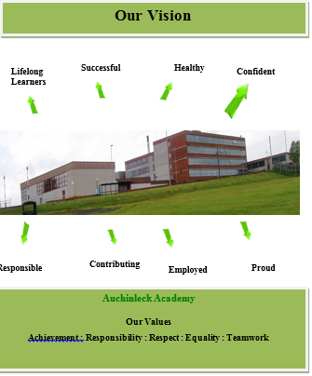

Improvement Plan 2017-18 - Summary of Priorities and Initiatives
Priority 1: Raising Attainment & Achievement - QI 3.2
- Attainment strategies in Senior Phase
- Further development of tracking and monitoring procedures in BGE
- Tracking of wider achievements
- Improvements in Literacy & Numeracy
- Implementation of Career Education Standard
- Review of options and curriculum pathways
- Review of self-evaluation processes
- Enhanced staff development opportunities

Priority 2: Learning, Teaching & Assessment - QI 2.3
- Improve the degree of challenge in lessons
- Improve learning and teaching in PLP period
- Improve primary-secondary transition
- Improve pupil leadership through outdoor learning
- Enhance the use of digital technology
- Ensure statutory requirements of RME are met

Priority 3: Ensuring Wellbeing, Equity & Inclusion - QI 3.1
- Meet the needs of our most vulnerable young people and their families
- Achievement of Level 1 Rights Respecting School Award
- Improve parental knowledge, awareness and partnerships
- Introduce Family Learning Programme
- Further develop targeted Nurture provision and embed whole school approaches to Nurture.
- Implement strategies towards improving physical and emotional wellbeing and attendance of most vulnerable young people
- Appropriate access to toilets and sick room
Review of Progress 2017-18
Establishment priority 1: | Raising Attainment & Achievement
- Derived from NIF priority:  - NIF Driver: | Improvement in attainment, particularly in literacy and numeracy  Assessment of children’s progress
Progress and Impact: | Success  - Rigorous results analysis at tracking periods to identify patterns of underachievement across pupils and the school.  - Review, evaluation and further development of S5 mentoring programme.  - Introduction of S4/5/6 target programme.  - Implementation of S3 exam diet and SNSA assessments. All departments are tracking pupil progress through the BGE using new numeric system.  - EAC Moderation framework produced to support schools  - Pupils are recording wider achievements in PLP  - S3 pupils will add achievements to their profile  - A large number of pupils have been awarded colours, this is recorded and monitored  - All departments are now aware of the Careers Education Standard and using to plan curriculum developments  - All staff trained on the MYWOW website  - MYWOW ambassadors in place and supporting staff and parents  - Learning rounds have been successfully introduced over 2 sessions. Learning rounds are currently being evaluated and changes being made to the format and paperwork. Many examples of good practice have been identified as a result of the learning rounds. Inservice days have been identified as the best way to share good practice. Staff have found learning rounds beneficial and are happy for these observations to replace the health check observations.  - Learning audits have been made more user friendly with streamlining the QI’s where possible, feedback has been given to staff on strengths and development needs. Staff have been able to put forward their ideas for the identified development needs and contribute to future planning.  Impact on Pupils  - Pupils aware of targets and next steps required to achieve targets.  - Pupils well prepared for SQA exams to increase attainment in the senior phase qualifications.  - Early focus on S3 attainment and identification of targets and pathways for national qualifications.  - All pupils are aware of the levels they are working at.  - Pupils identify targets for learning during learning conversations in all classes  - Pupil are developing a wide range of skills through participation in wider achievements both in and out of school  - Pupils aware of a range of careers linked to some subjects  - All pupils have logged in to MYWOW and can use it in career planning  - As a result of discussion of the development needs identified through the learning audit, some departments have asked to improve links in their subject with primaries and have discussed this with the HT.  - During the next in-service day staff will take part in a Learning and Teaching fair to share good practice and then pledge to incorporate into their own practice.  - Pupil views on what they find useful in lessons has been fed back to departments during the learning rounds process and departments have taken this feedback on board  - New N5 assessment procedures and changes in courses have been fully implemented
Next steps: | - Review timing and format of S3 exams.  - Use of Seemis Progress and Achievement to track progress in the BGE.  - Early identification of S4/5/6 pupils in SIMD 1-2 and introduction of specific mentor programme for this cohort.  - Parent and pupil study skills and knowledge of the curriculum workshops throughout session.  - Implement EAC Moderation Framework in school and across Education Group  - Introduce new SEEMIS Tracking and Monitoring tools  - Roll out pupil profiles to all pupils in S1 – S3  - Make effective use of the Careers Education Standard and Labour Market Information to plan curriculum developments  - Agree and implement new curriculum for The Robert Burns Academy in Auchinleck and Cumnock Academies from June 2019  - Trial new learning rounds process with staff and review as appropriate  - Continue to share good practice in a variety of ways  - Implementation of pupil learning and teaching group  - Implement new PRD process

Establishment priority 2: | Learning, Teaching & Assessment
- Derived from NIF priority:  - NIF Driver: | Closing the attainment gap between the most and least disadvantaged children  School improvement
Progress and Impact: | Success  - All PLP programmes have been reviewed and updated to reflect whole school values and priorities such as Rights Respecting School, Health and Wellbeing, and Improving Attendance  - Increased focus on wellbeing and pastoral issues in PLP means that all PLP Tutors have first line guidance role.  - PLPs were highlighted as a key strength during the recent Silver RRSA assessment due to the rights related content and the opportunities within the PLPs for pupils to manage their learning and express their views.  - Enhanced Transition Programme has been introduced for young people with the most complex needs.  - S1 Leadership Day.  - S2 Outdoor Learning Day.  - S1 and S3 Arran Activity Weekend.  - Outdoor Learning Month.  - Increased number of pupils completing Duke of Edinburgh's Award.  - Involvement with Field Studies Outdoor Learning Research Project.  - Robust online safety course delivered to all via S2 ICT and PSE  - ​School App implemented and ready to be shared with the school community  - Digital champions involved with the delivery of ICT to feeder primaries  - PT attended RME CoP meeting and shared good practice, developing links. Link with Samia Carmichael at Cumnock Academy has just been established.  - Time for reflection calendar now in place. A variety of issues are covered to ensure moral and religious aspects are prominent. One minister has been involved in the delivery of this.  - S6 pupils have lead most of the Time for Reflection assemblies as a leadership opportunity.  - Local authority has published a guidance note to be included in handbook.  - Courses have been revamped and replaced to include much more active learning, link in with Rights Respecting School, Outdoor learning and increase engagement in the subject. YPI has now been moved to S3.  - Most requirements of CfE briefing 16 have been met this year.  Impact on Pupils  - In recent consultations many pupils indicated that they have a quality experience in PLP.  - PLP lessons result in a productive start to each morning which sets the tone for the rest of the day.  - P7 pupils are well prepared for the transition to the Academy and are familiar with the building and key members of staff.  - Increased participation of pupils in outdoor learning activities.  - Increased outdoor learning experiences in the curriculum through implementation of Outdoor Learning Month.  - Pupils more engaged when learning outdoors.  - Increased pupil enjoyment of lessons when learning outdoors.  - Pupils linked learning with local environment.  - Digital champions are developing confidence and understanding through delivery of Digital Learning Week  - Our learners have been much more engaged and enthused about RME. The movement of YPI to S3 has been a huge success and learner voice confirms this.  - More independent learning tasks have been introduced to increase skills development.  - Challenge has increased from S1-S3 to ensure progression through levels.  - All pupils across the school have benefited from Time for Reflection.  - Pupils are able to link up their learning with their other subjects and broader lives especially in regards to their rights.
Next steps: | - Ensure that there is a consistent approach from all PLP Tutors to ensure high quality learning and teaching for all pupils during the daily PLP period. Involve PTCs more in this process.  - Include PLP lesson observations in Learning Rounds?  - Monthly sampling of PLPs by SLT  - Continue to ensure opportunities for staff to liaise with primary colleagues to achieve improved moderation and confidence in assigning levels  - Continue to deliver current outdoor learning and leadership programme.  - Implementation of John Muir Award.  - Development of Outdoor Learning Month.  - Introduce Yammer as a whole school resource to aid learning and teaching  - Develop code of conduct for use of school equipment and staying safe online.  - Introduce Glow forms to aid and record pupil/parent/staff opinions  - Develop link with Cumnock Academy more formally to enable smooth transition into new school.  - Work with link for moderation and to improve non-specialists understanding of what achieves a level.  - Professional learning plan needs to be made more explicit on SS & RME staff’s PRD’s.  - Some aspects of CfE briefing 16 still need to be addressed:  - Partnership development to include a wider range of religions  - Increase parental involvement in the delivery of RME and/or Time for reflection  - Include other religions in Time for Reflection  - Skills development to be made more obvious in line with DYW

Establishment priority 3: | Ensuring Wellbeing, Equity & Inclusion
- Derived from NIF priority:  - NIF Driver: | Improvement in children and young people’s health and wellbeing  School improvement
Progress and Impact: | Success  - All Action Plans have now been transferred to the Wellbeing Application  - Staff have been shown how to use the Application and are contributing to annual wellbeing assessments for all pupils with ASN.  - A new Support Department has been created to bring together the strengths of the Guidance and Support for Learning Teams, support inclusion and ensure that all pupils have access to the same level of support regardless of their needs.  - Achievement of Silver Rights Respecting School award  - Implementation of Rights Respecting Classroom Charter  - Relationship Framework revised and updated to include greater emphasis on children’s rights  - Interdisciplinary Project on Children’s Rights introduced into S1 curriculum  - Opportunities for learning about rights exist in most subjects  - Introduction of school app to increase communication between home and school.  - Small group of vulnerable S3 pupils have attended a Nurture group this session instead of French led by Yipworld and Vibrant Communities.  - A whole school Nurture Implementation group has been set up. The staff involved have been trained in Brain Development and Attachment theory.  - An Autism friendly Nurture room is now established as part of the Support Department.  - All staff have been trained in Restorative Approaches in both Auchinleck and Cumnock Academies.  - Appointment of Community Link worker who is providing in school support to 40 – 50 pupils  - Establishment of Inclusion Hub, successes outlined in Hub Improvement plan  - All staff and pupils agreed a new policy where pupils can ago to the toilet on request  - Sick room policy is fit for purpose  Impact on Pupils  - The new combined Support Department has resulted in closer working between Guidance and Support for Learning staff - this has led to improved support for the pupils who access the department.  - Support department has been used increasingly to support inclusion of young people with Social, Emotional and Behavioural needs and has contributed to a significant reduction in exclusions this session.  - The majority of pupils have a sound understanding of children’s rights and have indicated that they feel safe, valued, respected and listened to in our school.  - Behaviour and relationships across the school have improved since commencing our Rights Respecting journey. Exclusion rates have decreased.  - Pupils in S3 Nurture group have good relationships with Yipworld and Vibrant Communities staff and enjoy attending the group. All pupils involved are working towards a Playback Ice Transition qualification.  - The majority of pupils in all year groups have indicated that they feel safe, respected and included, and enjoy good relationships with staff as a result of our whole school nurturing ethos.  - Pupils are able to access a range of supports in school resulting improved wellbeing and attendance  - Pupils who were referred to ASG are attending regularly and achieving success in the Hub.  - Pupils feel respected and involved in decision making
Next steps: | - Implement new Authority Inclusion Framework and establish Inclusion group to raise awareness amongst pupils and staff of different support needs.  - Provide CPD for staff on Resilience and Growth Mindset and introduce whole school Resilience programme.  Achievement of Gold RRSA award as follows:  - Ensure that learning about rights takes place in all subject areas  - Increase opportunities for participation and decision making of pupils to influence and shape the life and work of the school  - Develop opportunities through assemblies, PSE, PLP and staff CPD to deepen the knowledge and understanding of articles across the whole school community, paying particular attention to language and key rights concepts (Inherent, Inalienable, Indivisible, Universal and Unconditional), as well as developing understanding of ‘Rights Holders’ and ‘Duty Bearers’.  - Introduction of S2 IDL on ‘World’s largest Lesson’ to enable pupils to look at global issues from a perspective of rights so that they develop a heightened sense of justice and equity.  - Facilitate more opportunities for pupils to initiate powerful advocacy and campaigning work, particularly with regard to children’s rights  - Subject specific parent evening and sharing of resources to increase success in National Qualifications.  - ICT committee to lead implementation of school app to maximise its use.  - Implement East Ayrshire strategic family learning framework  - Further develop targeted Nurture provision and create S1 and S2 Nurture programmes.  - Involve Nurture Implementation Group in using the HNIOS (How Nurturing is our School?) toolkit to identify strengths and areas for development in relation to our whole school approach to Nurture.

How Good is Our School?

What is our capacity for continuous improvement?

Our Improvement Plan is designed to develop our Vision, Values and Aims in every aspect of our school community. Each priority and initiative is informed by our approach of Looking Inwards, Outwards and Forwards through Self Evaluation which provides us with rich evidence on where we are now and what action we need to take to improve. In particular, this evidence is based on:

• Evaluations of our previous year’s plan
• New Initiatives from HT consultation exercise with all staff
• Common items from our Learning Audits
• Common items from our Quality Assurance Visits
• National and Local Authority Initiatives
• Parental Consultation
• Pupil Consultation

We are committed to ensuring that our self evaluation and improvement planning cycle results in measurable Impact.

The improvements to staff provision are themselves ultimately designed to impact on pupils’ success and are most particularly focused on ensuring that learning is optimised at every stage and every area of the school.

Quality Indicator 1.3 Leadership of Change
How well are we doing?

Strategic Improvement Groups lead change and innovation in the school offering leadership opportunities to all staff:

- Learning and teaching
- Raising Attainment
- Self-Evaluation
- ICT and Website
- Outdoor Learning
- Literacy and Numeracy
- Nurture
- Rights respecting School
- Inclusion
- DYW/STEM

How do we know? Evidence of Impact?

Improved attainment of school leavers
Improved number of leavers in positive destinations
Increasing levels of Literacy and Numeracy in the BGE

Next steps:

Focus on Attendance and Mental Health and Wellbeing

Establishment self-evaluation (using 1-6 scale): 5

Quality Indicator 2.3 Learning, Teaching and Assessment
How well are we doing?

Whole staff focus on improving consistency in learning and teaching across the curriculum:
- Learning rounds to share good practice
- Learning fair to share good practice
- Focussed classroom observations
- New Quality Assurance visits implemented
- Expansion of Outdoor Learning
- Improvements in Digital Learning

How do we know? Evidence of Impact?

- Excellent lesson document implemented and used in planning all lessons across the curriculum
- Professional discussion between staff on improving learning following learning rounds visits
- Positive staff feedback from learning fair
- Increased number of pupils learning outdoors
- Pupil and staff use of Show My Homework

Next steps:

- Continue to share good practice
- Implement Quality Assurance check in all departments each session

Establishment self-evaluation (using 1-6 scale): 4

Quality Indicator 3.1 Ensuring wellbeing, equity and inclusion
How well are we doing?

We have had a continuous focus on the rights of our young people and have ensured that every young person feels included, respected and involved. We have:

- Achieved Level 1 Rights Respecting School Award
- Improved parental knowledge of mental health issues and communication with home
- Developed targeted Nurture provision and are embedding whole school approaches to Nurture.
- Implemented strategies working towards improving physical and emotional wellbeing and attendance of most vulnerable young people
- Changed policies to allow appropriate access to toilets and sick room

How do we know? Evidence of Impact?

- Support department has been used increasingly to support inclusion of young people with Social, Emotional and Behavioural needs and has contributed to a significant reduction in exclusions this session.
- The majority of pupils have a sound understanding of children’s rights and have indicated that they feel safe, valued, respected and listened to in our school.
- Behaviour and relationships across the school have improved since commencing our Rights Respecting journey. Exclusion rates have decreased.
- Pupils in S3 Nurture group have good relationships with Yipworld and Vibrant Communities staff and enjoy attending the group. All pupils involved are working towards a Playback Ice Transition qualification.
- The majority of pupils in all year groups have indicated that they feel safe, respected and included, and enjoy good relationships with staff as a result of our whole school nurturing ethos.
- Pupils are able to access a range of supports in school resulting improved wellbeing and attendance
- Pupils who were referred to ASG are attending regularly and achieving success in the Hub.
- Pupils feel respected and involved in decision making

Next steps:

- Develop and introduce programmes to improve the resilience of all young people in the school, including Growth Mindset, Bounce back and other identified supports.
- Support all staff to ensure that every classroom is a nurturing environment in which all young people feel supported and can thrive
- Provide information and support to parents to allow them to find ways to support young people experiencing mental health issues in the home, through family learning, workshops and communications
- Develop and introduce programmes and individual supports for young people with mental health issues.
- Work towards and complete the RRSA Gold award

Establishment self-evaluation (using 1-6 scale): 5

Quality Indicator 3.2 Raising attainment and achievement / Securing Children’s Progress
How well are we doing?
- Rigorous results analysis at tracking periods to identify patterns of underachievement across pupils and the school.
- Review, evaluation and further development of S5 mentoring programme.
- Introduction of S4/5/6 target programme.
- Implementation of S3 exam diet and SNSA assessments. All departments are tracking pupil progress through the BGE using new numeric system.
- EAC Moderation framework produced to support schools

How do we know? Evidence of Impact?

BGE
- Highest ever numbers of pupils achieving Level 3 in Literacy and Numeracy
- Highest ever numbers of pupils achieving Level 4 in Literacy and Numeracy

SQA

- Significant increases in the number of Level 4 awards
- Reduction in the overall number of Level 5 Awards
- Significant increases in the number of level 6 awards

Next steps:

- Introduce a programme of supports to ensure improved attendance, attainment and destinations for the bottom attaining 20% in S4 and S5.
- Increase the involvement of Parents in supporting their young people to achieve through family learning programmes, parent workshops and improved communications.
- Identify target groups of pupils in the top attaining 20% in SIMD 1-3 from S4, S5 and S6 and develop a range of targeted supports to improve their attainment.

Establishment self-evaluation (using 1-6 scale): 4

Pupil Equity Funding:

Level of PEF funding: £98,400

How has this been allocated this session?

PT Nurture, Literacy and Numeracy
PT Raising Attainment
PT Attendance and Attainment
PT DYW
Mental Health Worker
Community Worker
Additional Departmental Allocation

Evidence of impact so far:

Following difficulties with recruitment and a later start for many of the staff, the following are positive signs that the investment is beginning to have an impact in the school:

- Establishment of Nurture groups and working towards embedding nurture principles across the school
- Highest ever levels of literacy and Numeracy in the BGE
- Improving attendance rates for a targeted group of young people
- Lowest ever levels of exclusions
- Highest ever levels of positive destinations
- Improved engagement in school for many young people

