



 Auchinleck Mental Health Nurse 2018 Newsletter

**March - May 2019**

**Exam Stress:** After requests from parents and pupils we arranged to offer relaxation sessions to pupils during exam times. This was facilitated by Mental Health Nurse Angie and Home link worker Ashley.



**May 2019**

**May is Mental Health Awareness Month at Auchinleck Primary.** Angie McDonald Auchinleck Academy Mental Health Nurse with help from S6 pupil delivered workshops focusing on Emotions and Anxiety for the pupils at Auchinleck Primary School.

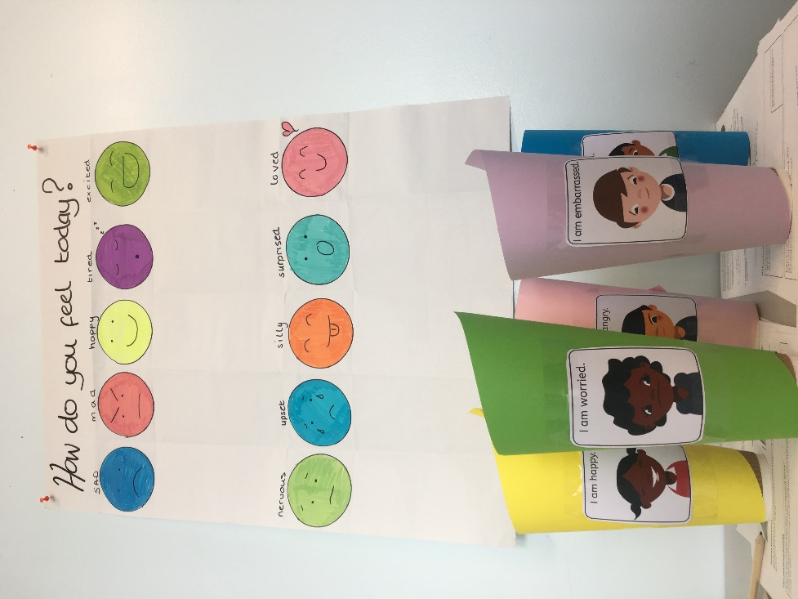 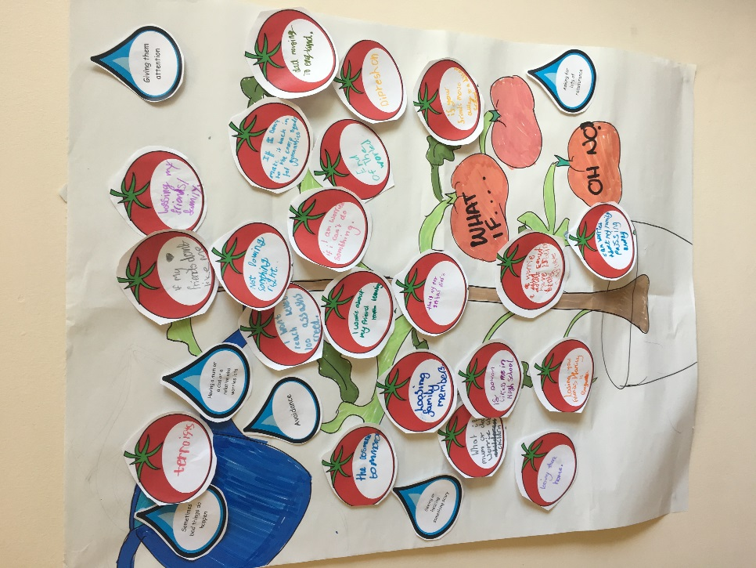

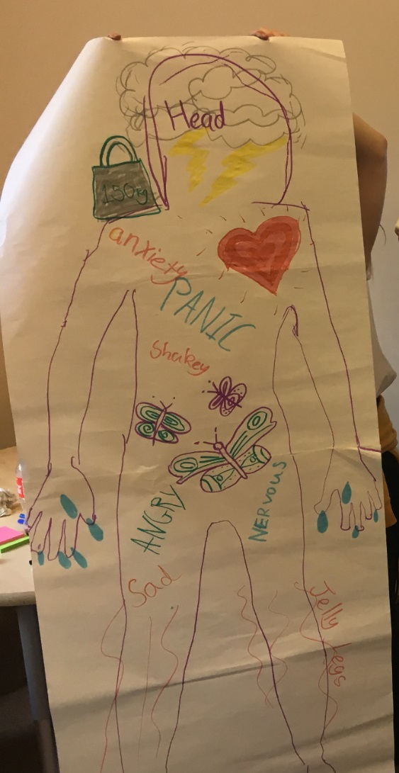 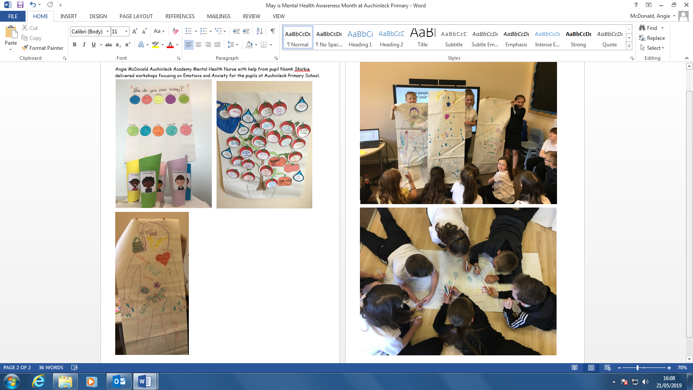

**When the Mental Health Nurse Came into Post**

**Timeline**

**April 2019**

**Summer School:**

Angie and Ashley Robertson home Link worker ran a stress and wellbeing workshop during the summer school timetable.

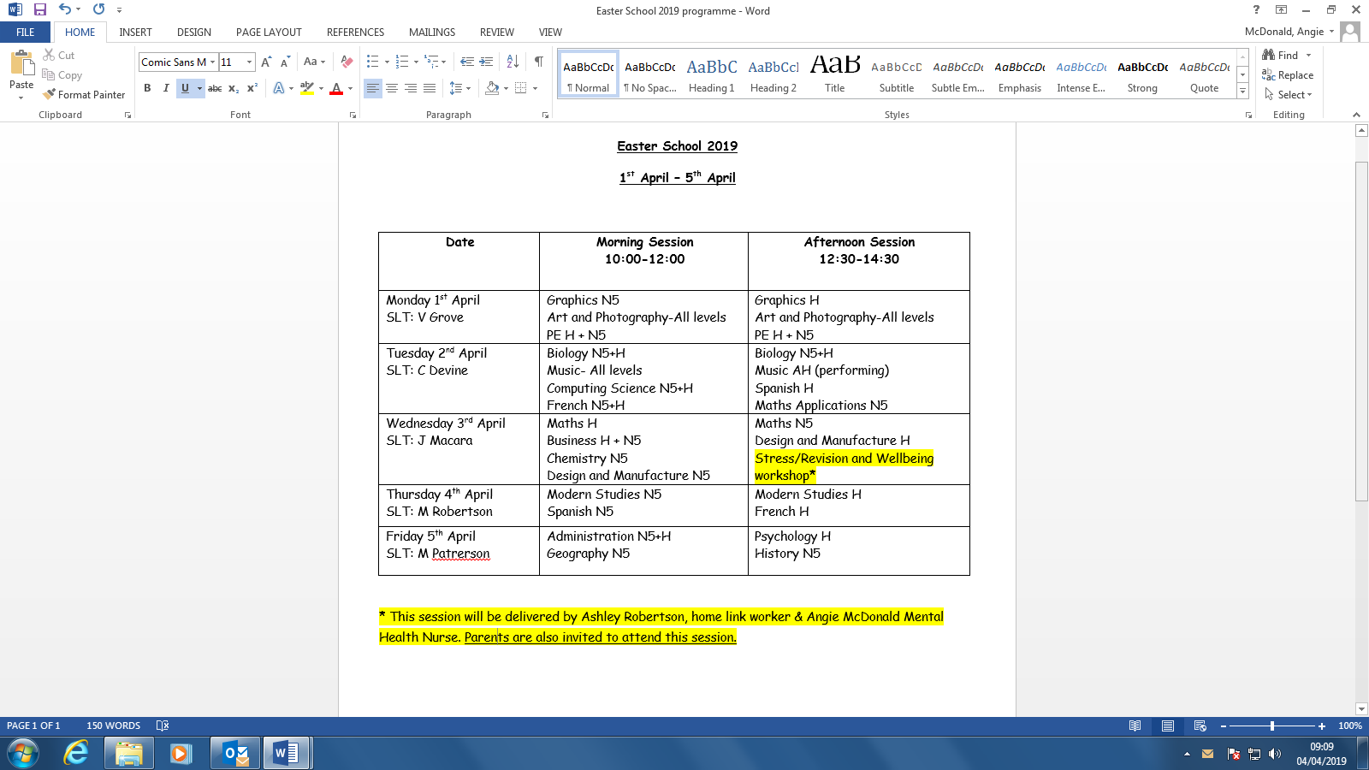

**March 2019**

Angie and CAMHS Team Leader Joyce Nish presented the progress of this new service model of mental health support for Auchinleck Academy Pupils at the British Medical Journal Conference held at Centre Stage Kilmarnock



Finding yourself in a **PANIC** about your exam?

**‘Take a Breath’** is an optional **15 minute** relaxation session/ relaxation space available for pupils to use during exams

**Plans for the Future:**

** **

**Is there anything you would like to see done differently with the mental health nurse service in school?**



**Any additional comments?**



 

**May 2019** 

Angie and CAMHS Team Leader Joyce Nish presented to the local GP practices to support appropriate referrals and to make them aware of Angie’s role within Auchinleck and how to make direct referrals.

Discussions taking place to run an S3 Mental Wellness Day after the success of involvement in L.I.A.M inspired day at Girvan Academy.

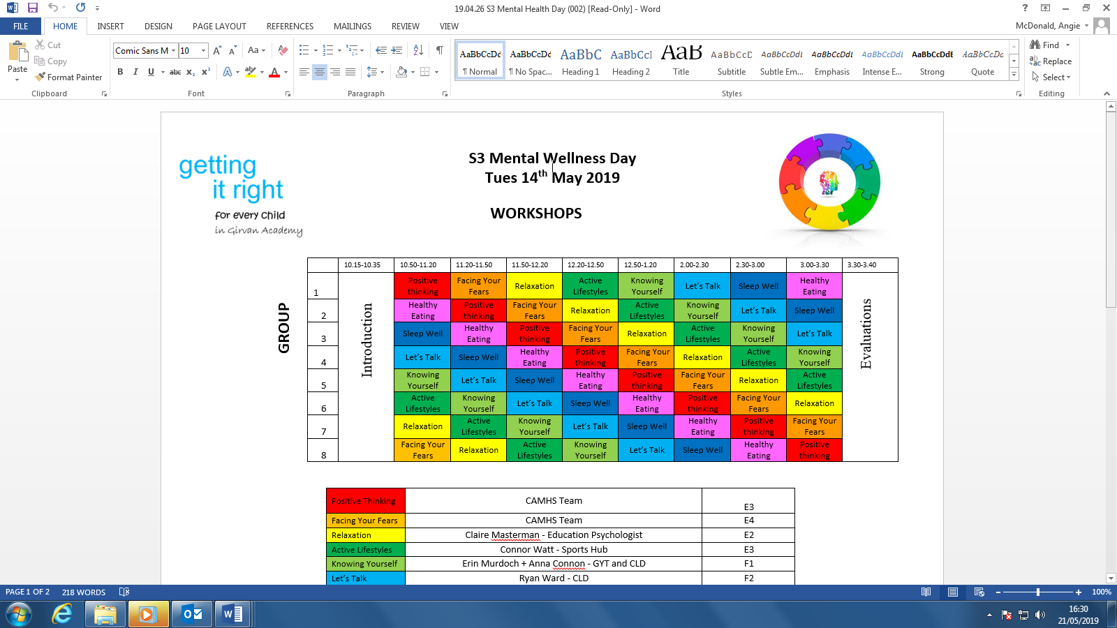

**Feedback:**

**Service Evaluation:** In addition to staff feedbackAngie has sought to get feedback from pupils focusing on their opinions of the mental health service in school.

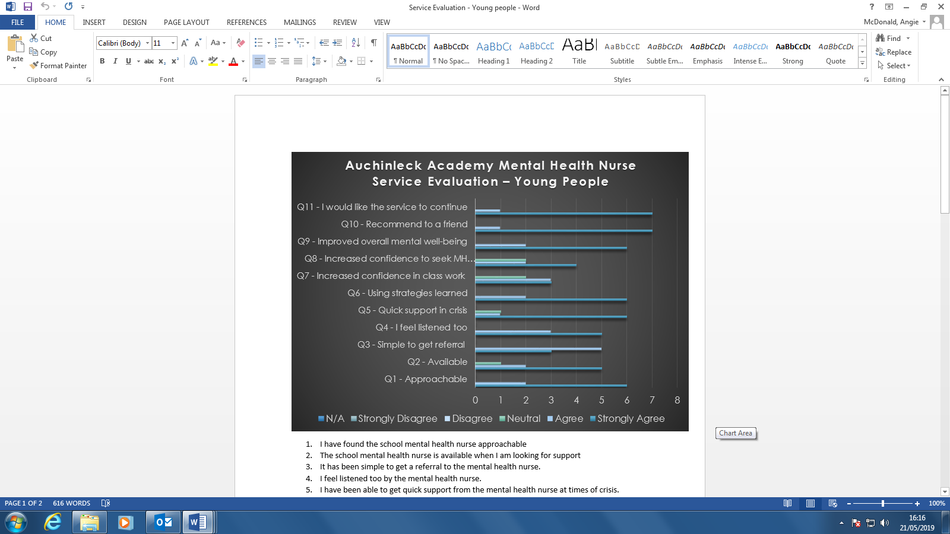

**What would you say have been the benefits of having a mental health nurse based in school?**

 

 



