



 Auchinleck Mental Health Nurse 2018 Newsletter

**February 2019**



* The boys have presented our pledge during school assemblies with the hope of recruiting more volunteers for training in Suicide Alertness, this has been offered to all pupils in S3 – S6.
* We have defined the role of those trained in school as follows; Being **approachable,** having an **alertness to signs** that someone may be struggling**,** having confidence to **ask** the suicide question, offering a **listening ear**, supporting other pupils to **get more help** by alerting school Mental Health nurse if pupils have expressed suicidal thoughts, plans or intent.

**Data Collection: impact on attainment and attendance**

Angie has begun using Linkert scale questionnaires to record levels of confidence, engagement, use of strategies learned in sessions and attendance at school.

**Feedback:**

**Service Evaluation:** 6 months into postAngie has sought feedback on the quality of the service provided in school. Feedback has been collated from subject teachers, school nurse, home link, head teacher, depute head teacher, guidance staff, and supported learning staff.

**When the Mental Health Nurse Came into Post**

**Timeline**

**November 2018**

* **Staff Training Opportunity:** Angie has delivered training on Cognitive Behavioural Therapy based approaches for anxiety and depression to school staff – there was approximately 30 staff in attendance.

**December 2018 – Suicide Alertness Training .** 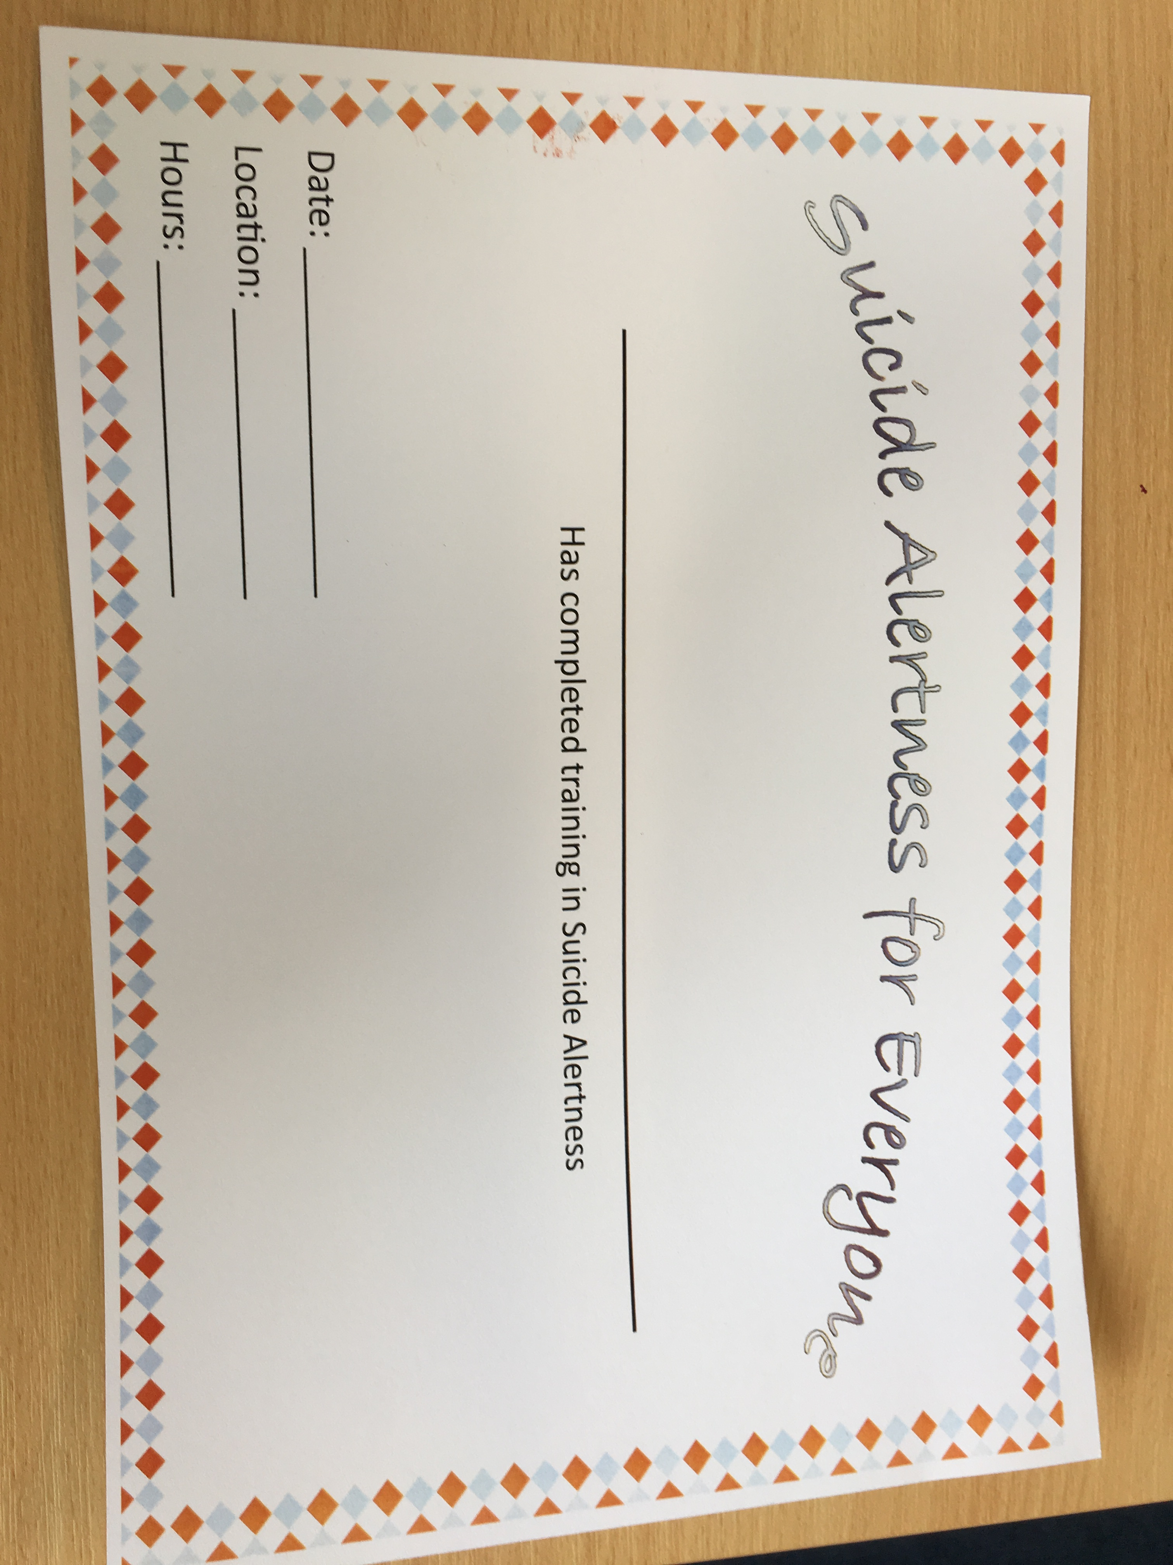

* Taking action on the frightening statistics around suicide and in particular the increased risk of suicide in males, the mental health nurse with support from Faye Forsyth from vibrant communities has introduced training on suicide alertness initially offering this to S5 and S6 boys. The uptake has been successful with 15 of the senior boys having voluntarily completed the training and also having made a commitment to regular meetings to focus on their mental well-being.

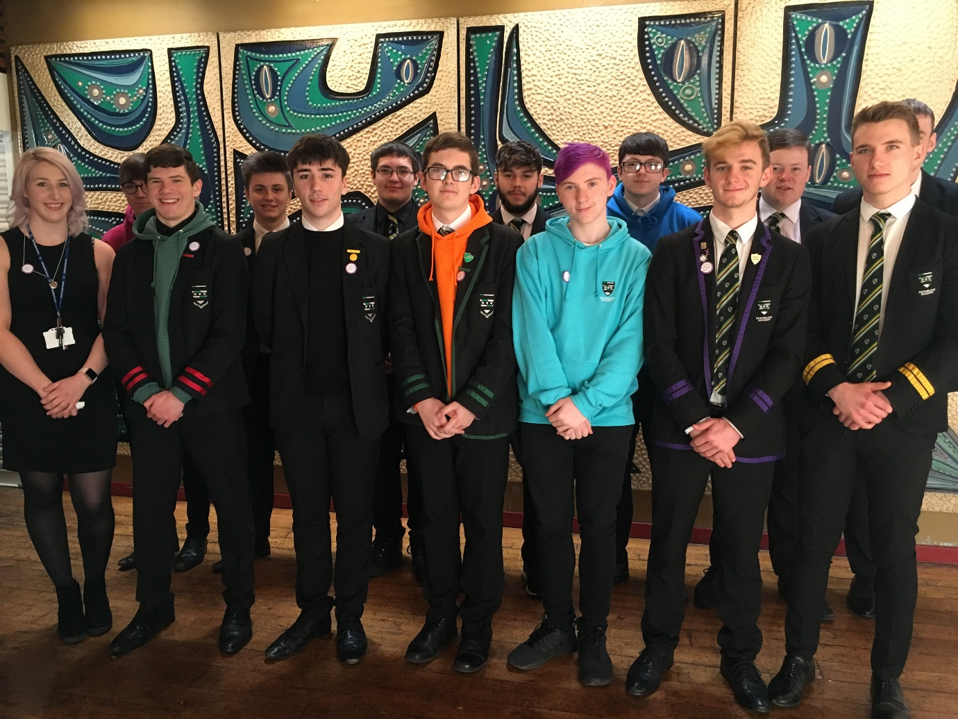

**The senior boys at Auchinleck Academy have been working alongside the school Mental Health Nurse to take action to prevent suicide.**

**January 2018 – The importance of Sleep**

* As requested by the nurture department Angie delivered a presentation to S1 and S3 pupils on the importance of sleep

The boys have now designed a badge to help pupils to recognise those trained within school – we are hopeful that this will break down some of the barriers and stigma around mental health and talking about our feeling

Huge benefit on young people’s mental health by pupils being able to self-refer through guidance or seeing Angie. Staff feel that young people are better supported to reach their full potential by getting mental health support. Young people feel that things are being done in school to support them. Also breaking the stigma around mental health by speaking about it but also having had mental health nurse visit classrooms makes her more visual around the school but also makes young people realise that ‘it’s okay not to be okay’ and that we can support them **within** school.

Also the mental health nurse has trained not only staff but also pupils to help support others – something that could not have happened here without Angie being in the school.

**Plans for the Future:**





* **Auchinleck Primary School** – Mental Health Awareness Month in May; Angie has met with staff at the P/S to timetable delivery of sessions for pupils during this month. Suggested topics were; Emotions, Anxiety and Sleep.
* Angie is currently working on plans to run an **Anxiety Management Group** using L.I.A.M as a structure.

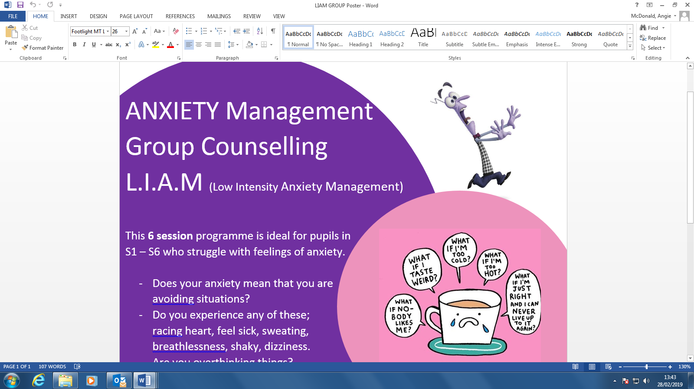

**What would you say have been the benefits of having a mental health nurse based in school? ****Is there anything you would like to see done differently with the mental health nurse service in school?**

  ** Any additional comments?**

