



 Auchinleck Mental Health Nurse 2018 Newsletter

**Data Collection**

* The Data Analyst has assisted Angie in setting up a system to gather the data. 

**Feedback:**

**&**



* The £152 raised from the suicide awareness day has gone towards:
* Mental Health Books for Pupils including:
* 

**When the Mental Health Nurse Came into Post**

**Timeline**

**September 2018**

http://athena/kmeh/eHealth/faceteam/PublishingImages/Capture.PNG

* **Care Partner System** for recording patient information has been made accessible in school for Angie’s recording.

**October 2018**

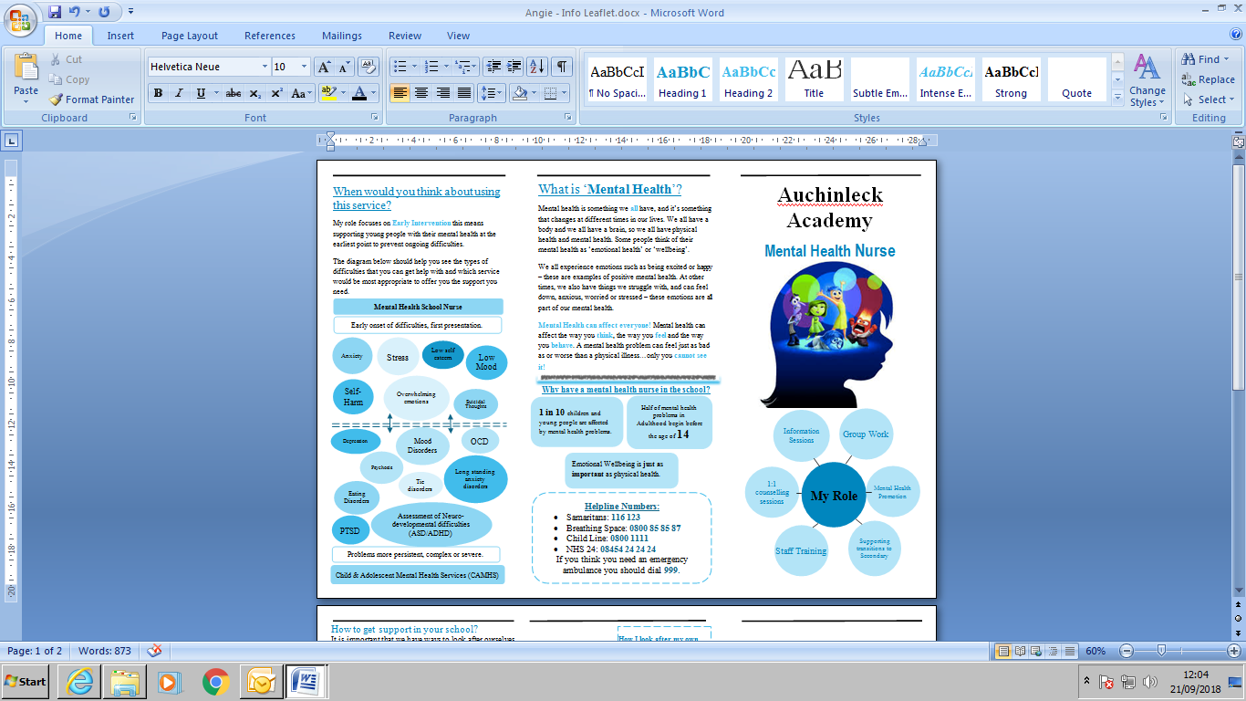

* Angie’s **information leaflet** has been finalised after review from staff, young people and COMS.
* Trained as a trainer for L.I.A.M:

[](https://www.bing.com/images/search?view=detailV2&ccid=YHozQGg9&id=FA99856F035E62F2632029E18CFE06965E294F74&thid=OIP.YHozQGg9TLZbKH_rcUFLlQHaHa&mediaurl=https://yt3.ggpht.com/-_unssSvXi54/AAAAAAAAAAI/AAAAAAAAAAA/w_2dN_MtdsU/s900-c-k-no-mo-rj-c0xffffff/photo.jpg&exph=900&expw=900&q=nhs+education+for+scotland&simid=608008213142897645&selectedIndex=2)

* Angie has now completed her training **in Low Intensity Anxiety Management (LIAM)** training supported by NHS Education for Scotland (NES). This will allow Angie to act as a mentor for Guidance Staff already trained and delivering sessions, Angie will also be able to deliver L.I.A.M to the wider staffing population. There is scope to also run groups in co-ordination with trained staff for pupils and parents.

Information Leaflet:

Lots of helpful information and bright colours

Can I move my appointment because after I had saw you I was able to concentrate in Maths it was so weird? (S2 pupil)

Information Leaflet:

I really like the description of Angie – allows you to get to know who you are confiding in – more comfortable environment.

Information Leaflet:

I liked the little middle page all about her – good to have an image to identify.

**Resources:**

Move the information about mental health closer to the front

**Plans for the Future:**

**What are Young People want form the service**

1. Would you use a drop box for leaving confidential messages?
2. Would you use information sessions if these were run at lunch?

[](https://www.google.co.uk/url?sa=i&rct=j&q=&esrc=s&source=images&cd=&cad=rja&uact=8&ved=2ahUKEwif9Y649svdAhWnxoUKHQ8aCBcQjRx6BAgBEAU&url=https://www.positivitycafe.com/&psig=AOvVaw17juaH02kQXO4iZRq85LGx&ust=1537613373241115)[](https://www.google.co.uk/imgres?imgurl=http://www.carena.org.uk/wp-content/uploads/2018/01/365.jpg&imgrefurl=http://www.carena.org.uk/pop-positivity-cafe/&docid=3At_sx8T46NeCM&tbnid=Qnvw6OHqs2vhEM:&vet=10ahUKEwj16LOo9svdAhULzaQKHRb3BP4QMwg4KAgwCA..i&w=403&h=229&safe=strict&bih=676&biw=1366&q=Positivity%20Cafe&ved=0ahUKEwj16LOo9svdAhULzaQKHRb3BP4QMwg4KAgwCA&iact=mrc&uact=8)

Angie is working with the Art Team to hold 1 lunch time a fortnight a Positivity Cafe for the 5th and 6th Years. Looking at building resilience.

[](https://www.google.co.uk/imgres?imgurl=https://i.pinimg.com/236x/0f/6f/00/0f6f0053d0f6a71c3cf55260c271c88a--mustache-pictures-smiley-faces.jpg&imgrefurl=https://www.pinterest.com/flipperfeet27/awesome-smiley-faces/&docid=iGH_wNg0bnHA5M&tbnid=ozchXyIgEsmzgM:&vet=10ahUKEwjfhIGR98vdAhVO6KQKHYYVC_QQMwg8KAAwAA..i&w=236&h=236&safe=strict&bih=676&biw=1366&q=cartoon%20moustache%20pics&ved=0ahUKEwjfhIGR98vdAhVO6KQKHYYVC_QQMwg8KAAwAA&iact=mrc&uact=8)

Plans are underway to look at a specific boys mental health group at Auchinleck: Angie is in contact with Faye Forsyth Vibrant Communities to roll out an amended version of ‘Safe Talk’ as a starting point to a boy’s mental health group.

**What are Young People want form the service:**

1. Would you feel comfortable to seek a first appointment if needed through your guidance teacher?
2. When would you be most comfortable to attend appointments?
3. Would you make use of a drop in clinic?
4. Would you like to see mental wellbeing groups run within the school?
5. If yes what topics would you suggest?