



 Auchinleck Mental Health Nurse 2018 Newsletter

**Progressing the work using Improvement Methodology**

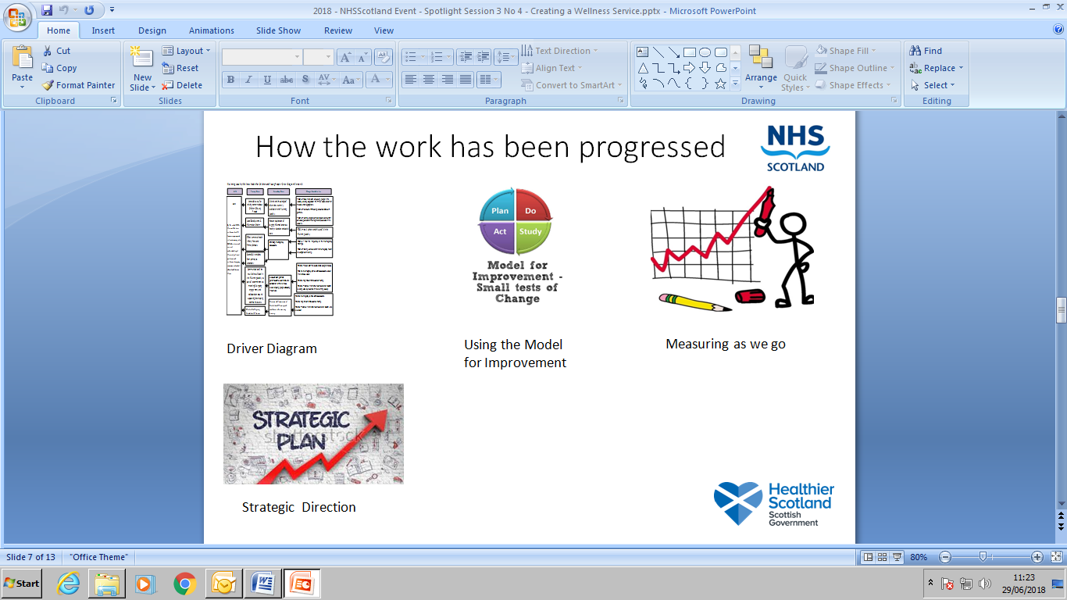

The work will be progressed using Quality Improvement Methodology and small tests of change using PDSA’s. The Data Analyst will be assisting Angie in setting up a system to gather the data.

* Angie is using RCADS (Revised Children’s Anxiety & Depression Scale) to determine how young people are feeling at the start and will compare this to when they have attended for a few sessions.

**Agreed Outcomes**

* School hope to see raised attainment
* School hope to see raised attendance

CAMHS want to ensure that young people see the most appropriate person in the right place at the right time. This will result in a reduction of referrals to CAMHS.

**When the Mental Health Nurse Came into Post**

**Timeline**

**August 2018**

* Angie McDonald came into post in August as the Auchinleck Mental Health Nurse funded jointly by the School using Pupil Equity Funding and by CAMHS in East Ayrshire.
* Angie has been allocated a great room which is near the school office.
* Her role focuses on **Early Intervention** this means supporting young people with their mental health at the earliest point to prevent ongoing difficulties. Angie has developed an information leaflet about her role.

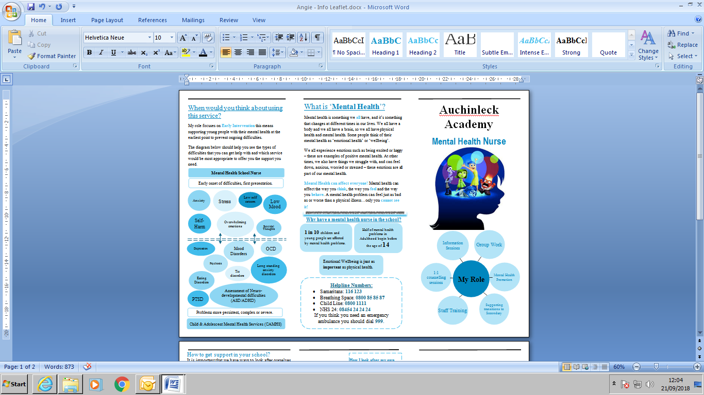

* Angie’s role defined below:-



* Meetings have already taken place with CAMHS, the School, Improvement Advisor, Data Analyst to capture the ongoing learning and evaluation of this type of role in a school.

It has helped in a discussion with a Mum and young person who had been to the GP about getting a CAMHS referral. Angie met with the young person and there no therapeutic requirements or a need to refer to CAMHS.

Self-Harm

Anxiety

Low Mood

**Plans for the future**

[](https://www.google.co.uk/url?sa=i&rct=j&q=&esrc=s&source=images&cd=&cad=rja&uact=8&ved=2ahUKEwif9Y649svdAhWnxoUKHQ8aCBcQjRx6BAgBEAU&url=https://www.positivitycafe.com/&psig=AOvVaw17juaH02kQXO4iZRq85LGx&ust=1537613373241115)[](https://www.google.co.uk/imgres?imgurl=http://www.carena.org.uk/wp-content/uploads/2018/01/365.jpg&imgrefurl=http://www.carena.org.uk/pop-positivity-cafe/&docid=3At_sx8T46NeCM&tbnid=Qnvw6OHqs2vhEM:&vet=10ahUKEwj16LOo9svdAhULzaQKHRb3BP4QMwg4KAgwCA..i&w=403&h=229&safe=strict&bih=676&biw=1366&q=Positivity%20Cafe&ved=0ahUKEwj16LOo9svdAhULzaQKHRb3BP4QMwg4KAgwCA&iact=mrc&uact=8)

Angie is working with the Art Team to hold 1 lunch time a fortnight a Positivity Cafe for the 5th and 6th Years. Looking at building resilience.

[](https://www.google.co.uk/imgres?imgurl=https://i.pinimg.com/236x/0f/6f/00/0f6f0053d0f6a71c3cf55260c271c88a--mustache-pictures-smiley-faces.jpg&imgrefurl=https://www.pinterest.com/flipperfeet27/awesome-smiley-faces/&docid=iGH_wNg0bnHA5M&tbnid=ozchXyIgEsmzgM:&vet=10ahUKEwjfhIGR98vdAhVO6KQKHYYVC_QQMwg8KAAwAA..i&w=236&h=236&safe=strict&bih=676&biw=1366&q=cartoon%20moustache%20pics&ved=0ahUKEwjfhIGR98vdAhVO6KQKHYYVC_QQMwg8KAAwAA&iact=mrc&uact=8)

Plans are underway to look at a specific boys mental health group at Auchinleck.

Watch out for further updates on Twitter and the Cumnock Chronicle the week beginning the 24th Sept 2018!

For further information please contact:-

Angie McDonald, Auchinleck Academy

Or

Joyce Nish, East CAMHS Team Leader

[Joyce.Nish2@aapct.scot.nhs.uk](mailto:Joyce.Nish2@aapct.scot.nhs.uk)

**What are Young People are presenting with so far...**



In the corridor near Angie’s room young people’s views are captured. They had to post a ‘Message of Hope’ of what they would say to someone thinking suicide was the only option.

