HOW DO I REVISE EFFECTIVELY?

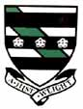

Study Hints

1. Attend supported study
2. Schedule regular study time
3. Be realistic with what you hope to achieve in each study session
4. Establish a regular study area at home e.g. desk, quiet area
5. Study short and often
6. Start study sessions on time
7. Study when you are wide awake (early mornings always best)
8. Set a specific goal for each subject you study – “by the end of this study session, I hope to have learnt……………………in Music.”
9. Study your most difficult subjects first.
10. Make summary notes on what you have learnt LOOK SAY COVER WRITE CHECK
11. Use diagrams and mind maps to help with learning
12. Highlight key words using highlighter pens
13. Take regular breaks
14. Vary your work e.g. make notes, draw diagrams, read, problem solve..….
15. Reward yourself!
16. Balance your time carefully between home, school and social outings
17. Produce revision timetable organised in advance and displayed for everyone to see

“You are doing your best only when you are trying to improve what you are doing”

Mnemonics

Mnemonics are one way of remembering a list. A mnemonic makes a
word or a phrase from a set of letters based on the list. All you
have to do is remember that first word or phrase and rest should
come flooding back. A mnemonic for improving your listening skills:

L= Look ahead
I = ideas
S=Signs & Symbols
T= Take part
E= Explore
N=Notes

Another very common mnemonic is the one to help you remember the colours of the rainbow. Richard of York gained battles in vain

What are the colours of the rainbow? …………………………………………….
Your turn: Make up three Mnemonics which could help you understand a particular aspect of a subject.

Spider Diagrams

• These can be used to record a lot of information in a small amount of space
• Generate new ideas and organise them at the same time

How to create a spider diagram:

􀁡 start with a large piece of paper or a sheet of A4
􀁡 use a selection of words and diagrams
􀁡 use colour, shapes, symbols, pictures and cuttings to bring the information to life
􀁡 use lines and arrows to connect ideas
􀁡 stick your learning map on your wall/door - anywhere it can be seen easily and often

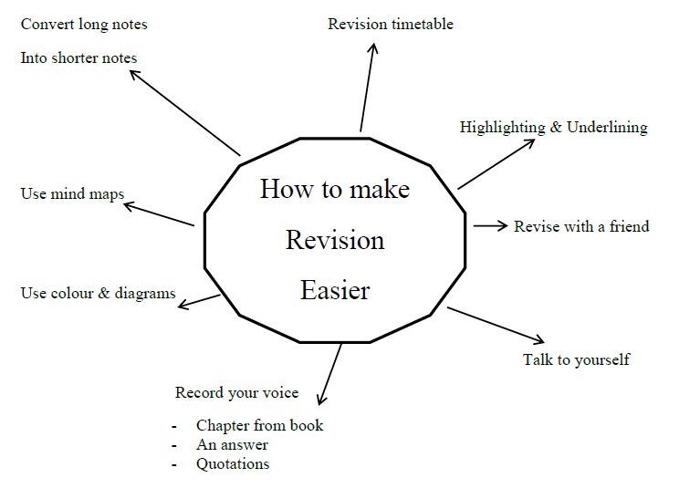

Mind Maps

Mind maps work a lot like spider diagrams however they make much more use of colour and images rather than words. In fact, some pupils prefer to use only images in their mind maps as this is their preferred learning style.

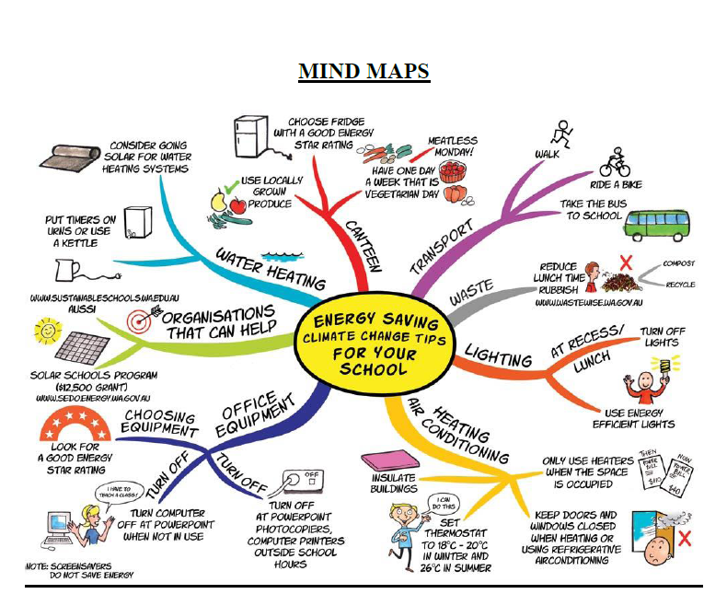
Brainstorm

Read the text you are revising carefully.

Now cover it up and brainstorm - write down all the bits of information you can remember as fast as you can in any order.

Look at your text again; add any bits you missed to your brainstorm, and alter any bits you got wrong.
The brainstorm is good for remembering information, but not for putting it in a correct order. So now use the words to create a key word plan, clock sequence or any other method to help you organise your ideas.

Review it

Reviewing means, “looking through again”. You go back to your key points and check them through once more. Better still : test yourself first, then check them through. A good time to review is straight after you have taken a break. Another good time is just before you go to sleep and again as soon as you wake up.
Reviews help you to recall (remember) what has been studied. If you don’t go back and review, you will forget most of what you thought you had learned. Reviewing shifts your learning from your short-term to your long-term memory.

Record it

Some people find it useful to record key points on cassette tape. They play the recording back while they sit or lie down with their eyes closed. Some prefer to let the recording “wash over them” while they are dozing or even sleeping.
People with a strong musical intelligence sometimes record a piece of music which they play while they are learning key points. They associate the information with the music and can often be heard humming quietly in exams!

Hide and Seek it
This is how to play key word hide and seek:
􀁮 Make a Key Word Plan (KWP)of the information you want to memorise
􀁯 Study the KWP for one or two minutes
􀁰 Put the KWP away. On a fresh piece of paper, write the KWP out from memory
􀁱 Now compare this with your original KWP. Did you miss anything out ? Check
􀁲 Put the first two KWP’s away. Take another piece of paper and write the KWP out again from memory.
􀁳 Compare this third version with the first two
􀁴 Repeat the process until the KWP you write from memory is the same as the original

Flash card it

- This method is really good for scientific formulae, technical terms or foreign words.
- Write out the items you want to remember on separate pieces of card. You can put them directly onto the object they are naming (foreign words for example) or on the wall of the bedroom where they will be seen before going to sleep and first thing in the morning.
- OR write out the item you want to remember on one side, and its meaning on the other.
- Any spare moment can be used (on a train or bus for example) to review the flash cards.
- Some people find that holding the flash cards above eye level helps them to memorise more easily.

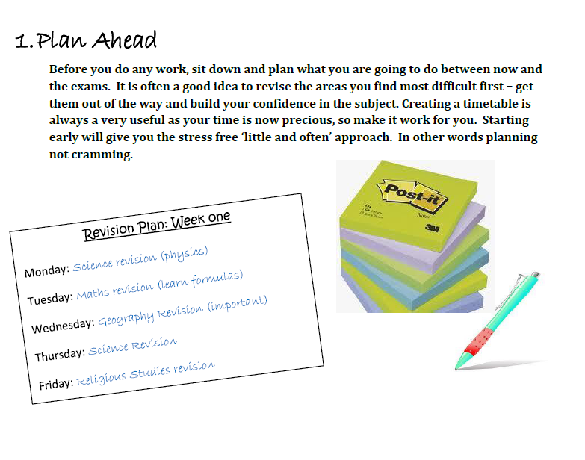
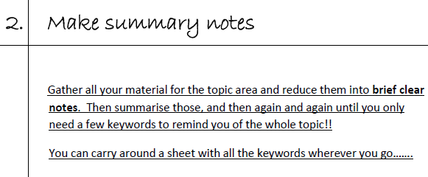

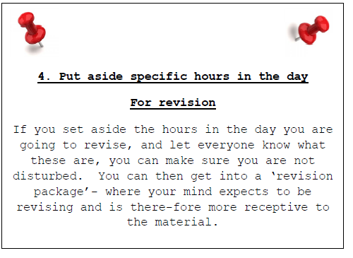
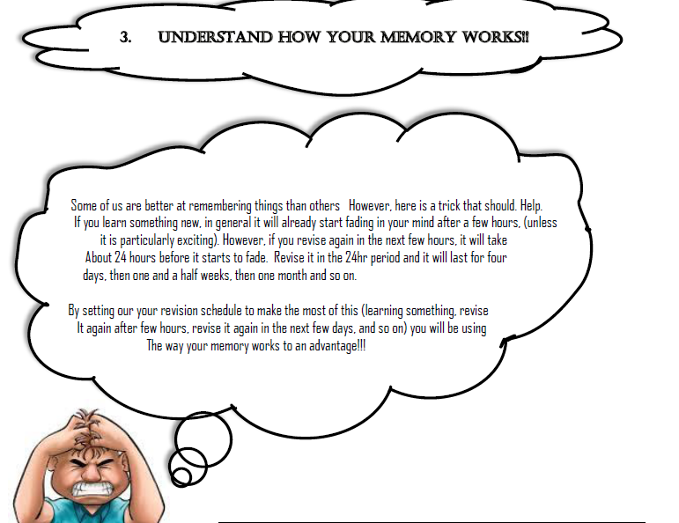

5: Eat Well! Your body is your best friend during this stressful time. Avoid junk food and drinks – tips can be found on http://www.bbcgoodfood.com/howto/guide/eating-exams to help prepare your body.
Learning Styles

Everybody has a preferred learning style. Knowing and understanding our learning style helps us to learn more effectively. Through identifying your learning style, you will be able to capitalize on your strengths and improve your self-advocacy skills.

Directions:
Place a tick in front of all statements that describe you. The list with the greatest number of checks is your dominant learning style.

List 1
1. ____reaches out to touch things
2. ____collects things
3. ____talk fast using hands to communicate what you want to say
4. ____constantly fidgeting (e.g tapping pen, playing with keys in pocket)
5. ____good at sports
6. ____takes things apart
7. ____prefers to stand while working
8. ____likes to have music in the background
9. ____enjoys working with hands and making things
10. ____likes to chew gum or eat in class
11. ____learning through movement and exploring the environment around you
12. ____may be considered hyperactive
13. ____good at finding your way around
14. ____comfortable touching others as a show of friendship (e.g. hugging)
15. ____prefers to do things rather than watching a demonstration or reading about it in a book

List 2
1. ____asks for verbal instructions to be repeated
2. ____watches speakers’ facial expression and body language
3. ____likes to take notes to review later
4. ____remembers best by writing down several times or drawing pictures and diagrams
5. ____good speller
6. ____turns the radio or TV up really loud
7. ____gets lost with verbal directions
A river cuts through a rock not because of its power but because of its persistence

8. ____prefers information to be presented visually, (e.g flipcharts or chalk board)
9. ____skilful at making graphs, charts, and other visual displays
10. ____can understand. and follow directions on maps
11. ____believes that the best way to remember something is to picture it in your head
12. ____follows written instructions better than oral ones
13. ____good at solving jigsaw puzzles
14. ____gets the words to a sing song
15. ____good at the visual arts (art work, such as painting, photography, or sculpture, that appeals primarily to the visual sense and typically exists in permanent form)

List 3
1. ____Follows oral directions better than written ones
2. ____would rather listen to a lecture than read the material in a textbook
3. ____understands better when reads aloud
4. ____struggles to keep notebooks neat
5. ____prefers to listen to the radio rather than read a newspaper
6. ____frequently sing, hum or whistle to yourself
7. ____dislikes reading from a computer screen especially when the background are fuzzy
8. ____when presented with two similar sounds, can tell if sounds are the same or different
9. ____requires explanations of diagrams, graphs, or maps
10. ____enjoys talking to others
11. ____talks to self
12. ____uses musical jingles to learn things
13. ____would rather listen to music than view a piece of art work
14. ____uses finger as a pointer when reading
15. ____likes to tell jokes, stories and makes verbal analogies to demonstrate a point

Total statements checking each category:

List 1 – Tactile/Kinesthetic learning style ____________
List 2 – Visual learning style _____________
List 3 – Auditory learning style _____________

Designed by Tammy Friemund, Study Skills Instructors (UM-College of technology 0 05/03/2010
Characteristics of a Tactile/Kinesthetic Learner:

• The “Do-er”
• Needs to touch, handle, manipulate materials and objects, especially while studying or listening
• Counts on fingers and talks with hands
• Good at drawing designs
• Often doodles while listening, thus processing information
• Good at sports, mechanics, using appliances and tools
• Often adventurous
• May find it hard to sit still for long periods
• May become distracted by their need for activity and exploration

Make your Learning Style work for you!

Tactile/Kinesthetic learner:
• Take frequent study breaks and vary your activities
• Make studying more physical-work at a standing desk, chew gum, pace while memorizing. Read while on an exercise bike, mould a piece of clay, squeeze a
tennis ball
• Use bright colours to highlight reading material
• Dress up your work space with posters and colour
• Play music in the background while you study
• When reading, first skim through the whole thing to get a feel for what it’s about, then read the chapter carefully
• Use spatial note taking techniques such as mind mapping
• Visualise complex projects from start to finish before beginning-this will allow you to keep the big picture in mind
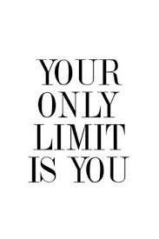

Characteristics of a Visual Learner

• Reader/Observer
• Scans everything; wants to see things, enjoys visual stimulation
• Enjoys maps, pictures, diagrams, and colour
• Needs to see the teacher’s body language/facial expression to fully understand
• Not pleased with lectures
• Daydreams; a word, sound or smell causes recall and mental wandering
• Usually takes detailed notes
• May think in pictures and learn from visual displays

Make your Learning Style work for you!

Visual Learners:
• Have a clear view of your teachers when they are speaking to you can see their body language and facial expression
• Use colour to highlight important points in text
• Illustrate your idea as a picture and use mind maps
• Use multi-media such as computer or videos.
• Study in a quiet place away from verbal disturbances
• Visualize information as a picture to aid learning
• Make charts, graphs and tables in your notes
• Participate activity in class-this will keep you involved and
alert
• When memorizing material, write it over and over
• Keep pencil and paper handy so you can write down good ideas

Characteristics of an Auditory Learner:

• Interpret the underlying meanings of speech through listening to tone of voice, pitch, speed and other nuances
• Prefers direction given orally
• Seldom takes notes or writes things down
• Prefers lectures to reading assignments
• Often repeats what has just been said talks to self

Make your Learning Style work for you!

Auditory Learners:
• Think aloud and talk to yourself
• Participate in class discussions/debates
• Make speeches and presentations
• Read text out loud-especially when proofreading or when tired
• Create musical jingles and mnemonics to aid memorization
• Use a tape recorder
• Discuss your ideas verbally with a friend or small group
• Use verbal analogies
• When doing math computations by hand, use graph paper to help your columns aligned
• Recite information over and over to better memorise material
• You may want to sit near the side or back of the classroom where there is less visual stimulation

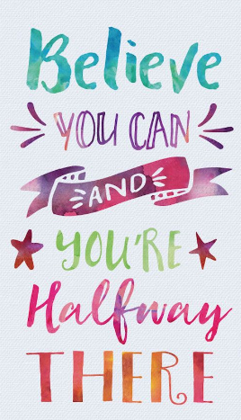

Create a revision timetable

List all your exam subjects and the amount of time you think you will need for each one. It is unlikely that the amounts will be equal. Many people find it advisable to allocate more time to the subject or topics they find the most difficult.

• Draw up a revision plan for each week. Don’t forget to work in some leisure / relaxation time too!
• Fill in any regular commitments you have first, such as sport’s activities or clubs you are involved in, and then the dates of your examinations
• Use revision checklists for each subject as a starting point. Look at what you need to know and try to identify any gaps in your knowledge. (A good way of doing this is to look at the results of past papers or tests you have worked through)
• Divide your time for each subject into topics based on the units in the revision checklist and make sure you allow enough time for each one.
• Plan your time carefully, assigning more time to subjects and topics you find difficult
• Revise often; try and do a little every day
• Plan time off including time for activities which can be done out in the fresh air. Take a 5 or 10 minute break every hour and do some stretching exercises, go for a short walk or make a drink
• You may find it helpful to change from one subject to another at ‘break ’time, for example doing one or two sessions of maths and then changing to Geography, or alternating a favourite subject with a more difficult one. It helps to build in some variety.
• Write up your plan and display it somewhere visible (maybe on your bedroom wall or above your desk wherever that may be)
• Adjust your timetable if necessary and try to focus on your weakest topics and subjects
• Don’t panic; think about what you can achieve, not what you can’t. Positive thinking is important!

SLEEP IS VITAL SO MAKE SURE YOU GET AT LEAST 8 HOURS SLEEP A NIGHT

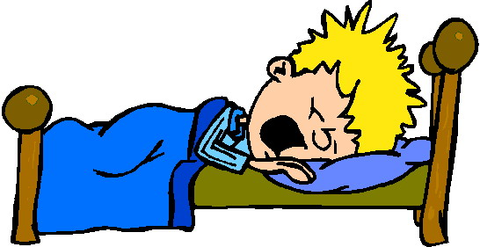

Examples of timetables
