P 4

2023/2024 Term 1 Overview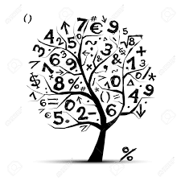

Language and Literacy across Learning

Spelling: Active Literacy Stage 4 –Representations of phonemes (most learners), individual learners may be revising previous stages and phonemes.

Reading: Non-fiction features and reading strategies using topic and Bug Club books.

Reading for enjoyment (Class and school library).

Writing: Revise basic sentence composition, descriptive writing, instructional writing.

Grammar: Revision of identifying and using nouns, proper nouns, adjectives and verbs.

Mathematics and Numeracy across Learning

Place Value:

* partitioning and expanding numbers
* identifying the value of digits in numbers
* ordering numbers
* identifying missing numbers / investigating sequences and patterns
* rounding numbers
* adding on 1, 10, 100 and 1,000
* addition and subtraction (using mental and written strategies).

Maths: 2D shapes, 3D shapes, tessellation, tiling and symmetry, money (coin recognition, totals, finding change, budgets)

Trips/Events

* Meet the Teacher Day
* Litter Pick
* Roald Dahl Day
* World Porridge Day
* Hallowe’en Activities
* Maths Week 2023
* MacMillan Coffee Morning
* Anti- Bullying Week
* Children in Need
* Road Safety Week
* Christmas Jumper Day

Health and Wellbeing

* Mental Health and Mindfulness
* Rights Respecting Schools
* Respect for our resources
* Eco Committee
* P.E: Skipping, possession games, social dancing
* Anti-bullying
* Road safety
* Bonfire and fireworks safety
* PATHS Programme

Interdisciplinary Learning

* Ancient Egyptians
* RME – Religious buildings, Christmas
* French – Greetings, numbers, days of the week and colours