Primary 6 Homework Overview 11/03/24

Spelling
Spelling: ‘k’
Copy your spelling words three times in your jotter, then diacritically mark (record the number of sounds, not letter, in each word).
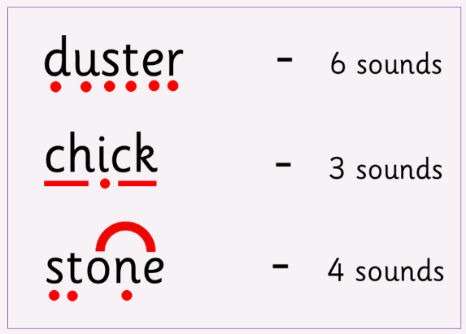

Otto | Busty | Ava
next  text  snacks  books  winks  bakes  quacks  snakes | explain  shrinks  hijacks  mistakes  tuxedo  fireworks  dockside  stinks | extraordinary  corkscrew  dreadlocks  disembarks  annexe  lumberjacks  bookseller  backstage

Numeracy and Mathematics
Multiplication Snakes: Choose your times table and level of challenge!

https://www.mathplayground.com/multiplication_snake.html
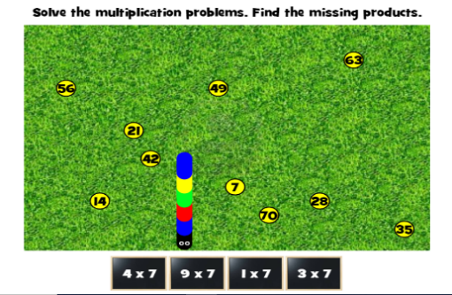


Converting Length: ‘mm to cm’
https://kids.classroomsecrets.co.uk/resource/year-3-equivalent-lengths-mm-and-cm-game/
