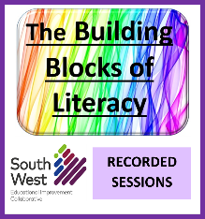
Building Blocks of Literacy:
recorded webinar sessions on Early Level Literacy*

East and North Ayrshire literacy teams have delivered the Building Blocks of Literacy professional learning to over 400 SWEIC staff over the last 3 years. This professional learning focuses on key areas of language development and literacy for our early level learners in primary classes.
Sessions on each of these topics:
- Language & Communication
  - Attention & Listening
  - Phonological Awareness
- Phonics
- Spelling & Handwriting
- The Balanced Reader
- The Balanced Writer
First/ Launch session
• Phonological Awareness screener
• The Primary One year
• Curriculum calendar
• Pace & challenge
• Classroom organisation

Who is this for?
This series of webinars is suitable for anyone new to teaching Early level, anyone with a remit of supporting children at Early level literacy learning, or any manager who oversees the Early level in primary school.

We are delighted to be able to leave all the presentations available on a new MS TEAM: Building Blocks of Literacy: Recorded Presentations. (join code: mpf903h). The accompanying resources can be found in the FILE tab.

A final few words from previous participants:

“All elements were relevant for my role as Primary 1 teacher.”
Dumfries & Galloway participant (March 22)

“I find the research and background information really useful and interesting. I have found the practical teaching ideas really helpful - it's always good to get new ideas to try in class.”
South Ayrshire participant (Jan.2022)

* as the programme focuses on the part of Early level which is taught in primary classes, not all material would be relevant for practitioners working in ECCs.

