**SWEIC Plan 2022/23:  
A Refreshed Vision for Consultation**

Since spring of 2020, children, and young people across the South West, as with the rest of Scotland, have faced a period of significant change and at times disruption in their learning as a consequence of the COVID 19 pandemic. Across our learning communities, staff have ably led flexible and creative responses to providing continued support for children and young people in their learning and wellbeing. There is an opportunity now to build on the innovation and positive outcomes which emerged at this time despite the challenges and ensure that every learner has the opportunity to build the resilience, skill and mindset that empowers them to become successful learners, responsible citizens, confident individuals, and effective contributors.

As a Regional Improvement Collaborative in considering the challenges that lie ahead, we are well placed across the South West to work together to support our agenda of ‘***coming back together stronger***’.

The [National Improvement framework 2022](https://www.gov.scot/publications/achieving-excellence-equity-2022-national-improvement-framework-improvement-plan/) sets out an ambitious plan which working alongside partners the ambition to develop an empowered and collaborative system, where young people have an equal voice, and everyone’s contribution is heard and valued and improving children and young people’s outcomes is at the heart of everything that is done. The second phase of the Scottish Attainment Challenge also sets out the expectation for us to accelerate progress, without overburdening the system.

**Key priorities of the National Improvement Framework 2022**

* Placing the human rights and needs of every child and young person at the centre of education
* Improvement in children and young people’s health and wellbeing
* Closing the attainment gap between the most and least disadvantaged children and young people
* Improvement in skills and sustained, positive school-leaver destinations for all young people
* Improvement in attainment, particularly in literacy and numeracy.

**The drivers of improvement in the outcomes achieved by children and young people through education are:**

* School and ELC leadership
* Teacher and practitioner professionalism
* Parent/carer involvement and engagement
* Curriculum and assessment
* School and ELC improvement
* Performance information

The four local authorities who come together as the South West Educational Improvement Collaborative had already broadly similar priorities within their Education Plans for 2022, as Councils aligned their priorities against key national agreements such as The Promise, the Morgan Report, and the Education Scotland Corporate Plan.

In considering how our SWEIC plan best supports this work, our aim would be to further develop our culture of collaboration through prioritising the NIF priorities and drivers alongside our focus on inclusion to improve the educational and life chances of the 75000 children and young people who live and learn in East Ayrshire, North Ayrshire, South Ayrshire and Dumfries and Galloway.

This will enable us to place front and centre in our plan the principles of Getting It Right for Every Child (GIRFEC), placing our children and young people and their interests at the heart of all that we do. This approach will be underpinned by children’s rights and its principles and reflect the United Nations Convention on the Rights of the Child (UNCRC) which will be embedded in all our workstream activity. Common threads for our planned inclusive approach can be identified through the strands of leadership, curriculum 3-18, ‘getting it right for all our learners’ - with a particular focus on wellbeing, recovery and equity and equality for all.

Common threads for our planned inclusive approach can be identified through the strands of:

* NIF priorities and drivers
* Curriculum 3-18
* ‘Getting it right for all our learners’ with a particular focus on wellbeing
* Recover
* Equity and Equality for all
* Leadership
* **Diagram

  Description automatically generated**Refreshed Scottish Attainment Challenge

**Revised SWEIC Priorities and Drivers 2022-23**

|  |  |
| --- | --- |
| **Priority Focus** | **Priority** |
| **Inclusion and Equalities** | Embrace diversity and equality by embedding inclusion as a priority for learning and teaching to remove systemic barriers to learning. |
| **Recovery** | Build on the innovation and strengths that have emerged over the past 2 years to support our children and young people move from pandemic to post pandemic. through a refocused approach with an emphasis on wellbeing and inclusion through Getting It Right For all Learners. |
| **Leadership** | Support empowerment and collaboration to enable leaders at all levels provide effective leadership at a time of significant change, prioritise appropriate learning experiences aligned closely with the needs of learners, targeting of resources, the school and its community’s context. |
| **3-18** | Support the development of pathways which best meet the needs of our children and young people through the delivery of a progressive, inclusive curriculum, developing skills and knowledge required to cope and adapt to life in the 21stcentury, regardless of the challenges and enabling them to thrive in a future which is increasingly unpredictable. |

**SWEIC Plan Drivers**

|  |  |  |  |  |
| --- | --- | --- | --- | --- |
| IMPROVEMENT | COLLABORATION | EMPOWERMENT | INNOVATION | BUILDING CAPACITY |

Having agreed these revised priorities and drivers, the Strategic Leads from across the SWEIC have asked that the workstreams remits for 2022- 23 are refocused to support delivery of these priorities by adding value and collaborative opportunity to enhance local authority activity. Each workstream will be supported by a number of additional subgroups which will report directly into the work stream.

In order to achieve our priorities and our vision of ‘**improving outcomes for learners by offering and facilitating peer to peer, school to school and authority to authority professional learning that is built upon collaboration without borders**’ each workstream will develop their plans to:

All workstreams aim to:

Support high quality learning, teaching and assessment 3 – 18

Support the rights of the child, inclusion, equity and wellbeing

Provide opportunity for connection and engagement to build capacity

Support development of leadership capacity

**SWEIC Workstreams … moving forward**

|  |  |  |
| --- | --- | --- |
| **Curriculum Innovation**  (previously e-Implementation) | **Equity and Equality for All**  (previously Closing the Gap) | **Getting it Right for All Learners**  (previously Planning for Learning, Teaching and Assessment) |
| Across all workstream activity there will be a 3 – 18 focus on Recovery, UNCRC, Inclusion, The Promise and Leadership. | | |
| Possible other areas for ‘added value’ activity from local authority plans include: | | |
| * e-Learning including @South-West Connects * Digital skills and pedagogy * Widening access * Routes to success * DYW | * Getting it Right for Every Child * Scottish Attainment Challenge * Wider achievement * Contexts for learning, e.g., Outdoor learning * Family learning | * Inclusive practice in the classroom * Pedagogy inc. Play Pedagogy * Transitions * Literacy, Numeracy and Wellbeing * Assessment and Moderation |
| Curriculum Refresh  Curricular Networks  Families of Schools and ELCs | | |

|  |  |  |  |  |
| --- | --- | --- | --- | --- |
| IMPROVEMENT | COLLABORATION | EMPOWERMENT | INNOVATION | BUILDING CAPACITY |

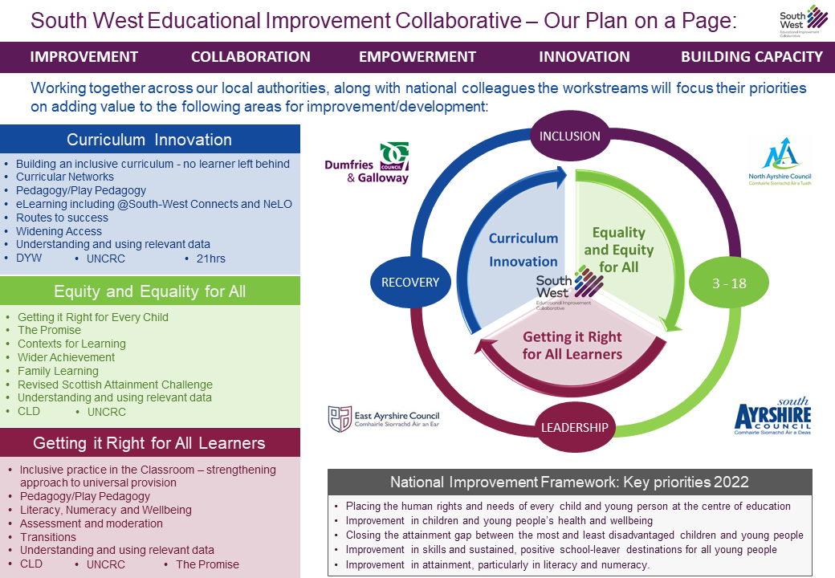

**Consultation on the SWEIC Plan**

We want to hear from staff from across the four local authorities, working in all areas of Education, on the SWEIC Plan 2022/23: A Refreshed Vision for Consultation.

Key areas covered in the consultation:

* In light of COVID 19, the recovery phase of the pandemic and the emerging themes from the LA plans – do you agree the priorities of the RIC moving forward are correct?
* Is there any area of SWEIC Plan 2022/23: A Refreshed Vision that you feel needs to be amended, added to or removed from the plan?
* Are there any other priorities you feel the RIC should be focussing ‘added value’ work on?
* Areas of interest for collaboration, professional learning and development next session.

**Consultation closes Friday 06 May 2022.**

[](https://sway.office.com/AZlg9WE7Bat4vO3X?ref=Link)

Click here to access the consultation form