The Education Endowment Foundation has been updated to support practitioners.  This includes updates to the teaching and learning toolkit.  Some of the interventions included in the toolkit which show best impact with relatively low-medium cost are identified as;  reading comprehension strategies, phonics, peer tutoring, oral language interventions, one to one tuition, mastery and feedback.  Metacognition and self-regulation have been rated one of the most effective tools for added value. It focuses on teaching learners’ specific strategies for planning, monitoring, and evaluating their own learning.  If any of these areas are identified as a gap within a school/cluster/LA data, these evidence-based interventions are a useful starting point when looking outwards. | 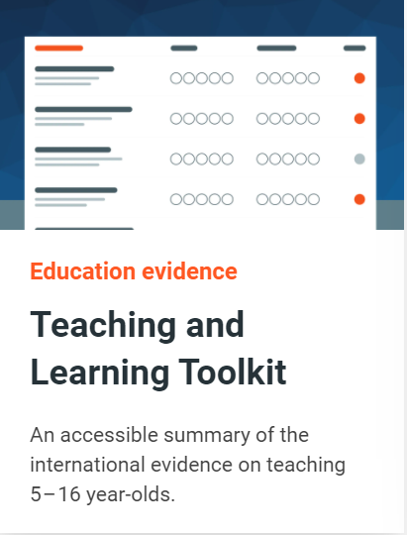
Also, there is brand new Effective Professional Development Guidance published this month which may be a useful read to those of you responsible for planning professional learning.  The guidance suggests that when designing and selecting professional development, ensure that it effectively builds knowledge, motivates staff, develops teaching techniques, and embeds practice. | 