Groupcall Xpressions - Account Registration for Parents
The following steps to create an Account Registration will only work if the school holds your correct email address and mobile number. If you are unable to create your account, please contact the school office to check this information is up-to-date.
When you are ready to set up your Xpressions login make sure that the mobile phone number that you have recorded at the school is switched on.
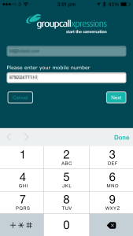
1. If you have not already done so, install The Xpressions App by searching for Groupcall (using wifi, where possible) from:-
2. When you have installed the app, open it and enter your email address then click ‘Next’.
3. Enter your mobile number and click ‘Next’.
If your details do not match the school records you will see the text ‘incorrect answer’ in red below the box. Correct and click Continue.
All personal details will be taken from the school records, so the information you provide needs to match what they have on file. If you are unable to enter details successfully you will need to speak to your school office. If you are sure you have entered information correctly but you still see an error message, it is likely that the school records are incorrect so please contact your school.
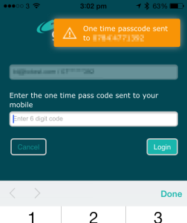
When you have entered details correctly you will receive a text message to your mobile phone containing a 6 digit code.
4. Enter this code on screen.
5. Press ‘Login’.
If you do not receive a code, use the ‘Resend Code’ function. However, there can be delays due to mobile phone providers and other factors outside of the control of the Xpressions app and the school, so please wait for at least 5 minutes and ensure you are in an area with mobile phone coverage.

Set Password
It is possible to use the Xpressions app without setting a password – you can simply use your mobile phone number in conjunction with your email address instead of a password. You will have to enter a code sent to you mobile number each time you log in to the app (or to the website) however, so you may find a password quicker.
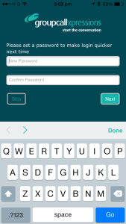
When you have successfully entered your email address, mobile number and the code you were sent by SMS, you will be asked if you’d like to set a password;
- Enter secure password.
- Re-enter the same password to confirm your choice.
  - You will see an error message if the passwords do not match exactly. Simply try entering the password of your choice again taking extra care to enter it the same each time.
- Press ‘Next’.
Alternatively you may select ‘Skip’ if you’d rather not add a password to your account.

Protecting data
Whilst having convenient access to your child’s data on your mobile device has many benefits, the portability and small size of many devices can make them easy to lose or an easy target for thieves. We recommend that you take some simple steps to protect your device.
The Groupcall Xpressions app can be secured with a PIN code that is independent of any codes set on the device. We recommend you set one when you login to Xpressions initially. This can also be done by clicking the padlock icon in the upper left corner of the app home screen entering a 4 digit passcode.

