St. Joseph’s R.C. Primary Respect for All Policy:
Anti-Bullying for Children & Young People
Respect for All
We are committed to providing a safe, supportive environment for all pupils. We value respect, dignity, fairness and inclusion and understand that bullying is never acceptable, as reflected by ‘Getting it Right for Every Child’ (GIRFEC). Bullying for any reason (prejudice-based such as bullying based on the protected characteristics listed in the Equality Act 2010, or other) will not be tolerated.

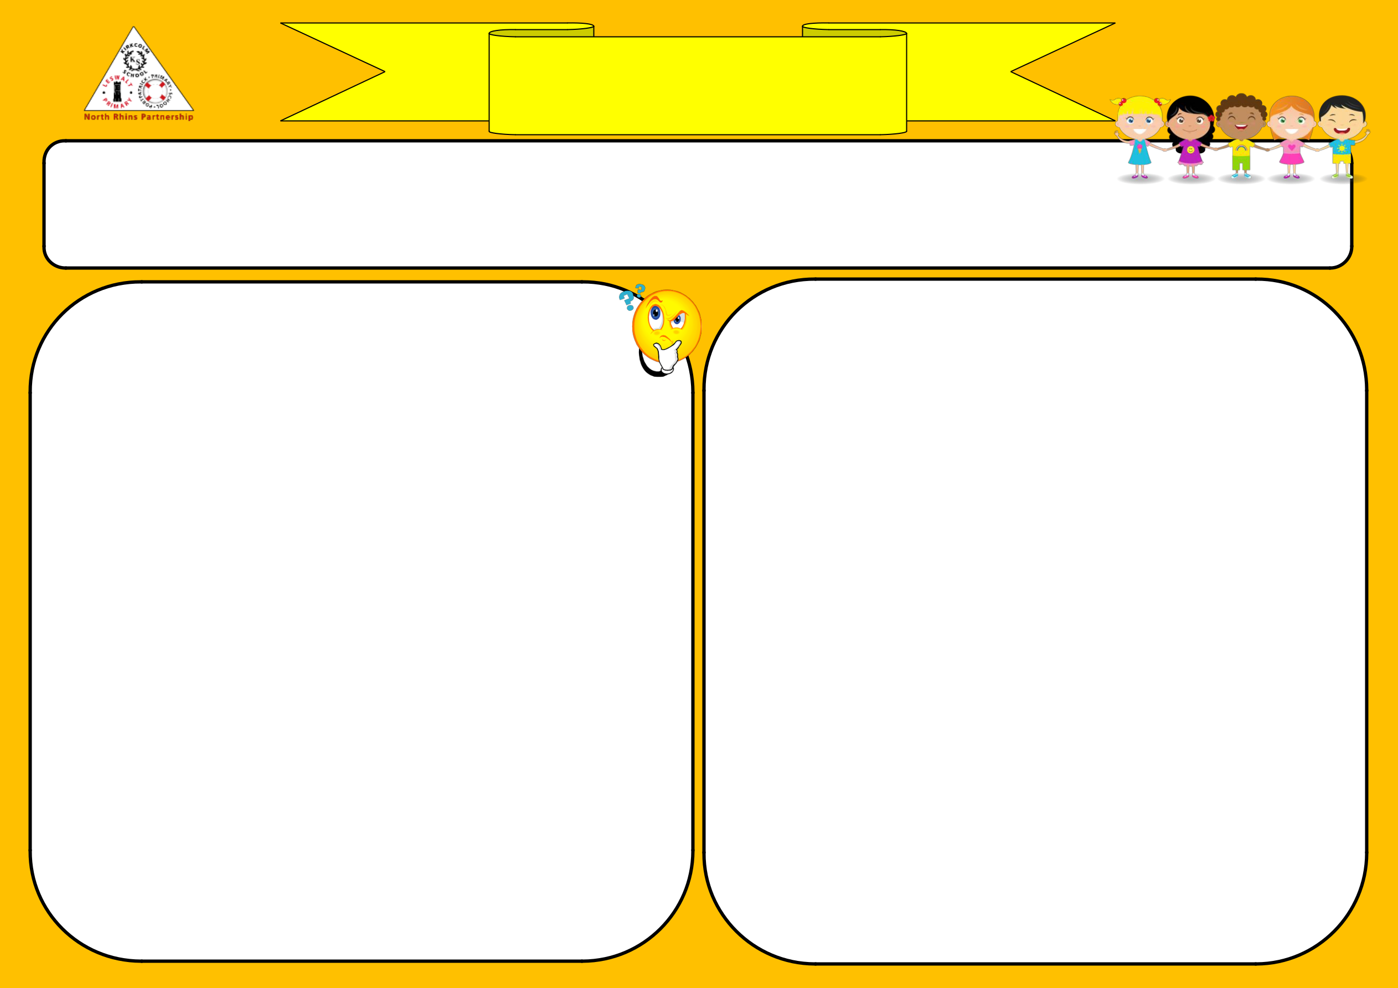

What is Bullying?
The nationally agreed definition in Scotland is: “Bullying is face-to-face and/or online behaviour which impacts on a person’s sense of physical and emotional safety, their capacity to feel in control of their life and their ability to respond effectively to the situation they are in. The behaviour does not need to be repeated, or intended to cause harm, for it to have an impact. Bullying behaviour can be physical, emotional or verbal and can cause people to feel hurt, threatened, frightened and left out.”
Bullying is a breach of children’s rights, as laid out in the UNCRC. It can occur for a variety of reasons, including: age, disability, gender, race, religion or belief, or sexual orientation (these are termed ‘protected characteristics’ in the Equality Act 2010). Any bullying behaviour or inappropriate language used in regard to any of the protected characteristics, will be challenged. It can involve:
- Being called names, teased, put down or threatened (face to face and/or online)
- Being hit, tripped, pushed or kicked.
- Having belongings taken or damaged.
- Being ignored, left out or having rumours spread about you (face-to-face and/or online).
- Sending abusive messages, pictures or images on social media through online devices
- Behaviour which makes people feel like they are not in control of themselves or their lives (face-to-face and/or online).Being targeted because of who you are or who you are perceived to be (face to face and/or online).
- Increasing the reach and impact of bullying or prejudice through the recruitment and/or involvement of a wider group.
When is it not bullying? Pupils will have fallouts, as this is a normal part of growing up and should be distinguished from bullying. This policy provides a clear definition of bullying and we will use it to educate everyone in our school community on bullying to help clarify this. We aim to develop resilience in our pupils so they are able to deal with fallouts and disagreements that are part of everyday social contact. However, we recognise that this behaviour shouldn’t unchecked, as it could lead to bullying.

Promoting Respect for All
We use a variety of proactive, preventative strategies, including:
- Relationships and school ethos - ensuring positive relationships between all pupils, staff and parents. We recognise that relationships are at the heart of everything we do and want to encourage pupils/parents to talk to us if they are worried or have a problem. We also ensure that all adults act as a good role model to the pupils.
- Promotion of children’s rights, respecting these and modelling this in all we do.
- Positive behaviour approach – we recognise positive examples of behaviour in school and praise/promote these, to encourage all pupils to behave positively, e.g. Merits/House points, certificates, Star of the Week, House rewards.
- Group work – where pupils are encouraged to work with those they may not normally socialise with, and work on social skills through class work including listening to others and being able to disagree respectfully.
- We actively talk about it and celebrate various events throughout the year, including anti-bullying week and Internet Safety Day (where our anti-bullying policy will be referred to), and teach about this. Kindness, respect, tolerance and celebrating difference through the various parts of the curriculum (e.g. RME, Health & Well-being) and at Assembly, where we talk about our school values regularly.
- We have talks from Childline and display the poster in school, and occasionally the community police officer delivers talks to the pupils.
- We have various positions of responsibility within school to ensure pupils are included and have the opportunity to participate, e.g. House Captains, Playground Monitors, Pupil Council, Eco Committee, Digital & STEM Leaders.
- We have various systems in classes, such as a worry monster/class box, and use circle time to encourage pupils to discuss their feeling regularly (and provide them with the language needed to express them self) and anything that they are worried about, promoting empathy.

Pupils’ Role Staff’s Responsibilities Parents’ Responsibilities

  - Be kind to each other and respect differences.
  - Think about how your words and actions may make someone feel.
  - Speak to your class teacher (or a trusted adult in school) about anything worrying you so we can help and are able to investigate incidents at the time of occurrence.
  - If you witness bullying behaviour, challenge it where safe to do so. Alternatively, report it to a trusted adult.
  - Always be honest when asked about any incidents.
  - Establish a climate of respect & trust.
  - Role model positive relationships.
  - Be proactive in our approach and actively promote tolerance, kindness, respect and compassion.
  - All (clerical, ASLA, catering) are responsible in being vigilant and reporting concerns to CT/PT/HT.
  - Remain vigilant to any incidents and listen to and take seriously any concerns from pupils or parents.
*Pass on any concerns to HT/PPT so all incidents can be fully investigated/recorded.
  - Support all pupils and families to resolve any incidents and inform them of outcomes.
  - Role model positive relationships, tolerance, respect and kindness to your child.
  - Talk to your child about bullying behaviour & the difference between this and fallouts; its impact and encourage them to talk to an adult if worried.
  - Monitor their social media use.
  - Promote the same approach to bullying as the school, so the child is getting the same message.
  - Report any concerns you have about your child to a member of staff as soon as possible
  - Work with the school to positively resolve any incidents that your child may be involved in.

Reporting Concerns & Responding to Incidents
Pupils/parents should inform a member of staff as soon as possible if they have any concerns about bullying. This concern will promptly be passed onto the HT/PT who will speak to all individuals involved to get a true account of events.
Our response will always be proportionate and fair, depending on the nature and severity of the incident. We will consider what the child receiving the bullying behaviour wants to happen, to ensure they are listened to as laid out in the UNCRC. We will support all those affected the bullying behaviour by using a restorative approach to repair the harm done between the pupils – this is a conflict resolution conversation between all those involved to establish what happened and the impact it has had on the other person(s), encouraging those displaying bullying behaviour to take accountability for their actions and consider what they would do differently. As its title suggests, it focuses more on a restorative rather than punitive approach to dealing with bullying behaviour. Support will also be given to the person displaying bullying behaviour to help identify what caused them to act this way, develop alternative ways of responding to these feelings and understand the impact of their behaviour. Parents/guardians will be involved in and informed of discussions too.
See appendix 1 for a flow chart of steps that will be taken in the event of an incident being reported to staff and appendix 2 for examples of support that pupils may receive. It may be the case that an incident occurred out with school but is having an impact on pupils in school. In this case, a similar approach will be taken but with more emphasis on parents being part of the discussion and the school playing more of a mediator role.
If you are unhappy with how an incident has been dealt with, please contact the school directly to discuss it further.
Recording of Incidents
We will log all incidents of bullying behaviour formally on
the Seemis ‘Bullying & Equalities’ module. This also enables us to see if there are any patterns of behaviour which need addressing, and ensure that incidents have been dealt with effectively and are not continuing to be of concern.

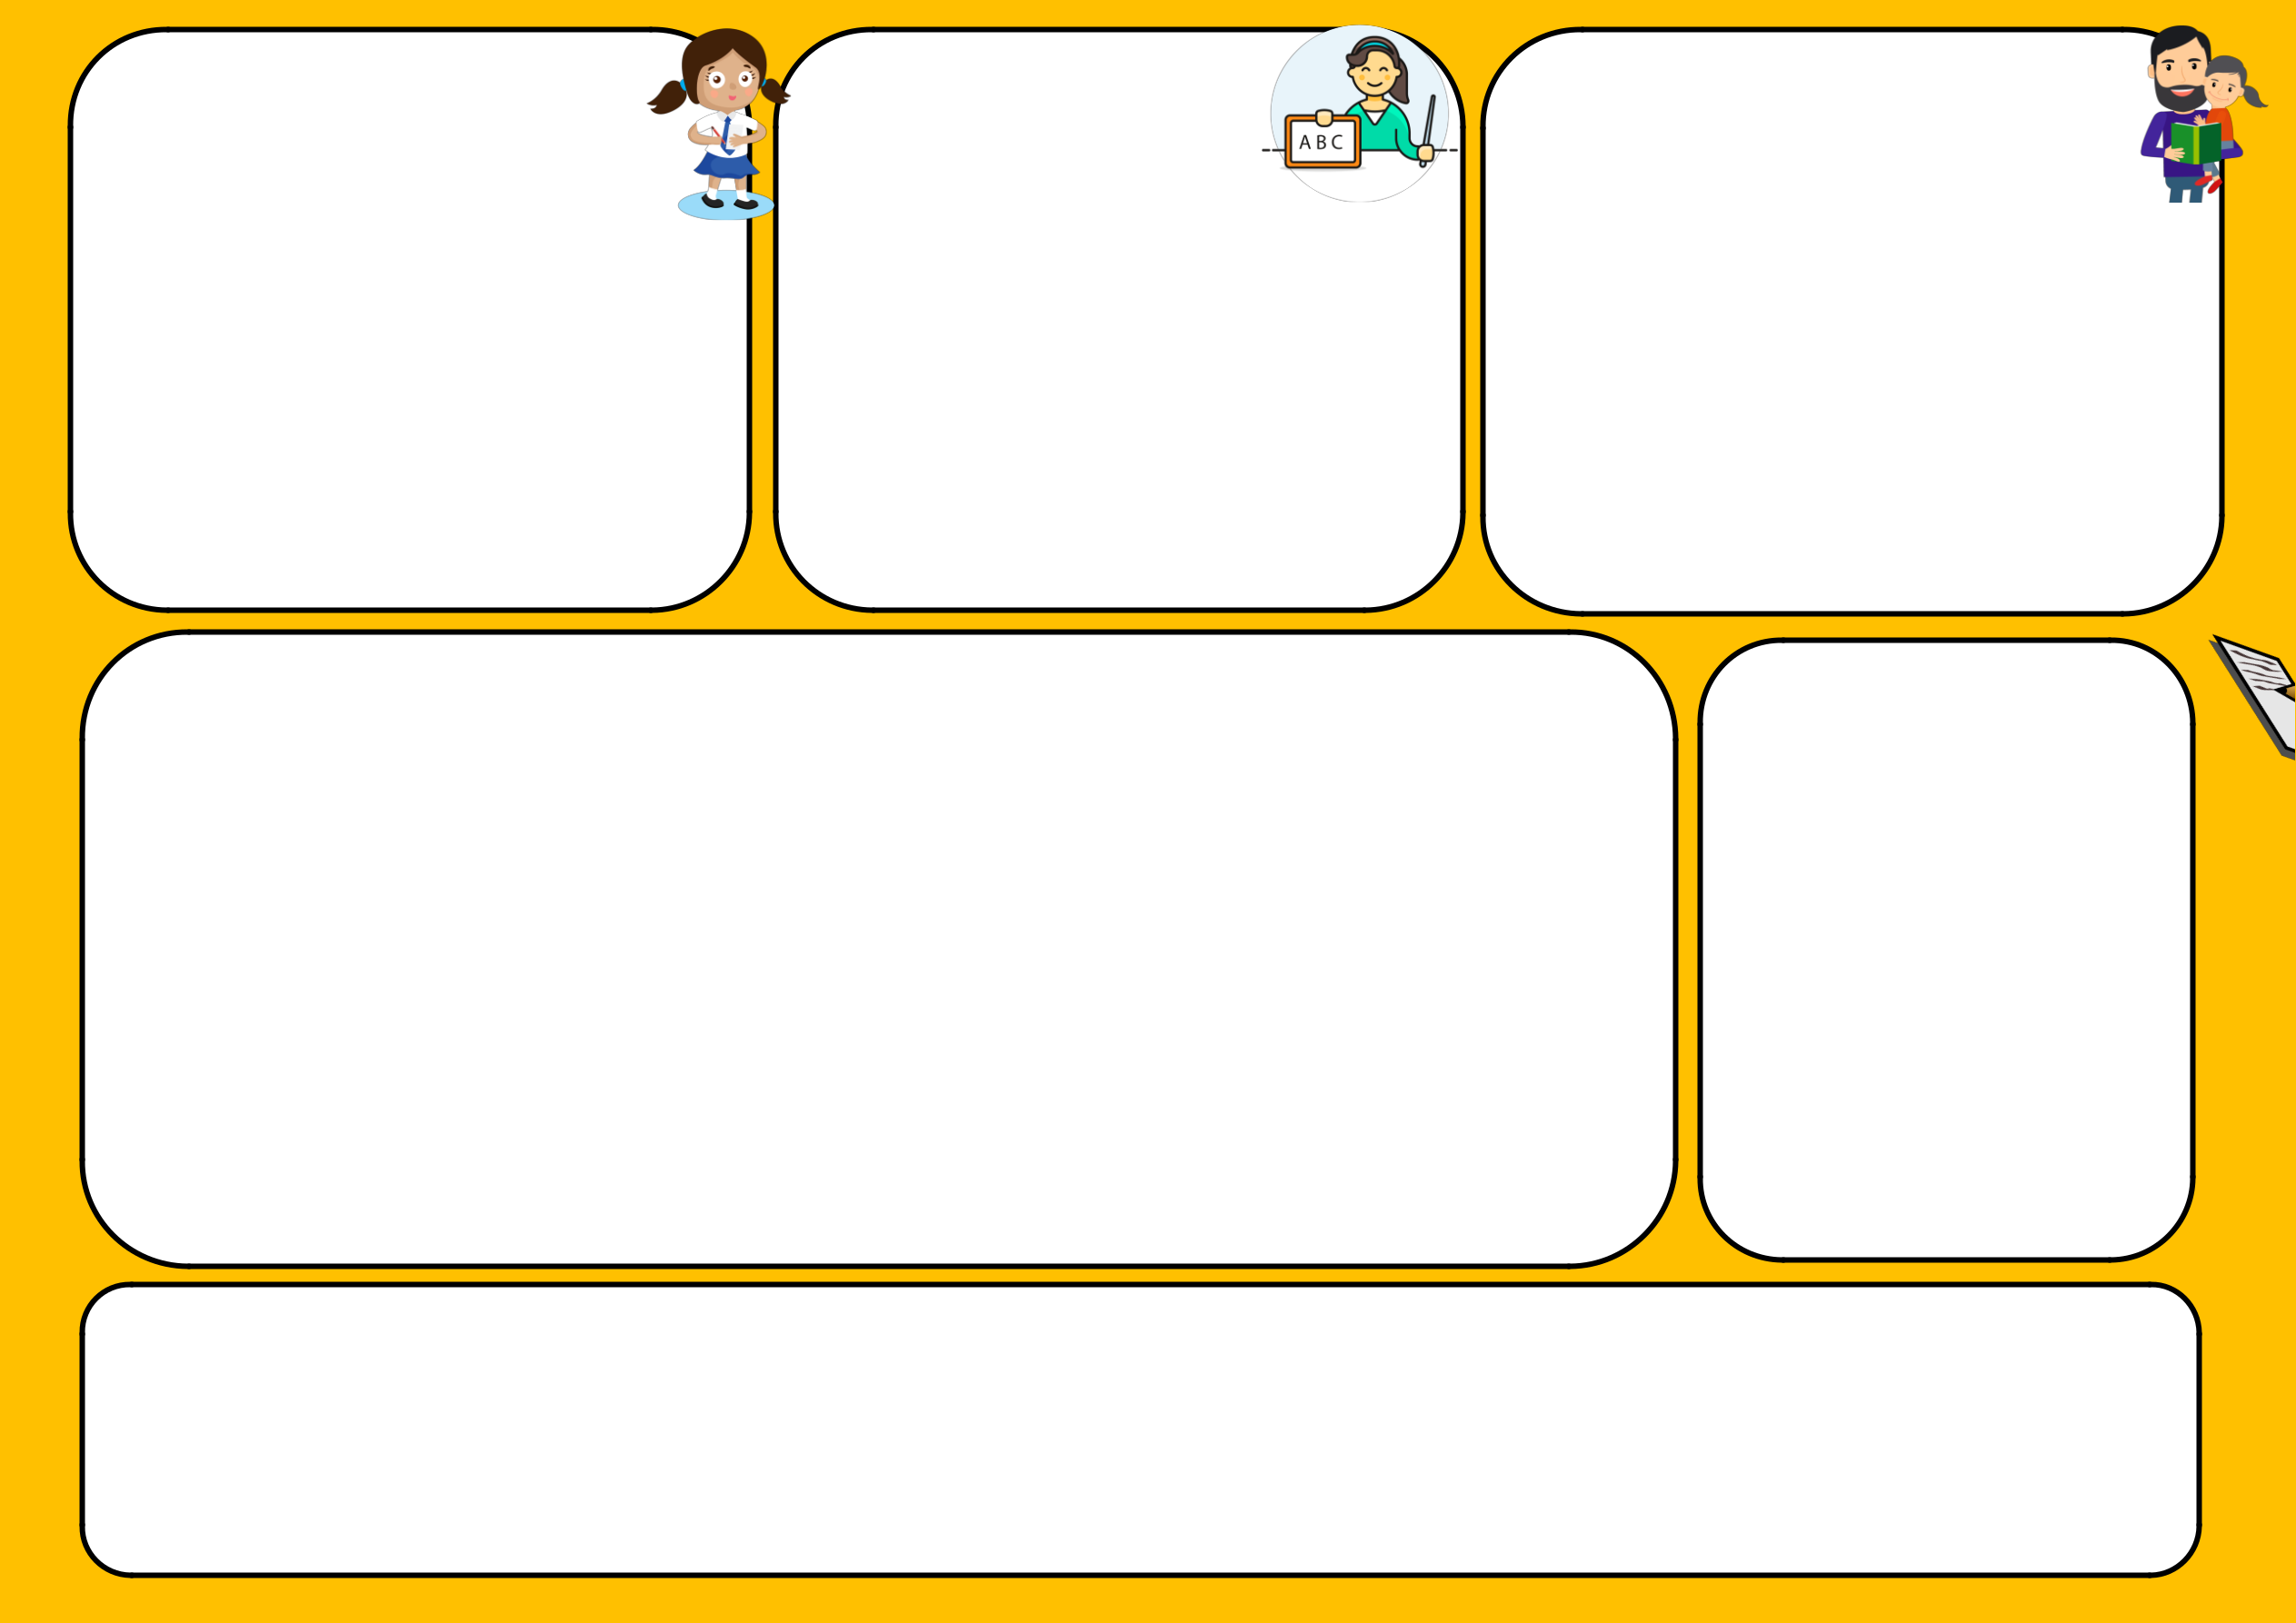
For further information:
National ‘Respect for All’ policy: Supporting documents - Respect for All: national approach to anti-bullying - gov.scot Respect Me website: https://respectme.org.uk/
Restorative Practice: https://www.anti-bullyingalliance.org.uk/tools-information/all-about-bullying/restorative-practice

Policy Last Reviewed; Nov 24. This document has been shared with parents via the Parent Council for agreement and is posted in our school entrance and on our Blog.

Appendix 1 Responding to an Incident Flowchart
Staff are informed about an incident, either by parents or pupil to help determine the severity of the incident, consider whether the incident involved:
    - Aggression?
    - Intent?
    - Persistence?
    - Discrimination around a protected characteristic?

Inform the Class Teacher, who will speak to all pupils | Report incident to HT/PT (if they are not in the school, pass onto the
involved and investigate fully. Use a restorative approach to | Class Teacher who will speak to all individuals involved (including
repair any harm done between pupils. | witnesses) and record what happened – when possible, call or email
 | HT/PT with this information).
If required, inform HT and PT (email/call if not in the | Use of restorative approach to repair the harm done between
building). | individuals and create a plan of action. Emphasise that such behaviour
 | will not be tolerated and the situation will continue to be monitored by
 | all staff. Inform pupils of the next steps to occur and the actions being
 | taken to support both/all of them.
If the situation was reported by a parent, inform them of
the outcome of any investigations.
 | HT/PT to inform parents of all those affected (display and receiving
 | bullying behaviour), so conversations can be had at home to support all
 | children and so a consistent, supportive approach is being taken by both
All to monitor the situation and check-in with pupils | home and school.
regularly to ensure it doesn’t continue/turn into bullying.
 | HT/PT to log the incident on Seemis Bullying & Equalities module, for all
 | those involved (display and receiving bullying behaviour).

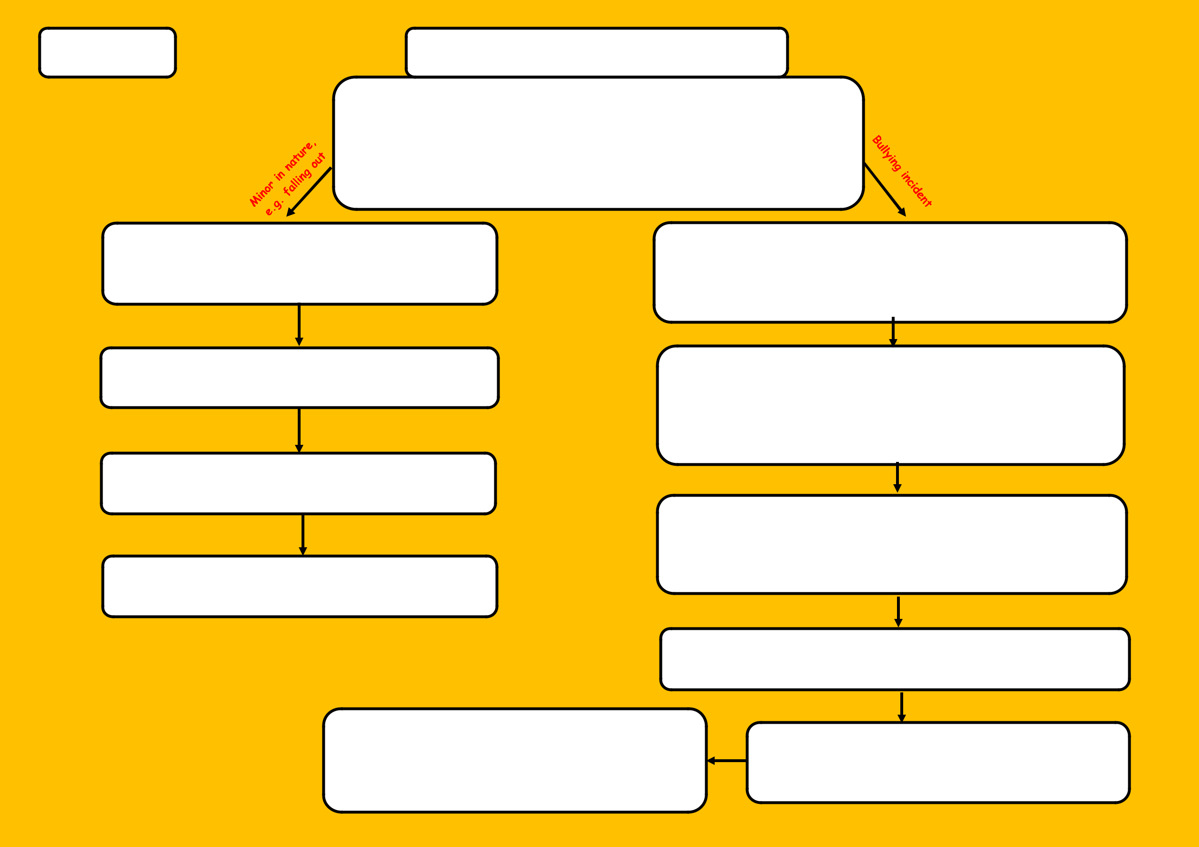
If situation continues, inform HT/PT who will invite parents of all involved into school for a meeting to agree a plan of action. If bullying behaviour continues, then exclusion may be considered as a last resort.

HT/PT to make all relevant staff aware, so the situation can be monitored and regular check-ins can occur to ensure it is not ongoing.


Appendix 2 Examples of Support That Pupils May Receive

Our response to incidents of bullying behaviour are child-centred and underpinned by values of fairness, equality and inclusion. As every situation is unique, it is difficult to define a ‘one approach fits all’ in response to incidents of bullying behaviour. However, here are different responses that we may take to help support pupils (Refer to WRP Behavioural Support Pathways for further information).
- Restorative discussion with all pupils involved – all staff have a ‘chat script’ with key restorative questions. This discussion acknowledges the feelings of all involved in the situation and helps to repair relationships and build resilience.
- Actively listening to what the person receiving the bullying behaviour wants to happen – this helps them to restore their sense of agency and feel in control of them self and their ability to affect what happens. Lots of reassurance that they have done the right thing.
- For those displaying bullying behaviour: clearly outlining what the behaviour was and why it was wrong, and the natural consequences they face if it continues. Helping them to identify the feelings that caused them to act in this way and explore alternative ways of responding to these feelings.
- A big focus on respect – you don’t have to get on with everyone, but you do have to respect them and ensuring that all pupils know what this means/looks like/sounds like. This may involve short-term focused group work with an adult.
- Regular check-ins with all pupils involved - ensuring that all pupils involved have a trusted adult they feel they can talk to about the situation, and opportunities for this to happen.
- Seeing all adults (home and school) working together and communicating, respectfully with their wellbeing as the priority.

We are guided by the Scottish Catholic Education Services (SCES) Equalities and Diversity Guiding principles
Principle 1: All people are made in the image and likeness of God, and are deserving of dignity and respect Principle 2: All learners are of equal value.
Principle 3: We recognise and respect difference.
Principle 4: We foster positive attitudes and relationships, and a shared sense of cohesion and belonging. Principle 5: We aim to reduce and remove inequalities and barriers that already exist
Principle 6: We aim to consult and involve widely
Principle 7: Society as a whole should benefit from our school policies Principle 8: We base our practices on sound evidence
Principle 9: Objectives

