West Rhins Partnership Rainbow Tables/Division

An introduction

**What is Rainbow Tables/Division?**

A numeracy scheme aimed at encouraging learners to recall and understand how to apply the multiplication and division facts within the 2 – 12 times tables. It is in a rainbow coloured progression from red-yellow-orange-green-blue-indigo-gold-platinum. Learners must show a solid understanding of the facts and answer all calculations correctly in regular tests before they move up a level.

|  |  |
| --- | --- |
| **Level** | **Focusing on** |
| **Red** | **x2, ÷2, find one half** |
| **Orange** | **x5 x10, ÷5 ÷10, find one fifth / one tenth** |
| **Yellow** | **x3 x4, ÷3 ÷4, find one third / one quarter** |
| **Green** | **x9, ÷9, find one ninth** |
| **Blue** | **x6 x7, ÷6 ÷7, find one sixth / one seventh** |
| **Indigo** | **x8, ÷8, find one eighth** |
| **Gold** | **x11, ÷11, find one eleventh** |
| **Platinum** | **x12, ÷12, find one twelfth** |

**How does it work?**

Multiplication and division will be explored regularly in the classroom through direct teaching, interactive activities, games, songs, rhymes and/or written work. The concepts are taught every term throughout each year so learning is continually being reinforced. Rainbow tables/division is an additional method of learning the facts and gives parents and carers a chance to support their child’s learning further.

Each learner (from approximately P5 onwards) is given a level to work within and a laminated support sheet will be given to use at home. Pupils always start at Red Level (x and divide by 2) and work their way up to Platinum (x and divide by 12). These facts will still be consolidated in school but the extra help at home will really, really help. ☺ A little goes a long way – 5 minutes before bed or whilst washing the dishes, having a bath etc. will have a positive impact.

**How are the facts assessed?**

Learners will be assessed at the end of each term so approximately in September, December, March and June. The exact dates of test days will be written on the sticker at the front of their homework diary but will also be in the school calendar and newsletter as a reminder. Learners will be given a sheet with a variety of questions on it asking them to either multiply, divide or find a fraction. A range of vocabulary is used to ensure the learner can cope with calculations presented in a variety of ways. Past learned facts will also be included to keep knowledge and understanding of these fresh. The tests are not timed. Orange (10x 5x), Yellow (3x 4x) and Blue levels (6x 7x) are split in to 2 parts to learn one set at a time to make this easier for your child.

A score of 90% is needed to move up a level. Assessments are tracked in an ‘assessment tracker sheet’ and will be discussed each term during ‘attainment consultations’ between the class teacher and HT/PT and also during ‘Learning Conversations. This will help to identify those learners who require further support or those needing more challenge. The rate of progress is completely individual to each learner so they can achieve what they are truly capable of and achieve personal success.

Here is an example of a test sheet for Yellow level:

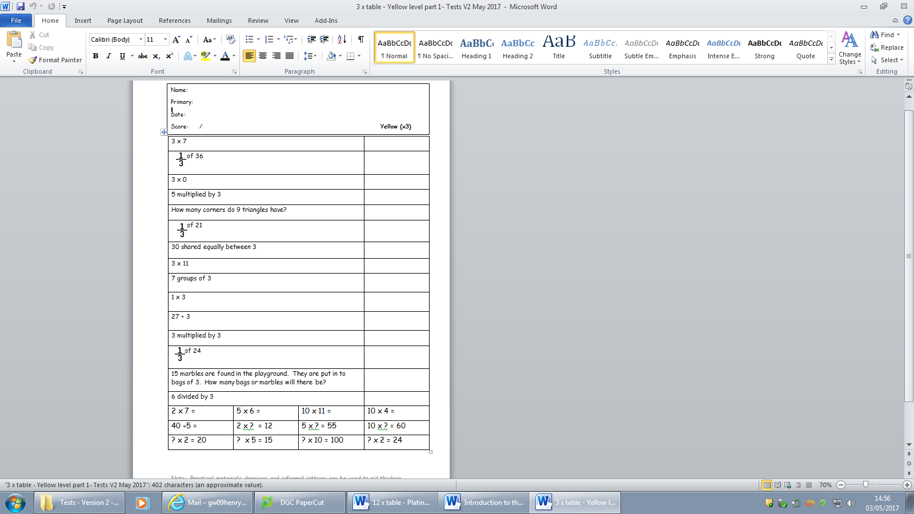

There are 2 or 3 word problems within each test also. This is to test application of the facts in a context. Try making up word problems at home to help! Learners who struggle with reading will be given support in the word problems.

At the bottom of each test there will be a random selection of previous multiplication facts from tests they have already passed. This is to keep prior learning fresh.

**What happens when my child passes Platinum level (x12)?**

In the old Rainbow Tables scheme we used, we had learners as young as P3 and P4 who were able to recall the table facts they were focusing on at that time and pass Platinum level. However, when it came to applying this knowledge in division, fractions… or even just after a few weeks… the recall of facts was not consistent anymore. This is where ‘Random Rallies’ come in! Once your child has passed ‘Platinum’, they will be tested on a variety of the table and division facts across all the tables! This will help keep the facts fresh and help them apply across all their learning in numeracy.

**How can I support at home?**

These facts will still be consolidated in school but the extra help at home will really, really help. ☺ A little goes a long way – 5 minutes each day at breakfast, before bed or whilst washing the dishes, having a bath etc. will have a positive impact. A sticker will be put in the cover of each child’s homework diary which identifies which level they are working on. They will also be given a laminated support sheet which has all the facts which they should know related to that level as well as strategies, hints and tips on the back to help at home.

Please feel free to talk to any member of staff within the school if you require more information on how to support your child at home or if you think your child is struggling.

Here is an example of a support sheet for Red Level:

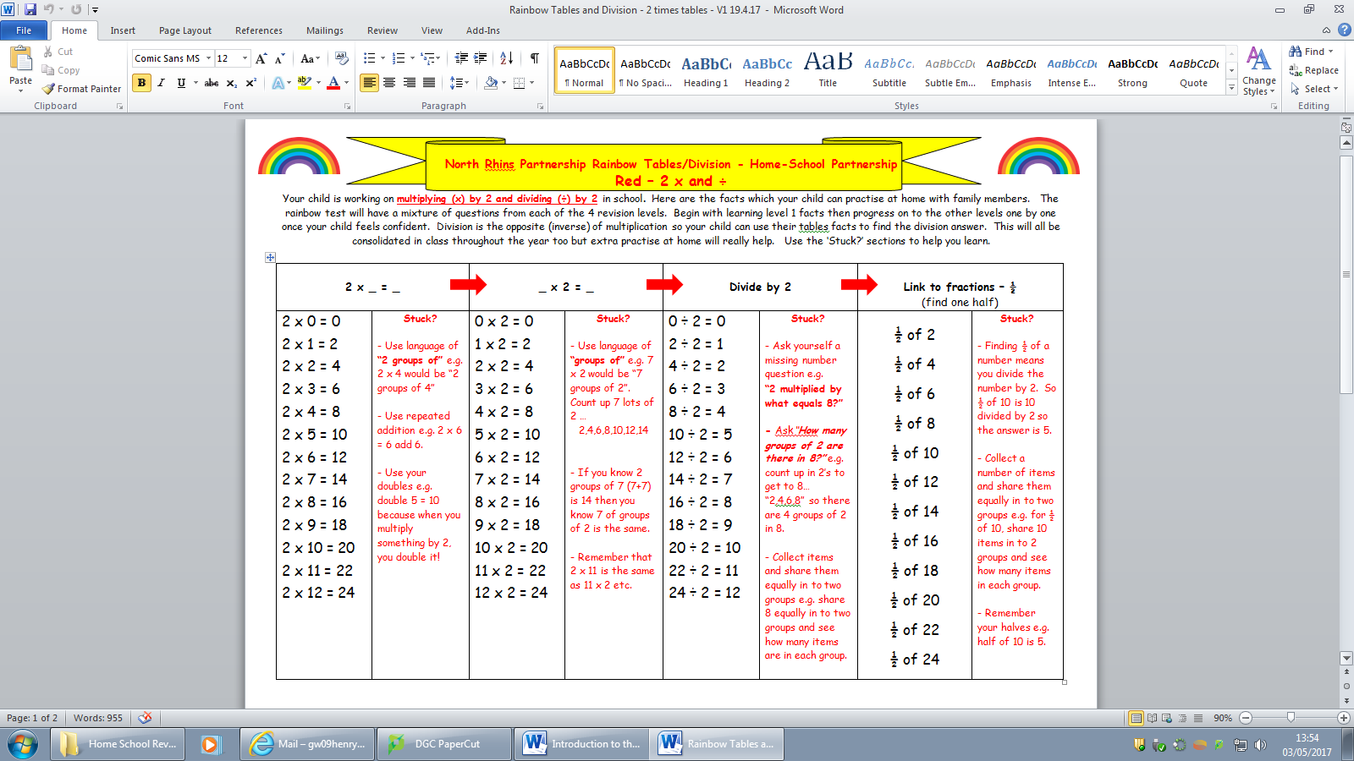

**How is passing a level celebrated?**

Whenever a learner passes a level, they are issued with a certificate. A copy is sent home and another copy kept for their ‘Proud Books’. A merit is also given for this too and certificates are given out at whole school assemblies so the success is shared with everyone.

Here is an example of a certificate:

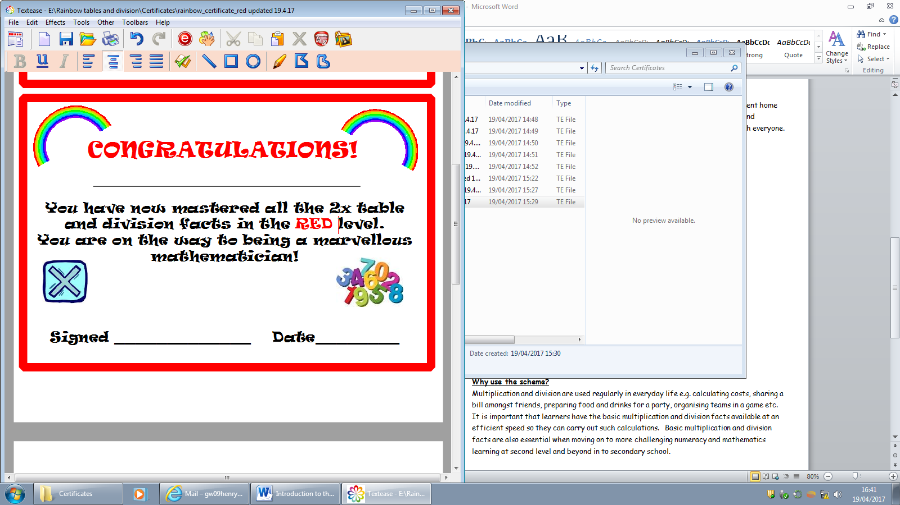

**Why use the scheme?**

Multiplication and division are used regularly in everyday life e.g. calculating costs, sharing a bill amongst friends, preparing food and drinks for a party, organising teams in a game etc. It is important that learners have the basic multiplication and division facts available at an efficient speed so they can carry out such calculations. Basic multiplication and division facts are also essential when moving on to more challenging numeracy and mathematics learning at first and second level and beyond in to secondary school.

Furthermore, in recent surveys within Scotland (Scottish Survey of Literacy and Numeracy 2011, 2013, 2015), division has shown to be an area in numeracy which learners lack confidence in. Multiplication, however, was one of their strengths. If learners can understand the inverse relationship between multiplication and division, then division calculations become so much easier to work with. The rainbow table and division scheme really encourages these connections to be made, as well as the connections with fractions too (which learners also lack confidence in).