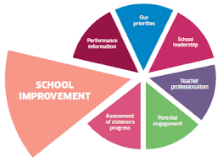

**School Improvement Plan Priorities**

**2023-2024**

Raising Attainment & Achievement

Raising Achievement

All pupils to be given an opportunity to engage with pupil voice groups so that they can lead activities in school.

Literacy & Numeracy

Plan for a range of comprehension, text types and numeracy skills to improve learning & teaching. Reorganise our reading books to match the authority recommendations.

Raising Attainment

Review assessments processes and adopt authority progression frameworks to track and monitor for each pupil.

Inclusive Practice

Family Engagement

Provide opportunities for families to participate in the life of the school

Promoting Rights

Achieve Bronze Rights Respecting Schools award.

Offer children choice in the topics/contexts they learn about

Respect for All

Create a *Respect for All* policy that fits with the DG authority model.

Digital Technologies/Developing Meta Skills

Monitoring and Tracking

Create progression frameworks to track children’s progress in digital literacy and meta-skills (skills, for life, learning and work).

Pupil Skills

Offer opportunities for digital clubs to build children’s skills in coding and problem solving.

Teacher Skills

All staff will undertake professional development in digital skills to support learning teaching.