Irongray Community Newsletter – Spring 2024
For both new and established residents, we hope the following information is of use!
Find our website at: www.irongray-community-council.co.uk
Find Irongray Parish on Facebook too.
Your Community Council – who are we? Iain Mitchell (chair), Susan White (vice chair), Andrew Middleton (treasurer), Ruth Phoenix, Gary Peacock, Roy Hiddleston, Jan Hogarth, Ken and Annabel McBride (joint secretaries): 01387 730318. Email contact is: irongraycc@gmail.com
Would you like to get involved? The Community Council is always keen to recruit new members - a warm welcome awaits anyone willing to join. If interested and have 90 minutes to spare every other month, please speak to a member or email: irongraycc@gmail.com
Your local Dumfries & Galloway Councillor email contacts are:
iain.howie@dumgal.gov.uk pauline.drysdale@dumgal.gov.uk john.young@dumgal.gov.uk
Can we contact you, our residents, by email? If happy to provide your email address, please contact us at: irongraycc@gmail.com
Irongray Community Council Chairman’s report – Spring 2024
Meetings: The Council met in the Hall during 2024 in January and March. Further meetings are planned for May (when the AGM will be held), July, September and November. Members of the community are welcome at all meetings.
Finance: The annual grant of £465.70 has been received from Dumfries & Galloway. Annandale and Nithsdale Community Benefit Company (which administers funds from the Harestanes windfarm) have increased our annual grant from £2000 to £4000 and that sum has already been paid to us. The ANCBC grant is paid over to the Irongray Community Trust to hold and disburse on behalf of the community; grants have been awarded to both Shawhead WI and the Baby and Toddler group to support their activities. To receive our full grant for next year we must spend all this year’s grant by 31st August so we always welcome suggestions for community projects for us to help fund.
This support to the community by ANCBC is much appreciated.
Defibrillator: This unlocked cabinet is mounted in a prominent position on the external wall at the Shawhead Hall door, the unit is immediately accessible and automatically guides a user through the process, therefore simple to operate. Please remember it is immediately available for use by anyone in an emergency, but training can be arranged if required - it is very important we all feel able to use it if it should be needed.
Planning Matters: The Council continues to monitor closely any planning applications or intentions concerning the Barnsoul Caravan Park. The site is now open.

Irongray Community Council Treasurer Report: Both accounts are in the black.
Parish Hall Account Balance: £1686.10 - The hall income is increasing as activities start up again after Covid. In particular, the Ceilidh was a great success and generated a surplus of over £600 boosted by Solway Recycling kindly supplying the bar. The hall continues to be subsidised by Community Council funds. Please consider the hall if you have a meeting or celebration to organise.
Community Council Account Balance: £6362.15 - The latest ANCBC wind farm grant increased this year to £4000 and has been paid over to the Community Trust Account. Please let us know if you have any ideas for expenditure on projects for the benefit of the community. The defibrillator has been upgraded at a total cost of £650. Both the Shawhead Rural and the Parent and Toddler Group have been financially supported by the Community Council.
Shawhead Village Hall
The Hall exists to provide a venue and forum for community use. Refurbished in recent years, we are very keen to encourage increased use of this attractive facility and would remind all it is available for hire. So, for your next function, celebration or any booking enquiry, please email: phoenix.ruth@yahoo.co.uk
Hall Let Rates – inclusive of heating and lighting
Clubs/Organisations within Irongray - £12 per hour. Outwith Irongray - £15 per hour
Concessionary rate - £10 per hour Private Lets - £15 per hour
In addition to being available for hire, we’d be delighted to hear from anyone interested in running a new group or activity. And remember – funding can be made available for beneficial community projects through our annual grant from ANCBC (Annandale & Nithsdale Community Benefit Company). Applications for this funding are invited for consideration – download a form from the Irongray website or email irongraycc@gmail.com
Hall – current programme:
Badminton Club,
Junior coaching session Tuesday 6.45 to 7.30pm, cost £1. For upper primary and lower secondary years. All welcome.
Seniors meet Tuesdays, 7.30 – 9pm. £2.50 per person. Contact Annabel 01387 730318.
Women’s Rural Institute,
Meets third Wednesday of each month, September - June, 7.30 - 9pm
Contact Carol for a syllabus: 01387 730286
Shawhead Baby and Toddlers Group
Meets alternate Friday mornings (term time) 10.00 to 11.30am
The cost is £3 per family (includes a snack for the children).
Contact Jillian Hiddleston, 07553756482. Or follow ‘Shawhead Toddler Group’ on Facebook.
Welcome back to the Senior Citizens group – generally meet on the first Thursday afternoon of the month. For info, please contact irongraycc@gmail.com
Can we remind all vehicle owners that the parking area outside the Hall is private and for Hall users only. We urge drivers to respect this.
Events:
Litter Pick – next one is scheduled for 14 April 2024, meet at the Hall 1pm. Please help keep our roadsides tidy. Bags and pickers will be available but please provide your own gloves.
Following the hugely successful February Ceilidh in Shawhead Village Hall… there’s a plan afoot for another similar event to be held late summer. More details will follow…
Recent years have shown a trend of much reduced entries for our Irongray Craft and Produce Show so we do need to revise and refresh the format. Suggestions and comments from the community will be welcomed - please email: irongraycc@gmail.com
Shawhead Primary School:
Our Blog is up, running and called ‘Shawhead Shout Out’! You can access this by:
Using Google to search 'Shawhead Shout Out' and you should see it as the first hit.
Once you're on the home page you could save as one of your favourites.
The best way to view the site is on a laptop, desktop or I-Pad. On your phone it's best to look at it in 'landscape' mode
We hope that we can have a section on there for the community council.
Term 3 was busy and all goings on can be found on the Blog. We also achieved our Eco Schools Scotland 7th Green Flag - an amazing achievement - and given a commendation for excellent work on learning for sustainability. This was all work pupils have been doing since 2022 and has culminated in this award.
This term we will have lots of exciting, fun things going on and we would like to arrange a ‘school tidy’ morning and invite parents and the community to come along and help tidy up our outside area – more details to follow
Finally, many congratulations go to Milly and Roddy, two of our pupils, who shone recently as winners at the D&G inter-school badminton competition. Very well done to both!
Irongray Parish Church News: - If you have not worshipped with us before, you would be most welcome at any of our services. Our normal services last for about an hour and on a Sunday we have tea, coffee and refreshments after worship and a time to socialise with each other.
Morning Worship takes place at Irongray on the 2nd and 4th Sundays of the month at 10am. On the 1st and 3rd Sundays of the month worship is at Terregles Parish Church.
On the 5th Sunday we meet in Lochrutton Mission Hall in Lochfoot.
The formal Holy Communion at Irongray Parish Church will be celebrated on Sunday 26th May at 10a.m.
I'm here for everyone in Irongray parish, so if I can be of any help or you'd simply like a chat, feel free to contact me at the Manse. Gary Peacock 730759

Irongray Book Club - Meets every second Monday evening, 7pm, each month. This is a great way to discover both new and old titles and is always a good social evening – new members are very welcome. For more details, please contact Pat on 07777 695802
Cairn Valley Community Transport: Shawhead - Castle Douglas service.
This minibus runs every second Thursday through Shawhead - for dates and more info, please email: alansnademill@outlook.com
Timetable: bus departs Moniaive 11.15am, stopping at Kirkland, Wallaceton, Dunscore, Newtonairds and Shawhead at 11.45am; the return trip leaves Castle Douglas 15.05pm.
Speed Limit reminder: Can we remind residents and their visitors of the mandatory 20mph speed limit now in place in the village. For genuine concerns regarding speeding vehicles, please contact the police on 101 with registration number details.
Attention dog owners! Surrounded by farmland and animals, please do keep your dog under control and know where it is at all times. If you see anything of concern, please report it by calling 101. Dog Fouling - Also, we take the opportunity to remind owners that not picking up after their pets is not only antisocial, but illegal too!
Our Website is: www.irongray-community-council.co.uk
We hope this will be an effective platform for communication - though we’d very much welcome an interested and skilled volunteer to assist with this – please step forward if you can help!. Any constructive suggestions for inclusion will be hugely welcomed - projects, articles, images or photographs (past and present) with local relevance. Please speak with a community councillor or email us at irongraycc@gmail.com

And finally… We hope this newsletter is of interest and would welcome feedback and constructive criticism. Please do get in touch with any suggestions for inclusions or improvement! Email us at: irongraycc@gmail.com
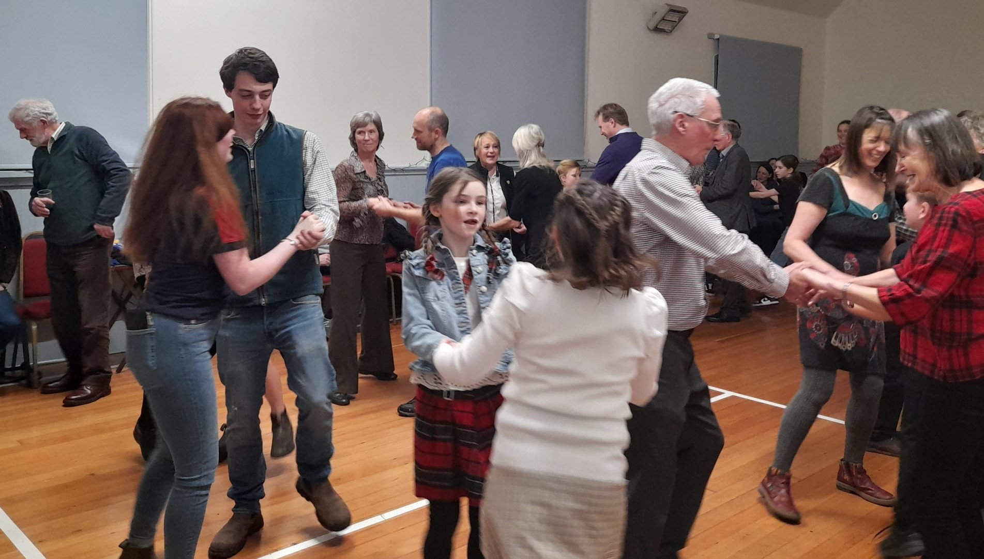
February Ceilidh

Printed with the kind co-operation of Solway Recycling Ltd: www.solwayrecycling.co.uk

