My Care Plan

My name is: ………………………………………………………….

My Date of Birth is: ……………………………………………

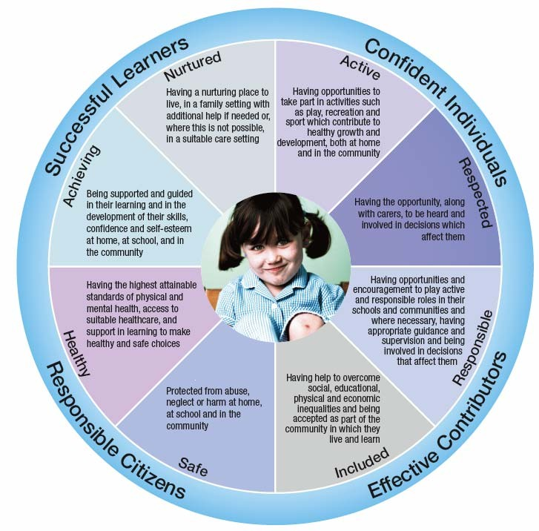

You will find lots of information about me in my

Care Plan including who is in my family and what my favourite things are.

Special people in my life

(GIRFEC links – Included, Nurtured, Safe )

Who lives in my house with me? My Pets -

Other special people in my life…

How do I cope with being away from my family?

I will be brought to the nursery by:

I will be picked up from the nursery by:

My story so far…

(GIRFEC links – Included, Nurtured, Respected)

Other settings/groups I have attended or still attend…

Sometimes I may get upset, you can comfort me by…

Things that may upset, frighten or worry me…

Can I use the toilet by myself? Yes No with Assistance

(Please circle)

Am I toilet training? Yes No

You can help me with my toilet training by….

Some of my favourite things…

(GIRFEC links – Included, Nurtured, Respected)

Places I like to visit, things I like to talk about or explore…

Songs I like to sing and stories I like to read…

Things I like to play with/my favourite toys and games…

Some aspects of your child’s wellbeing, health and safety will progress naturally and will be monitored over time, other areas will be focused on in their NEXT STEPS as agreed with you and your child. Personal plans are reviewed every 6 months or updates sooner when significant changes happen.

Child’s Name………………………………………………………………………

: What is going well? What areas need actions? How will nursery/home/partners support me? **Completed by Keyworker and Parents**

|  |  |  |
| --- | --- | --- |
| **Wellbeing Indicators** | **What is going well? What areas need support?** | **How will nursery support me?** |
| **SAFE**  *Sense of danger and own safety – at home and out and about, strangers.  *Listening to adult to stay safe.  *Fears/coming to adults if worried  **Date: Update:** |  |  |
| **HEALTHY**  *Medical conditions, medication, glasses, hearing aids.  *Eating habits and food  *Sleep routines, daytime naps  *Toileting  **Date: Update:** |  |  |
| **ACHIEVING**  *Confidence  *Interests and talents Development of movement skills, language, emotional and social.  *Health Visitor  **Date: Update:** |  |  |
| **NURTURED**  *Important people in my life who I spend time with.  *Things that are important to me and my family.  *My likes/dislikes and Preferences.  * Special comforts that help me feel secure  * What do I need encouragement with?  * Previous ELC experience or similar Settling in at nursery and separating  **Date: Update:** |  |  |
| **ACTIVE**  *Outdoor activities, sport or physically active hobbies/interests    *Favourite activities, toys or outings.  **Date: Update:** |  |  |
| **RESPECTED**  *How does my family involve me in everyday decisions?  *How do I make my needs and wants/ideas known?  **Date: Update:** |  |  |
| **RESPONSIBLE**  *What is my behaviour like at home and away from home?  *Following rules and routines and cooperating with adults  *Being kind and helpful  *Independence and self-help skills (handwashing, tooth brushing, dressing, coat/shoes, using cups and cutlery)  **Date: Update:** |  |  |
| **INCLUDED**  *Playing with others and forming friendships  *What might be tricky for me at nursery  *Important things you need to know about me and my family (home language, religious celebrations, things I cannot take part in)  *What jobs, special talents or interests do my family have that would be good to know about?  **Date: Update:** |  |  |

My next steps taken from my Keyworker report

My Allergies/Food and Drink Preferences;

(GIRFEC links – Included, Healthy, Safe, Respected)

If I am bottle or breast fed -

What type of milk do I drink? ..............................................................................................................................

How much milk do I drink? ....................................................................................................................................

How often do I drink my milk? .............................................................................................................................

|  |
| --- |
| I am allergic to: …………………………………………………………………………………………………………………………………………………….  Signs and symptoms: ……………………………………………………………………………………………………………………………………………  …………………………………………………………………………………………………………………………………………………………………………………..  What you need to do: ………………………………………………………………………………………………………………………………………….  ………………………………………………………………………………………………………………………………………………………………………………….  (See my allergy plan) |
| Food and drinks that I like… |
| Food and drink that I don’t like… |
| Food and drink that my family do not want me to have…  Reason: ………………………………………………………………………………………………………………………………………………………………  Reason:……………………………………………………………………………………………………………. |
| Do I use cuttlery at meal times? Yes No With Assistance  Do I drink from a cup? Yes No With Assistance  What type of cup do I use? ……………………………………………………………………………………………………………………………… |
| How can you support me with eating and drinking? |

Medication and Other relevant Information

 (GIRFEC links – Included, Healthy, Safe, Respected)

Am I currently taking and long term medication? Yes No

(If ‘**Yes**’ please see my medical form)

Is there anything you would like us to help you with for your child’s development?

Is there anything else you would like us to know?

**The Care Plan will be reviewed with the parents every 6 months**

Please note that is the responsibility of the parents to keep us up to date with any immediate changes that need to be made to this Care Plan.

Parents Signature: ………………………………………………………………………………………………………….

Staff Signature: ……………………………………………………………………………………………………………..

Date Completed: …………………………………

Review Date: …………………………………………

Review Date: …………………………………………

Review Date: …………………………………………

Review Date: …………………………………………

Review Date: ……………………………………………… Review Date: ……………………………………………