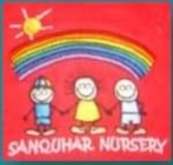 My Allergy Plan

Photo

My Name is: ……………………………………………………………………………………..

Date of Birth: ………………………………………………………………………............

I have the following allergies: ……………………………………………..........

……………………………………………………………………………………………………………

Emergency Contact Details:

* Name: …………………………………………………….. Contact Number: ………………………………………………….
* Name: …………………………………………………….. Contact Number: ………………………………………………….

I require ……………………………………………………………………………………………………………………………………….. Medication for my allergy.

(Please see attached medication form.)

Symptoms of my Allergy includes: (please tick)

* Swollen lips, face or eyes
* Itchy/tingling mouth
* Hives or itchy skin rash
* Abdominal pain or vomiting
* Sudden change in behaviour

Additional Information:

I hereby authorise staff at Sanquhar Nursery to administer the medicines listed on this allergy plan for my child.

Parents Signature: ……………………………………………………………………. Date: ………………………………………………….