Your Ref:  Our Ref: S:\Directorate\Head of Education (Quality & Curriculum) \Quality Improvement\Alternative Certification  Date: 28 July 2026 | Skills, Education & Learning  Directorate  The Bridge  Glasgow Road  Dumfries  DG2 9AW
To All Parents / Carers | Any enquiries please contact  Jim Brown  Phone: 01387 260403  Email: ChiefEducationOfficer@dumgal.gov.uk.
Dear Parent / Carer,

As national messages around easing COVID restrictions give us all hope of a return to something a little more “normal” I wanted to provide an update on how qualifications will be awarded this year. The next few weeks will be critical in determining the grades and qualifications your daughter / son will achieve this session. I know many young people and indeed many of you will be anxious about what is ahead and hope this letter can offer an update on arrangements and provide some reassurance around the alternative approach to certification this year.

Following the cancellation of a formal exam diet, schools have now put plans in place to allow your daughter or son the very best opportunity to achieve the grades they deserve in each of their subjects. Education Scotland, the SQA and officers from the local authority have also been involved in monitoring how these plans have been shaped and implemented at school level. All staff delivering national qualifications in Dumfries and Galloway have been involved in professional learning activities to ensure they understand the national standards for their subject. Staff have planned assessments for young people that will help to provide clear evidence that their work is in line with national standards and they will use the evidence generated to make a judgement about the provisional grade to award. It is important

that young people work hard for these assessments so they can achieve the grades they are capable of. Please encourage them to maintain momentum over the last few weeks.

To ensure fairness and consistency across different schools, a moderation process has been put in place – this means that assessment instruments, mark schemes and samples of marked work are checked by other teachers in your own child’s school, by teachers from other schools in Dumfries and Galloway and by SQA markers who work in the local authority. The SQA have also requested samples of marked work from every school and they too will provide feedback to ensure the grades submitted to SQA are correct.

Provisional grades for all pupils will be submitted to SQA by 25th June and they will certificate as normal on 10th August. All Headteachers in Dumfries and Galloway have agreed that their staff will provide ongoing feedback to pupils about progress and that they will share the provisional results with pupils before the summer holidays. This will ensure that there is an opportunity for you and your daughter / son to get advice and support if necessary before the holidays begin.

The SQA are currently finalising details of what an appeals system might look like this year and once these arrangements are confirmed they will be shared with you. The SQA are also exploring how they might be able to make arrangements for a very small number of pupils who have experienced such significant disruption to their learning this year that their assessment evidence is incomplete. Again, once information is clarified by the SQA it will circulated for your information.

I know how hard this year has been for our young people, for our staff and for parents and I want to thank you all for the support you have provided during periods of lockdown or blended learning. I want to emphasise that our teachers are doing all they can to help ensure the best possible outcomes for everyone and would value your support through these final few weeks as pupils complete assessments. I send my best wishes to all our young people for the remaining weeks of term and hope that you and your family can look forward to some “normality” and hopefully some sunshine during the summer.

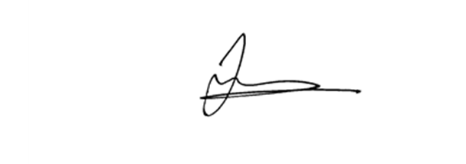
Yours sincerely

Jim Brown
Head of Education (Quality & Curriculum) & Chief Education Officer

