Your Ref:  Our Ref: S:\Directorate\Head of Education (Quality & Curriculum)\Quality Improvement\Alternative Certification  Date: 31 July 2026 | Skills, Education & Learning  Directorate  The Bridge  Glasgow Road  Dumfries  DG2 9AW
To All Pupils | Any enquiries please contact  Jim Brown  Phone: 01387 260403  Email: ChiefEducationOfficer@dumgal.gov.uk.
Dear Pupil,

As national messages around easing COVID restrictions give us all hope of a return to something a little more “normal” I wanted acknowledge that, for you and all of our senior pupils, the next few weeks will be critical in determining the grades and qualifications you have been working for throughout this very difficult school year.

I want to reassure you that our school staff are working hard on what has become known as the Alternative Model for Certification. This means that, following the cancellation of a formal exam diet, schools have put plans in place to allow you the very best opportunity to achieve the grades you deserve in each of your subjects. All staff have been involved in professional learning activities to ensure the national standards are understood by all. Staff have planned assessments for you that will help to provide clear evidence that your work is in line with national standards and they will use this to make a judgement about the provisional grade to award you. Education Scotland, the SQA and officers from the local authority have also been involved in monitoring how these plans have been implemented.

School staff will use the assessment evidence you provide to determine your provisional grade. To ensure fairness and consistency across different schools, a

moderation process has been put in place – this means that assessment instruments, mark schemes and samples of marked work are checked by other teachers in your own school, by teachers from other schools in Dumfries and Galloway and by SQA markers who work in the local authority. The SQA have also requested samples of marked work from every school and they too will provide feedback to ensure the grades you are awarded are correct.

Provisional grades for all pupils will be submitted to SQA by 25th June and they will certificate as normal in August. All Headteachers in Dumfries and Galloway have agreed that their staff will provide ongoing feedback about your progress and that they will share the provisional results with you before the summer holidays. This will ensure that there is an opportunity for you to get advice and support if necessary before you break up at the end of term.

The SQA are currently finalising details of what an appeals system might look like this year and once these arrangements are confirmed they will be shared with you. The SQA are also exploring what arrangements could be put in place for a very small number of pupils who have experienced such significant disruption to their learning this year that their assessment evidence is incomplete. Again, school staff will share this with you once the details are clearer.

I know how hard this year has been for you and I want to emphasise that your teachers are doing all they can to help ensure the best possible outcomes for you. Please keep working hard for the next few weeks so you feel you have shown your best as teachers make final judgements about your work. I wish you well for the rest of term and hope that you can look forward to some “normality” and some sunshine during the summer.

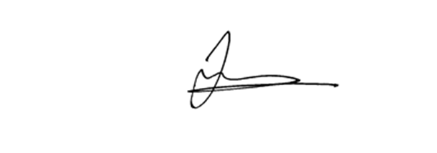
Yours sincerely

Jim Brown
Head of Education (Quality & Curriculum) & Chief Education Officer

