Numeracy

First Level
Challenge yourself to create a game using your hundred square. | Bake something with someone at home and convert the ingredient quantities into g/kg and ml/l. | Think about probability! Come up with some statements and state their probability. (likely/unlikely, even chance, impossible/certain) | Choose a question that you can ask all the members of your family.  Create a bar chart based on the answers.
Throw a dice to create 2-digit, 3-digit and 4-digit numbers.  Then decide if the number you have made is an odd or even number. | Practise writing numbers in words:  P2 up to 100  P3 up to 1000  P4 up to 10000 | Practise your times tables on Topmarks… challenge yourself with ones you don’t know! | Use paints to practise partitioning 2-digit numbers.  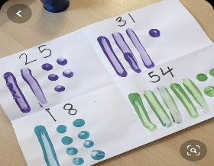
Create a boat out of whatever you can find at home (with permission) to take Katie Morag to Granny Island’s. See how many pennies it can hold! | Regularly practise SAMSON strategies using previous examples of sums that you have. | Use https://whiterosemaths.com/resources/classroom-resources/problems  to complete a maths problem a day | Use a mirror to help with doubling and creating symmetrical patterns with shapes! See the photo below.  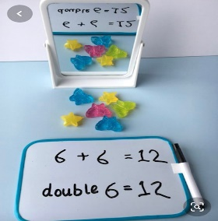
 | Play a game of bingo with your family linked to your learning in number. | Build yourself a shape pizza like the one below!  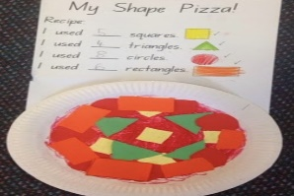
4.5.2020 – 28.5.2020

Take a picture of the activities you do and post them to your portfolio on DoJo!

Name: Class:

