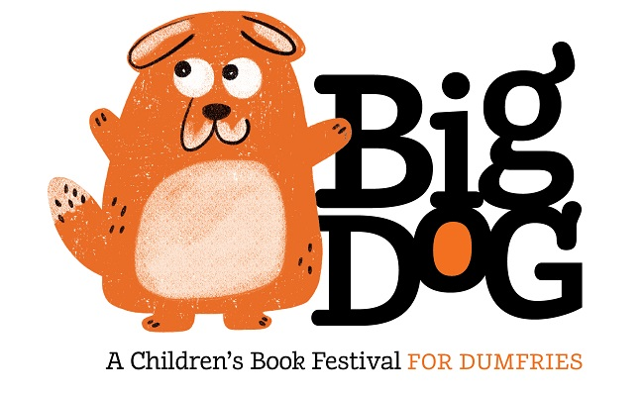
BIG DOG IS BACK

“I’m coming back – it’s another great programme and I just can’t wait!” And with that Big Dog bounces around barking happily.

That was his reaction when asked if he was looking forward to his 3rd Annual Festival in Dumfries which runs from 29th to 31st March. Regular visitors to all the delights of this enchanting celebration of children’s literature will recognise Big Dog at once. Named after Nana, the canine nanny in Peter Pan, he’s big and friendly, and loves reading so much he just wants to share the joy of it with children of all ages and their families.

And what a line up of authors and stories Big Dog and his team have planned for the 2019 Festival. For the teeny-tinies, amongst other treasures, “A Song For Bear” by author Gabby Dawnay and artist Alex Barrow, is sure to be a hit, and Julia Jarman will explain why bathing in her “Big Red Bath” is like no other.

For older children, all-time favourites Anne Fine and Cathy Cassidy will be there, while Scotland’s Children’s Book Award-winner Ross Mackenzie is sure to delight with “The Elsewhere Emporium”, his eagerly awaited sequel to “The Nowhere Emporium”.

Anne Fine, who will be in conversation with children, said: “I’m really looking forward to coming to Dumfries and the Big Dog Festival. Nobody quite understands what it is about meeting a real, live author that turns so many young people into more passionate readers. But teachers, parents and librarians are all agreed that it works. And it’s wonderful for the author. I'm fascinated by the questions I’m asked, both about the writing process and about the books.”

Storytelling, drawing and a chance to get creative in a variety of workshops are all sure to appeal to all age groups, especially in the hands of the masters of their craft, who will ensure that all the events are enormous fun.

The Theatre Royal will once again play host to many of the events, with others at the Robert Burns Centre, the Dumfries Museum and Moat Brae.

Wigtown Festival Company, who run the event, are delighted with the programme and grateful to the funders and sponsors of Big Dog.

Programme Director Anne Barclay said: ‘Big Dog returns for the third year with exciting activities for all the family. Children and their grown ups can look forward to stories, songs, film and making over the long-weekend event. We're grateful to our funders Baillie Gifford and SSE for their support to bring the programme of more than 20 events to life, offering families from Dumfries & Galloway and beyond the opportunity to meet and hear stories from some of the nation's best children's writers.”

Editors: For more information contact
Anne Barclay, Wigtown Festival Company, 11 N Main St, Wigtown, Newton Stewart DG8 9HN anne@wigtownbookfestival.com

