[](https://www.google.co.uk/url?q=http://annanacademyorguk.ipage.com/aims--values.html&sa=U&ved=0ahUKEwi5hqjGzsHdAhXGTMAKHfr0AUsQwW4ILjAM&usg=AOvVaw3eC8CMvmhOX_Fs-TgtHnky)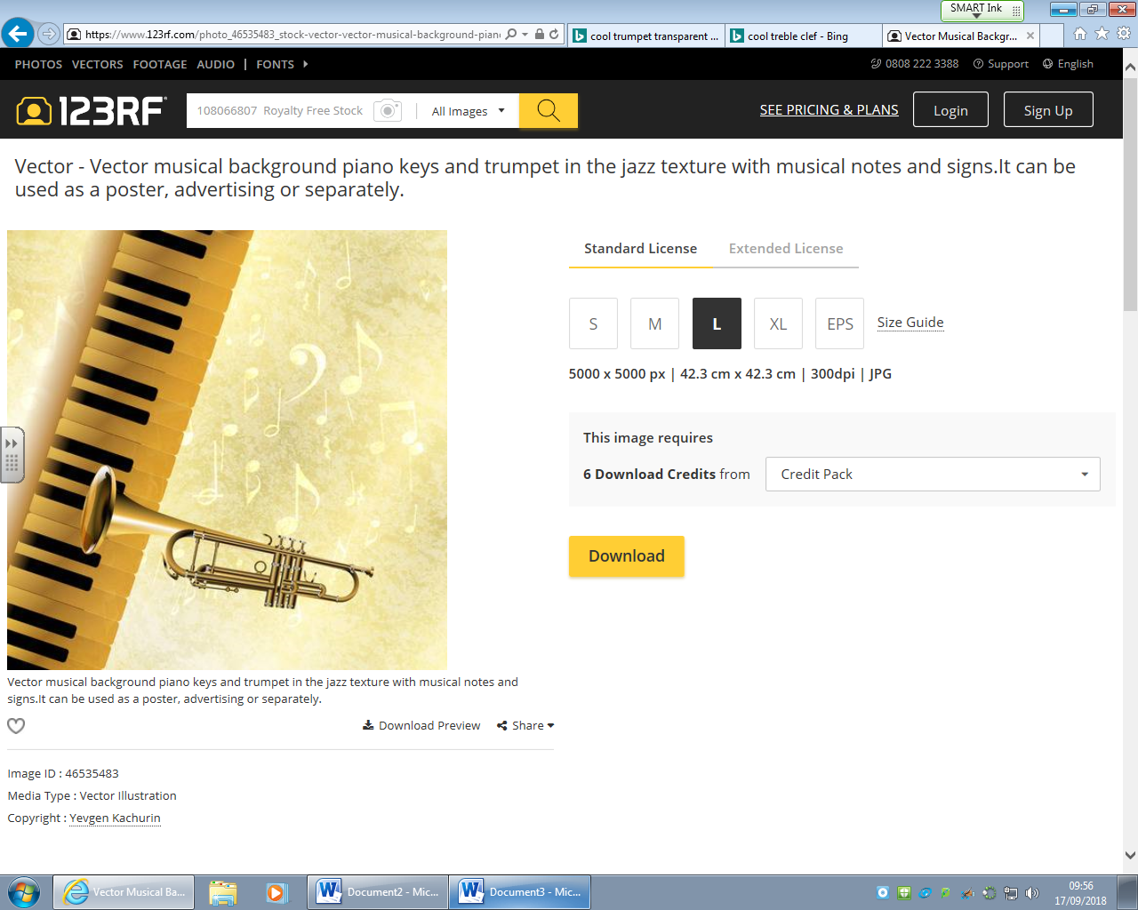**s**

**Friday 21st September 7:30pm**

**Annan Academy Assembly Hall**

**+ Soloists!**

***Annan Academy Band***

**Tickets available from the school office or at the door.**

**Aduts £5. Under 26’s Free**