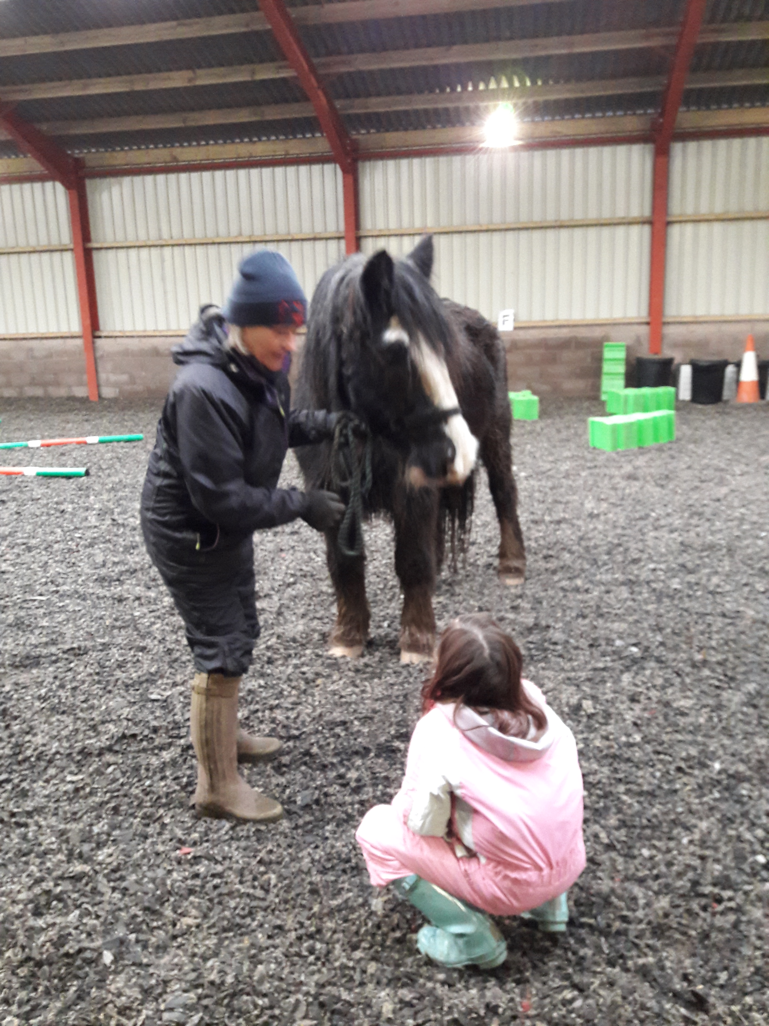  June 19th & 26th 2018  learning with horses  Schools Taster Sessions £10 per pupil  We are offering your young people the chance to come and sample a session here at Mossburn Farm on two dates in June from 1pm to 2.30pm. All activities are ground based (no riding) and are led by Sue Pike (Eagala Equine Specialist) and Alison Mann (Project Manager). Schools can nominate up to 4 pupils to attend and places will be allocated on a first come, first served basis. Please see our website for more information about the benefits of the sessions with horses. There will also be an opportunity to meet our other animals!  Follow us on Facebook - www.facebook.com/LWHmossburnCommunityFarm/  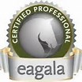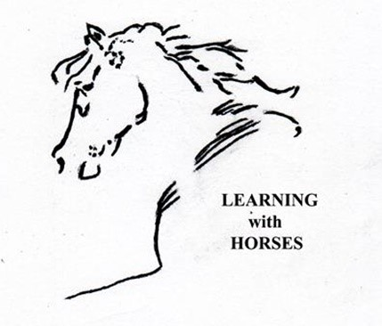 Funded by 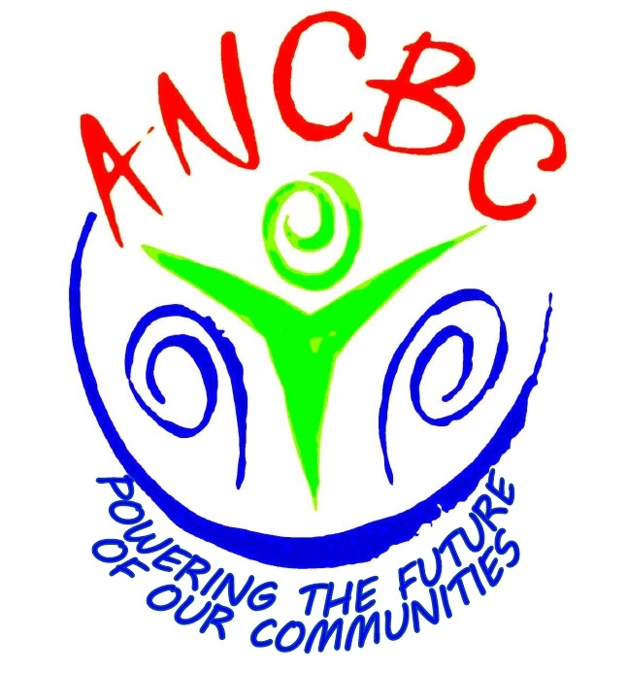  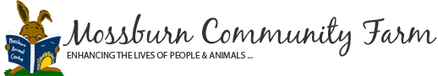 supported by  Registered charity SCO21652 | Meet the Horses and hear their stories  ────  Pet and Groom the Horses  ────  Take part in  Activities with the Horses  ────  Build your Confidence and have fun!  ────  Meet new people and work together!  Learning with horses  Mossburn Community Farm  Lockerbie, DG11 1LE  Tel:07841 976356 Alison/07792 611824 Sue  Email: learningwithhorses@outlook.com  Website: http://www.animal-assisted-therapy.org/home.html

