Ref: KL/  Rephad Primary School and Nursery Ladies Walk  Stranraer  DG9 8BW | Any enquiries please contact:  Mrs Karen Logue; Head Teacher  Mrs Eilidh Paisley; Nursery Manager  Tel: (01776) 704195  Email: gw08officerephad@ea.dumgal.sch.uk

Dear Parent / Carer,

School App
We are moving to a new school app after the break. We will begin to use the app from Monday 7th November so take the opportunity to download it now to get used to it. There are several benefits of the SAFER SCHOOLS APP. Firstly, it does not incur a cost for the school. Secondly, it also comes with free safeguarding advice our digital safety and other wellbeing information that you may find helpful as a parent/carer. Next, there is a pupil version of the app so they can access activities and quizzes to reinforce how to safely navigate the web as well as social media. Finally, there are many digital supports for staff to continue our regular lessons on internet safety. You can choose to use as much or as little of the information within the app that suits your needs. We will all take time to get used to the new app and discover various ways that we can use it to meet our own school needs. To begin with though – we will just use it to send notification messages as we do now with our current Jigsaw app. Please use the information at the end of the newsletter to download the app for yourself, or for your child as you feel appropriate. You can have both apps on your device at the same time but we will only be using the Safer Schools one from the date above.

FOR PARENT/CARERS
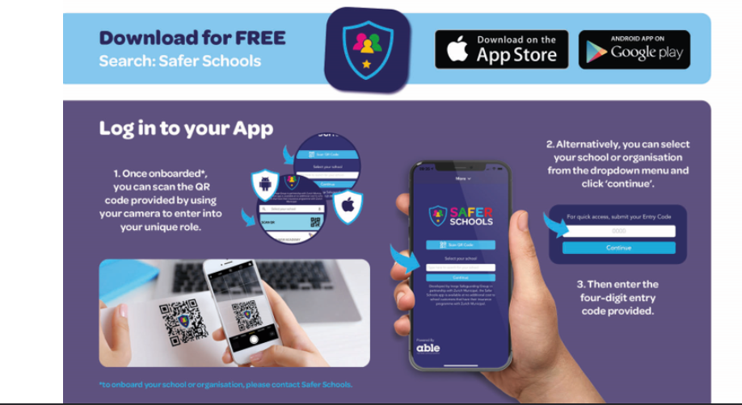
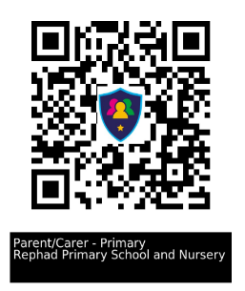
Code 7440

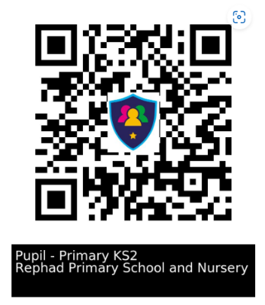

FOR CHILDREN P4-P7 CODE: 9342

