Safeguarding and Child Protection in Portpatrick Primary
It’s everyone’s job in Portpatrick Primary to keep you safe.
All adults in your school keep you safe.



Adults in your school keep you safe.
The Child Protection Coordinator might need to share your worry with other safe adults.

The adult may share your worry with the Child Protection Coordinator.

They help to keep you safe.

Are you worried or don’t feel safe?
Talk to an adult in school.
We will listen to you.

Are you worried or don’t feel safe?
Talk to an adult in school.
We will listen to you.


Are you worried or don’t feel safe?


Talk to an adult in school.
We will listen to you.

Safe adults will check in with you to make sure you are safe and feel included.

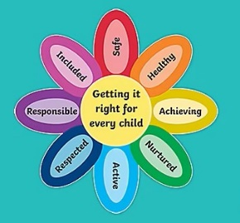

Remember, you can ask for help no matter if your worry is big or small – we will listen and help you.

HOW TO TELL SOMEONE ABOUT A WORRY
Choose an adult that makes you feel safe.
This might be an adult from home or at school.

se an adult that makes you feel safe.
This might be an adult from home or at school.

This might be an adult from home or at school.


Choose a time when it is easy for you to talk.

Choose a time when the adult has time to listen.
They want to help you.

How to tell a safe adult about your worry:
Talk about it Write it down Draw it




The adult will tell you what they will do next.

It’s ok if it feels scary to say your worry out loud. Your safe adult will help you.
If you feel that things don’t change, keep speaking out until they do.

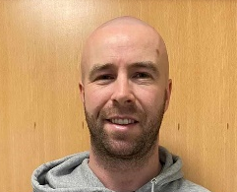

In Portpatrick Primary
Your Child Protection Coordinators are Ms. Whorlow and Mr Morrison.
If I don’t want to speak to an adult in school or at home, I can call Childline on 0800 11 11.
Childline is open 24 hours a day, 7 days a week.
If I am in IMMEDIATE danger, I can call the Police on 101 or 999 in an emergency.

