

Dear Parent/Carer,

Your child’s regular attendance at school is extremely important. Our agreed target of attendance here in the West Rhins Partnership is 95%. Attendance levels have continued to decline over the region in the past few years.

The illustration below indicates the expected levels of attendance at school and the correlation between the number of days missed and attendance percentages for each child.
Arriving late to school consistently also has an impact on your child’s education.

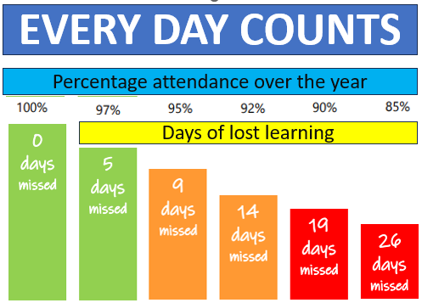
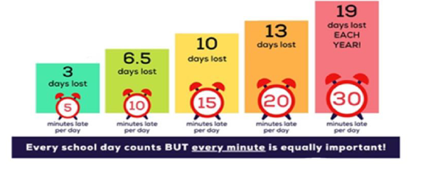

Attendance data is analysed every month by school staff, and we will be in touch to discuss any concerns as they arise. We understand that personal circumstances can result in poor attendance or regular late coming for your child and are sympathetic to this. If this is the case, please don’t hesitate to contact us and we will work together with you in the best interest of your child.

Dumfries and Galloway Council have developed a dedicated resource hub for parents and carers, where you will find some support and guidance in relation to supporting your child's regular attendance at school.

https://blogs.glowscotland.org.uk/dg/schoolattendance/

We understand that consistent attendance is key to your child's attainment and wellbeing, and we're here to work with you on this journey. Whether you are seeking tips, advice or simply need to understand the importance of school attendance, this site offers practical tools and resources designed to help your child thrive.

Yours Sincerely


Ms. Mandy Whorlow
West Rhins Partnership Head Teacher
Portpatrick: 01776 810395 St. Joseph’s R.C.: 01776 703460

