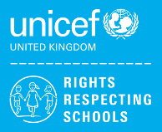

**We are a Unicef UK Rights Respecting School!**

**What is the Rights Respecting School (RRS) award?**

RRS is an initiative ran by Unicef UK. Unicef is the world’s leading organisation working for children and young people and their rights. In 1989, governments across the world agreed that all children have the same rights by adopting the UN Convention on the Rights of the Child (UNCRC). These rights are based on what a child needs to survive, grow, participate and fulfil their potential. Unicef work to ensure that the Rights of the Child are upheld and that all children enjoy their rights. The RRS award is based on principles of equality, dignity, respect, non-discrimination and participation.

**Why participate in the RRS award?**

Schools already involved in the award have reported a positive impact on relationships and wellbeing. Therefore, the West Rhins Partnership aims to have children’s rights at the heart of our ethos and culture, to improve well-being and to develop every child’s talents and abilities to their full potential. As part of this plan we are working towards recognition as a ‘Rights Respecting School.’

**How will our schools achieve the RRS Gold award?**

West Rhins Partnership pupils learn about their rights and we embed these values into daily school life. A Rights Respecting School models rights and respect in all its relationships – andencourages

everyone to respect others’ rights too. The overall aim is to empower pupils with the knowledge, skills and values to grow as responsible, active citizens.

There are 3 different awards:

* Bronze: Rights Committed
* Silver: Rights Aware
* Gold: Rights Respecting

The journey to the gold award can take 3-4 years, and every award achieved is valid for a 3-year period, after which schools must be re-accredited.

**What happens next?**

As part of our work toward the Gold award, we will:

1. Ensure our pupil led group help as the driving force behind all of our work. However, all pupils will be able to contribute to our work, through our suggestions box in the school hall.
2. Discuss the Rights of the Child at assemblies.
3. Create classroom charters, outlining our key rights in school and how we can respect others’ rights.
4. Review our practice in school against the RRS criteria.
5. Write an action plan for taking our work forward.

**How can you help at home?**

Talk to your child/ren and ask them what they have learned recently about children’s rights; discuss with them how they can respect others’ right; and ask them their opinion on their rights.

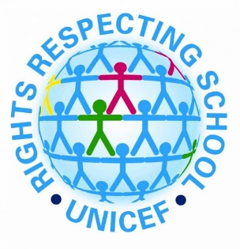

**Home School Agreement**

The award recommends we involve our families as much as possible. Here is a home-school agreement showing how we can all support children’s rights and build a positive ethos in our school. We would be grateful if you would help us support this.

**Where can I find out more?**

Further information about the ‘Rights Respecting School’ award can be found at:<https://www.unicef.org.uk/rights-respecting-schools/>

Here is a link to the UNCRC, in child-friendly language, that you could use to talk to your child about their rights: <https://www.unicef.org/southafrica/SAF_resources_crcchildfriendly.pdf>

Thank you for helping us on our Rights Respecting journey!

**Portpatrick Primary**

**Rights Respecting School Award**

**Parent Information Leaflet**