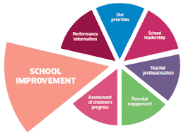

**School Improvement Plan Priorities**

**2023-2024**

Raising Attainment & Achievement

Raising Achievement

All pupils to be given an opportunity to engage with pupil voice groups so that they can lead activities in school.

Literacy & Numeracy

Plan for a range of comprehension, text types and numeracy skills to improve learning & teaching.

Raising Attainment

Review assessments processes and adopt authority progression frameworks to track and monitor for each pupil in literacy & Numeracy

Inclusive Practice

Family Engagement

Provide opportunities for families to participate in the life of the school

Promoting Rights

Achieve Gold Rights Respecting Schools award.

Offer children choice in the topics/contexts they learn about

Inclusion

Support pupils with additional learning needs through targeted interventions and Health & Wellbeing initiatives.

Digital Technologies/Developing Meta Skills

Monitoring and Tracking

Create progression frameworks to track children’s progress digital literacy and meta-skills (skills, for life, learning and work).

Pupil Skills

Ensure children have a range of digital technology experiences to support the development of their digital literacy skills development

Teacher Skills

All staff will undertake professional development in digital skills to support learning teaching.