**Safeguarding and Child Protection in Portpatrick Primary**

It’s everyone’s job in Portpatrick Primary to keep you safe.

All **adults** in your school keep you **safe.**

Adults in your school keep you safe.

**The Child Protection Coordinator** might need to share your worry with other **safe adults**.

The adult may share your worry with the **Child Protection Coordinator**.

They help to keep you safe.

Are you **worried** or don’t feel **safe**?

**Talk to an adult** **in school.**

We will **listen** to you.

Are you worried or don’t feel safe?

**Talk to an adult** in school.

We will listen to you.

Are you worried or don’t feel safe?

**Talk to an adult** in school.

We will listen to you.

Safe adults will check in with you to make sure you are **safe** and feel **included.**

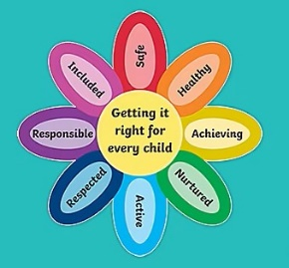

**Remember, you can ask for help no matter if your worry is big or small – we will listen and help you.**

**HOW TO TELL SOMEONE ABOUT A WORRY**

Choose an **adult** that makes you feel **safe.**

This might be an adult from **home** or at **school.**

se an adult that makes you feel safe.

This might be an adult from home or at school.

This might be an adult from home or at school.

Choose a **time** when it is easy for you to **talk.**



Choose a time when the adult has **time to** **listen.**

**They want to help you.**

**How to tell a safe adult about your worry:**

**Talk** about it **Write** it down **Draw** it



The adult will tell you what they will do next.

It’s ok if it feels scary to say your worry out loud. Your safe adult will help you.

If you feel that things don’t change, **keep speaking out until they do.**

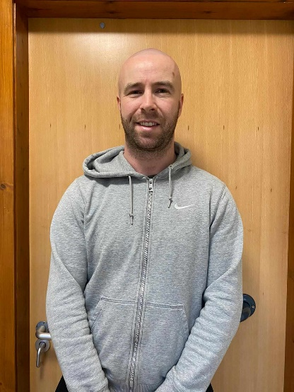**In Portpatrick Primary**

**Your Child Protection Coordinators are Ms. Whorlow and Mr Morrison.**

If I don’t want to speak to an adult in school or at home, I can call Childline on 0800 11 11.

Childline is open 24 hours a day, 7 days a week.

**If I am in IMMEDIATE danger, I can call the Police on 101 or 999 in an emergency.**