Portpatrick Primary School 2023 - 2024
Eco Committee Minutes– 05/09/23

Primary | Portpatrick Members
P1 | George
P3 | Josh
P3 | Ella
P4 | Adam
P5 | Rebecca
P6 | Lacey
P7 | Lewis (House Captain – Portree)

- Welcome - Ms. Whorlow welcomed our new Eco Committee members for 2023 - 2024. Everyone said they were keen to start working to help make our school as environmentally friendly as possible.
- Sharing Our Success - Ms. Whorlow showed our renewed Eco Flag award certificate for both schools. She also shared details of the letter we received from Keep Scotland Beautiful which praised the children’s hard work, initiative and dedication towards achieving all of their Eco Schools targets over the last two years.
- Environmental Review – Ms. Whorlow explained that Keep Scotland Beautiful has changed their environmental review process. We now use an online form to talk about where we are in relation to the 10 eco target areas. This helps us decide what we should focus on next. The children watched a short video to learn about this environmental review. The results can help schools decide which elements to select to create an action plan for. The children worked together to make judgements on where we think we are on each of these elements. As a result of this review, the children decided that we should work on Litter & Waste, Climate Action and Global Citizenship. A copy of our review is posted on our blog and shows some of the ideas that the boys and girls have already come up with.
Action: Ms. Whorlow to draft an action plan for each target, using ideas from the children and activities that are planned in our school
- Eco Responsibilities Rota - The committee talked about what Eco roles and responsibilities the team could do regularly to be more eco-friendly. We liked the idea that everyone should have a turn in taking a different responsibility area. Lewis has offered to create a rota.
  - Litter Bugs
  - Water Wallabies
  - Energy Eagles
  - Recycling Racoons
  - Garden Giraffes
Each Eco Committee member would earn a merit for their house team each week for carrying out their responsibility on the rota.
Action: Lewis to draft an eco-responsibility rota
- Litter – The children agreed that there is litter present in school. Lewis said this is mostly down to seagulls pulling litter back out of the bin. He suggested that we set a target to try and get a bin with a gull-proof flap. He said he has seen these at Girvan and he thought they would be a good idea for us. Rebecca said we could perhaps fund raise to buy a bin like this to reduce litter.
- The children agreed that we should carry out a litter survey and a litter pick today. Lewis, Adam and Josh were keen to conduct the litter pick after Ella, Rebecca and George have completed the survey. The group agreed to share the results of the survey with each class to make everyone mindful of using our bins for their snack litter.
Action: Ella, Rebecca and George to carry out a litter survey
Action: Lewis, Adam and Josh to carry out a litter pick
- Eco Mascot and Eco Code – Ms Whorlow has opened up a new competition for this year for our children to design the winning Eco Mascot for Portpatrick Primary. This should reflect the aims of our Eco journey for this year. She shared images of previous mascots to help the children. There is also a competition to create our new Eco Code (poem, rap etc.) that demonstrates our promises and aims for this year. A slip has been sent home with every child so that families have the opportunity to work on this project together. The winning designs will be displayed for the whole year on our Eco Notice Board. The eco group talked to each class to explain what are targets are and what they mean so that children can incorporate these aspects into their competition entries. The closing date has been set for 30th of September 2023
Action: All children are invited to enter our Eco Mascot and Eco Code competition
Action: Ms. Whorlow to update the Eco Committee display wall
- AOCB – Ms. Whorlow will update the Eco Schools display board to reflect our new action plan..
- Date of Next Meeting – To be scheduled

Actions | Who by? | When by?
Draft an action plan for each target, using ideas from the children and activities that are planned in our school | Ms. Whorlow | 30/09/23
Lewis to draft an eco-responsibility rota | Lewis | 23/09/23
Carry out a litter survey | Ella, Rebecca and George | 05/09/23
Carry out a litter pick | Lewis, Adam and Josh | 05/09/23
Enter our Eco Mascot and Eco Code competition | All pupils | 30/09/23
Update the Eco Committee display wall | Ms.Whorlow | 30/09/23

Eco Schools Competition 2023 – 2024

Can you design our new Eco School mascot?

We would love to see your designs. The winning mascot will be displayed for the whole year as our new character to support our fabulous eco work.
Make sure to theme your work on our targets for this year!
Litter and Waste, Global Citizenship & Climate Action

Here are some previous examples

Can you create our new Eco School Code?

Are you creative enough to write a rap, a poem or song, or whatever you like, to represent our goals and promises for this year’s eco activities? Try to base your work on our target areas. The winning code will be displayed for the whole year as our new code for everyone to see.

Here are some previous examples.
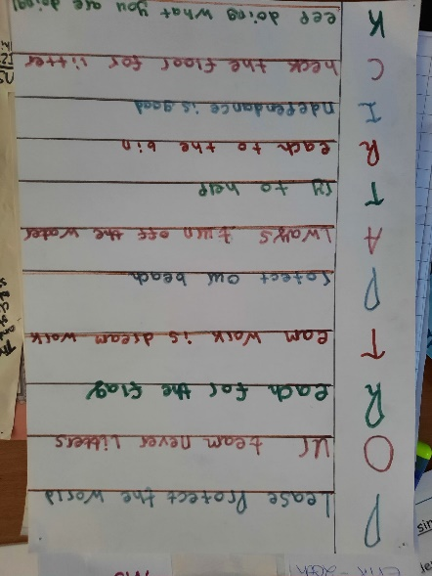
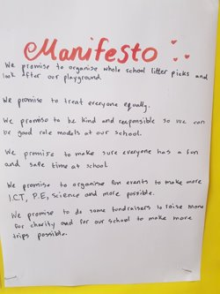

Please return your entries to school by 30/09/23
Good Luck!

