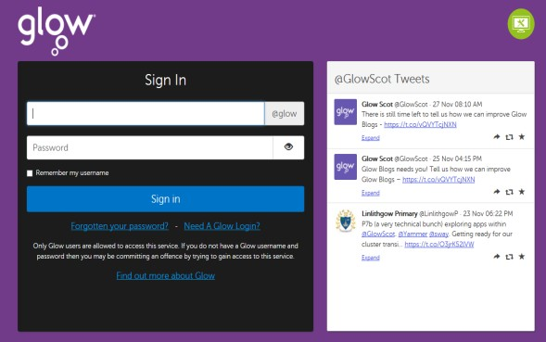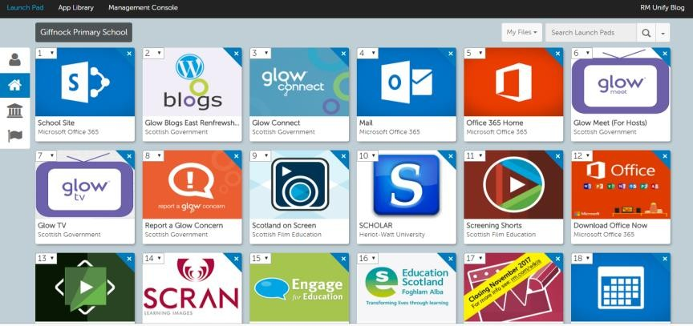
Accessing Glow
You can log in to Glow from home simply by going to the Glow Sign In page. https://sts.platform.rmunify.com/Account/SignIn/glow

The Glow username is always in this format:
gw00surnamefirstname

From the Launchpad you can navigate to all the other areas of Glow.
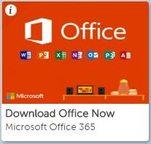
Download Microsoft Office365
Office 365
For all Glow users, it is possible for you to use Microsoft Office on your home machines - PC, Mac, phones and tablets.

This will allow you to use a range of Microsoft products (Word, Excel, PowerPoint, Access, OneNote etc.)

To Download Office Apps
To do this from RM Unify, you will need to see this tile. It is on the Launchpad when you log into Glow. If you cannot locate it, search for Office in the search bar.

To download the software to a PC or Mac, click on this tile and follow the instructions on the screen.

Please note that if you are downloading to an iPad or iPhone then the process is different. You need to download the apps from the App Store and then log in using your Glow username.

When logging in, you will be asked to enter your username. This is your Glow username plus the domain e.g. gw15surnamefirstname@glow.sch.uk

Once you do this, you will be transferred to the usual Glow login page. After entering your details, registration is complete.

The Glow username will only activate the software for as long as that account is active in Glow.

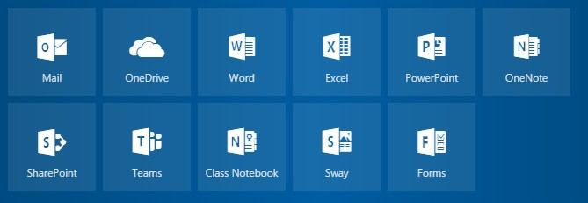
Microsoft Office365 through Glow
Microsoft Office365 is available through the Glow Launchpad.

This includes Word, Excel, PowerPoint, Sway and Forms, which are the most commonly used software within our school. Work is automatically saved via the OneDrive facility, allowing easy collaboration in projects.

.

Internet Safety and Social Media

We live in a world where access to the internet is increasingly common, so it is really important that we educate and support our young people to use technology effectively and safely. We have gathered further information for you to highlight the importance of internet safety and keeping your child safe online.

The following social media platforms require the user to be 13 years or older, (and with parental control to access it up the age of 17 years)
Instagram Facebook WhatsApp Twitter Snapchat

The NSPCC website gives detailed advice about a range of social media apps.
https://www.nspcc.org.uk/keeping-children-safe/online-safety/

The National Online Safety site aims to equip school staff, parents and pupils with the knowledge they need to understand online dangers. https://nationalonlinesafety.com/

The body responsible for applying UK PEGI ratings is the Games Rating Authority (GRA). Games for computers are labelled as age appropriate e.g. 12, 16 and 18 years of age. These are legally enforceable meaning that they should not be supplied to persons below those respective age bars.

Games such as Assassin's Creed, Call of Duty and Grand Theft Auto are intended for
older players i.e. 18 years due to explicit violence or other inappropriate content.

We use a wide range of resources to support learning, including:
- www.thinkuknow.co.uk by CEOP
- Promoting Anti Bullying week and Internet Safety Day initiatives
- All children and families receive a Responsible User Agreement upon enrollment
- Digital Leader training
- We are a Rights Respecting School and promote UNCRC Children’s Rights
- Learning about internet safety as part of our Health and Wellbeing Curriculum
Practical Tips and Guidance
- Talk to your child about what they are doing online – the NSPCC website has conversation starters
- Watch ThinkUKnow films and cartoons with your child
- Encourage your child to go online and explore with supervision
- Keep up-to-date with your child's development online
- Set boundaries in the online world just as you would in the real world
- Keep all equipment that connects to the internet in a family space
- Know what connects to the internet and how
- Use parental controls on devices that link to the internet, such as the TV, laptops, computers, games consoles and mobile phones

Useful Websites Literacy and Numeracy
Useful Websites

Other Curricular Areas

ICT Games – a selection of games for Literacy and Numeracy http://www.ictgames.com/resources.html

Spelling Games
https://www.topmarks.co.uk/english-games/7-11-years/spelling-and-grammar

Dolch Word – Lists and games for common words
http://www.dolchword.net/

Jackanory Junior – features online stories being read aloud
https://www.bbc.co.uk/programmes/b007t9wg

Zebra – reading website for emerging readers
https://www.roythezebra.com/

The Literacy Shed – short films and animations
https://www.literacyshed.com/

Storyline Online – listen to stories http://www.storylineonline.net/

Cool Math games
http://www.coolmath-games.com/

Sumdog Maths – your child’s login is in their homework diary. Also available as an app. https://www.sumdog.com/

Hit the Button maths. Also available as an app. https://www.topmarks.co.uk/maths-games/hit-the- button
Internet Safety information and games
https://www.thinkuknow.co.uk
.
Information from NSPCC on keeping children safe
https://www.nspcc.org.uk/keeping-children-safe/
NSPCC advice about Social Media and apps
https://www.internetmatters.org/hub/resource/net-aware/

Dance Mat Typing – an introduction to touch typing for 7-10 year olds http://www.bbc.co.uk/guides/z3c6tfr

Originally Woodlands Junior – resources for many curricular areas http://primaryhomeworkhelp.co.uk/

BBC Bitesize – links to many curricular areas. Early/First Level https://www.bbc.co.uk/education/levels/zgckjxs Second Level https://www.bbc.co.uk/education/levels/zr48q6f

Topmarks – links to many curricular areas https://www.topmarks.co.uk/

Coding websites https://code.org/
https://scratch.mit.edu/ Scratch (ages 7+) https://www.scratchjr.org/ Scratch Jr (ages 5-7)
https://microbit.org/projects/make-it-code-it/ You don’t need a Microbit as the website offers a simulator

CBBC Newsround http://www.bbc.co.uk/newsround

Crickweb – interactive resources for a variety of curricular areas http://www.crickweb.co.uk/Early-Years.html http://www.crickweb.co.uk/Key-Stage-1.html http://www.crickweb.co.uk/Key-Stage-2.html

Tables Trees – multiplication games http://www.amblesideprimary.com/ambleweb/me ntalmaths/tabletrees.html
Duolingo – Most children have an account set up at school – select your language if not
https://www.duolingo.com/learn

Please note that many of these games require Adobe Flash Player. Flash Player is being phased out on some website..

Useful Apps – Literacy and Numeracy

Fry Words  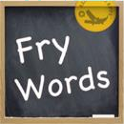  Flashcards based on the common word list we use | Phonics Genius  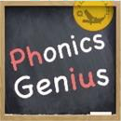  Over 6000 words, group by phonics rules | Chalk Pad  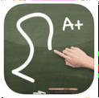  Draw on a  chalkboard | Jumbled  Sentences  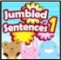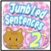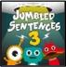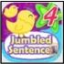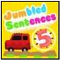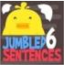  Interactive way to improve writing skills
Dragon Dictation  Easy to use voice recognition app. Dyslexia friendly | Collins Big Cat Readers  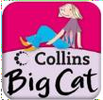  Set of 8 books. Read to me, read by myself, Story Creator | CBeebies  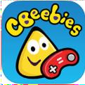  Games and fun features to help your child learn as they play | Bluster  Rhymes, prefixes, suffixes, synonyms, homophones, adjectives and more
Math is Fun  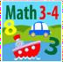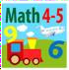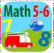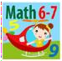  Series of apps to target increasingly harder maths calculations | Math Kid  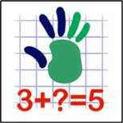  Aimed for ages 4- 12, with a range of maths calculations and skills | Teach Me  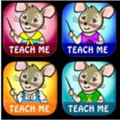  Series of 6 apps, for toddler to age  8. Mixture of literacy and numeracy | Spelltower  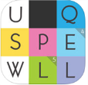  Giant version of Boggle, find and spell words in an enormous letter grid.  For ages 9+.
Marble Maths  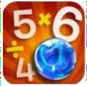  Designed for ages 9+  Marble mazes to help develop maths skills | Sumdog  Multiplayer games for maths, reading and writing | Hit the Button  Develop mental maths and calculation skills.  Has 97 different  game modes | Comics Head  Retell stories and experiences through a visual format. Create comics and photo  journals

Useful Apps – Other Curricular Areas

Book Creator  Create your own books, with music, narration and video | Shadow Puppet  Create short video clips. Digital story telling | Kodable  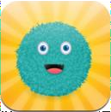  Progressive coding  for younger children | Scratch Jr  Children as young as 5-7 can enjoy coding with Scratch Jr.
iMovie  Create movie trailers and short movies quickly and easily | Stop Motion  Create stop motion movies instantly, with themes and sound effects | Science 360  Videos on a wide range of topics from the National Space Foundation | The Human Body by Tinybop  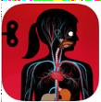  Investigate the body and interact with the organs
Sock Puppets  Hit the record button and the puppet will automatically  lip-sync to your voice | HP Reveal (previously known as Aurasma)  Bring everyday things to live! Create your own Augmented Reality | Green Screen  Just like they use in the movies!  Combine images from your camera and merge them  onto a background | Tellagami  Create a quick animated video called a Gami

School Blog Sites

https://blogs.glowscotland.org.uk/dg/LeswaltPrimarySchool/
http://blogs.glowscotland.org.uk/dg/portpatrickprimary/
https://blogs.glowscotland.org.uk/dg/kirkcolmprimary

