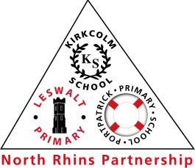
Portpatrick’s Inclusion Pledge

We promise that:

Everyone is welcome at Portpatrick Primary.

We respect everyone’s race, religion, culture and beliefs.
We know that everyone is unique, with different likes and dislikes.
We treat each other with kindness and courtesy.
We understand that we all learn at a different pace.
We recognise that everyone has different skills and talents.
We invite everyone to play together.
We help and support each other.
We involve everyone in learning together.
We don’t judge people on what they have or don’t have.
We treat everyone as we would like to be treated.

